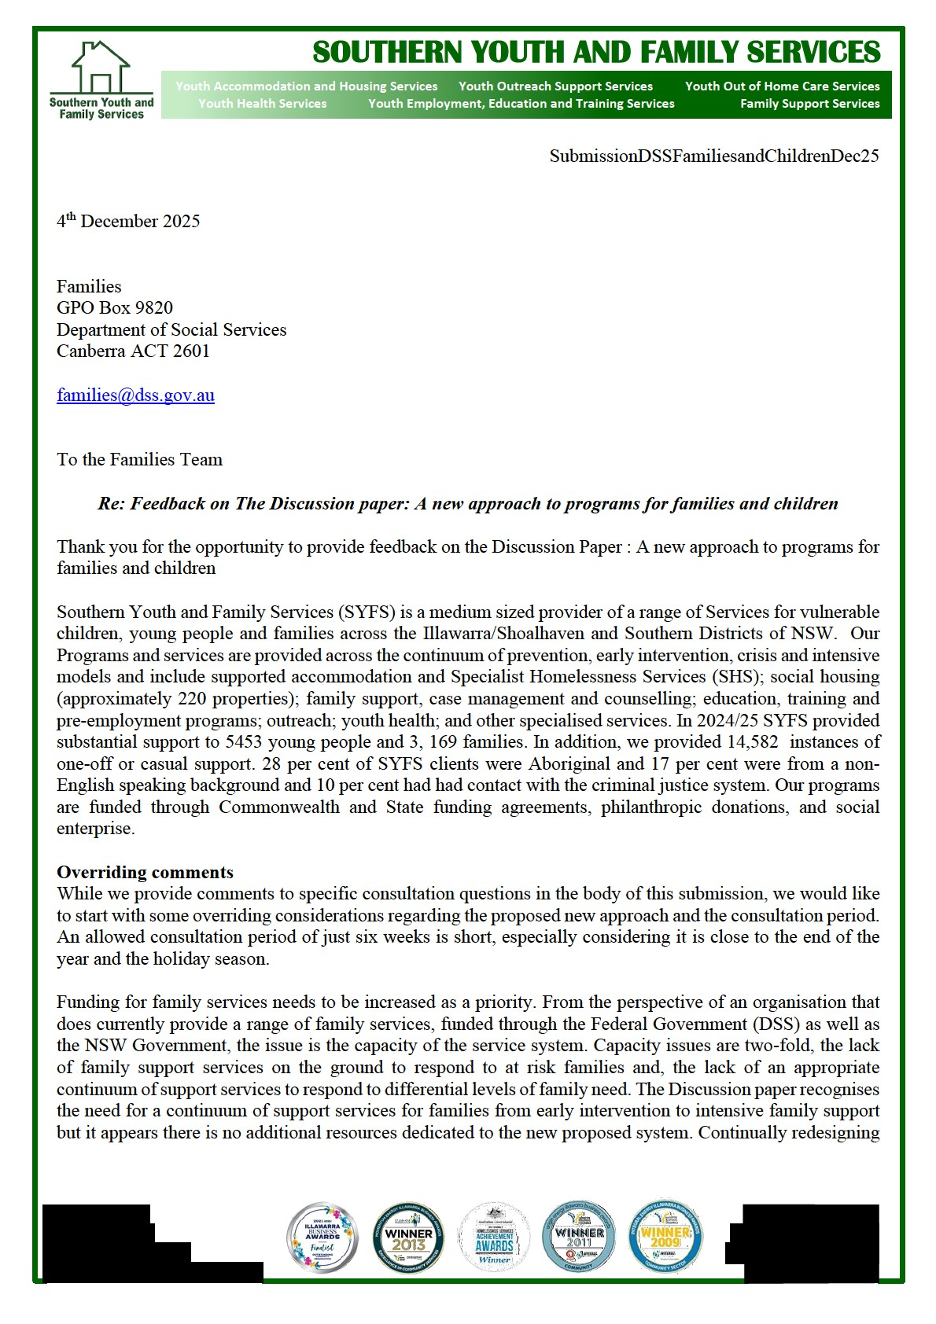

and reconfiguring the service system continuum, without additional resources is counterproductive and ignores the reality of the impact on complementary systems while stating to prioritise co-located and integrated service systems. We also note that a competitive open tender is counterproductive to cooperative and integrated service systems.

Thoughts on the recommended new program structure.

Vision and outcomes
The vision does include young people however the two outcomes listed do not. Considering the focus areas under the improving family wellbeing also not include young people we would like to see children and young people and their families considered priorities throughout all components of the proposed new program. Young people appear to be a secondary consideration.

Prioritising investment
The early intervention focus in the Discussion Paper is on children 0 – 5 years. The focus of early intervention is not just early in the life of a child but early in an identified issue/problem. The Paper does indicate that DSS will continue to fund services that support children throughout childhood and adolescence, but the funding priority is on children 0 – 5 years. Young people need to be listed as an identified investment priority, or they will be excluded in a competitive tendering process. Again, young people appear to be a secondary consideration within the proposed new service. It is essential that young people are considered a priority group. Some of the issues for children and young people only arise at the onset of adolescence. To see this as less of a priority than for instance issues for children 0-5 years is a significant problem in our view.

Services informed by and responding to community need
While not referenced in the Discussion Paper, the Evidence Summary puts emphasis on place-based initiatives, and this certainly features prominently in the rest of the supporting documentation. As the Communities for Children Facilitating Partners (CfC FP) are one the proposals to be subsumed under the proposed new approach. We would be very concerned if there was intention to expand the CfC FP place-based model. It is our experience that this model adds an additional layer of accountability and reporting for partner services, and that there can often be poor transparency (and potentially bias) in funding decisions made by the Facilitating Partner and/or community committee, or at least a community perspective of this. This particular model does not remove the competitive nature of regular open tendering, does not necessarily mean better coordinated or integrated services nor necessarily result in relational contracting. It also can add costs to the Program and reduce costs of the direct service delivery as the FP takes administration funding. We have also experienced and heard of some very poor practice by the FP include poor administration, late payments, inadequate understanding of issues such as the Equal Remuneration order and indexation. In addition, using a FP in a community can in fact cause tensions that should and can be avoided if the department maintained its role as funder.

Assessing community need
Grant applications are to be assessed according to community need. We have some concerns regarding basing considerations using some key data sources. Previous DSS open tender processes based on identifying community need via data sources, and according to statistical areas has led to some odd configurations. For example, one FMHSS in our area services the Shoalhaven as well as a small group of LGA’s in the Wollongong area some 70 kilometres distance apart. This was the identified area for the tender.

Indexes of disadvantage are useful, but in regional and rural areas there are unique local access issues that can make an area in need of a particular service because it is impossible to access that service in a neighbouring geographic area – e.g. transport routes or a broader location divided by mountain ranges.

2

Working together
We welcome the introduction of a single set of reporting requirements regardless of the number of services that a provider is contracted to provide. We trust that this will not result in one huge report requirement rather than several smaller reports.

We also welcome the attempt to simplify and streamline reporting requirements but remain sceptical that this will improve the reporting burden on services. It seems that the new program will actually collect more “qualitative” data in order to show service impact. It also remains unclear to us how continuing to report session instances in the DEX system fits within a greater emphasis on outcomes nor the use of this data to DSS.

Providers will be able to choose between a standard funding agreement or a relational contract. The difference between a relational and standard contract is not however clear. The Paper indicates that a relational contract should generally include clear governance and accountability, flexibility, and a focus on outcomes, not just activities. All these would be in a standard agreement as well so it is unclear why a relational contract would be preferred.

Thank you for considering our feedback.

3

