




A new approach to programs for families and children
1

December

2025

Discussion paper response
About toy libraries
Toy libraries are a magical space where children and adults come together to celebrate and connect through play – and then take that play back home through borrowing toys and educational resources.
Toy Libraries Australia is the national peak body representing 300 toy libraries across Australia and supporting over 175,000 children, parents and carers who use toy libraries each year.

Figure 1: Benefits of toy libraries
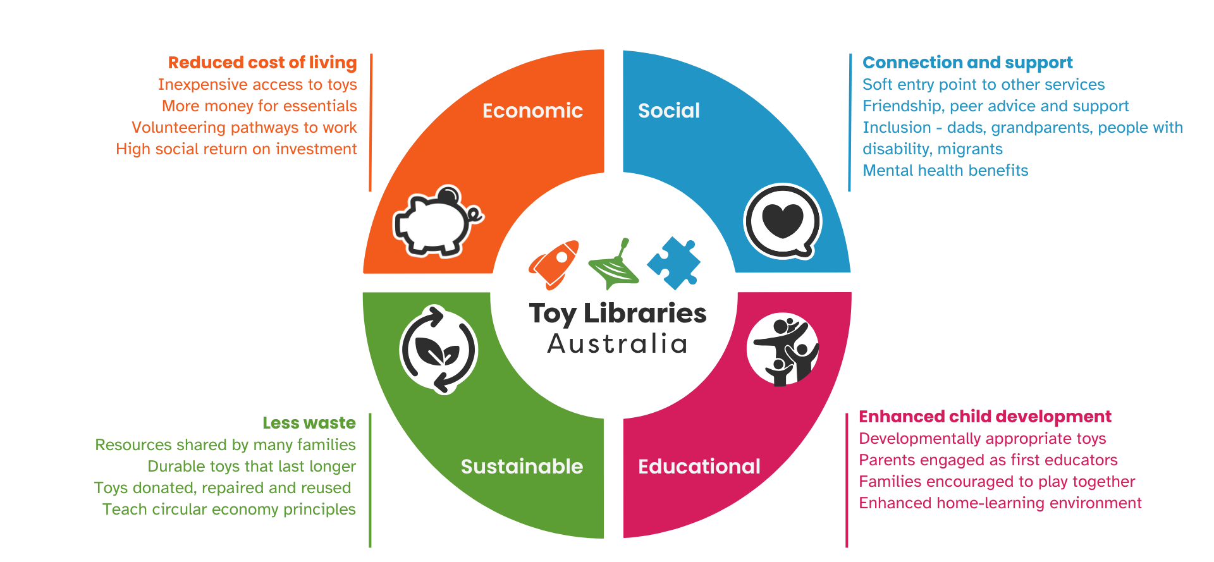
There are many benefits to toy libraries. Benefits relevant to this program include:
- providing a soft entry point to early years services where families can just turn up – without booking in, making any ongoing commitments, or needing to ask for specific help
- bringing play into the home through toys that engage both parents/carers and children
- being available at a time that suits a family’s existing schedule, including outside of working hours and at weekends
- filling gaps in early years services between the new parents’ services and the formal play-based early education available to 3- and 4-year olds
- being affordable for all families regardless of financial circumstances
- providing a flexible way for new parents to meet and support each other
- actively engaging dads, grandparents and other carers in the child’s life
- offering a stable mainstream connection for families who have a child with a disability or development concerns that are always there no matter what else is happening in a family’s life
- having connections that help parents to understand issues and what supports exist at different transition points.

Vision and outcomes
Does the new vision reflect what we all want for children and families?
Vision: All children and young people are supported by strong families who have the skills and confidence to nurture them
Feedback at the townhalls highlighted that communities are missing from vision and outcomes. The new vision could be strengthened, and communities included, by building on the vision developed for the Early Years Strategy:
All children and young people in Australia thrive and reach their full potential when nurtured by empowered and connected families who are supported by strong communities.
Are the two main outcomes what we should be working towards for children and families? Outcome 1: Parents and caregivers are empowered to raise healthy, resilient children.
Outcome 2: Children are supported to grow into healthy, resilient adults.
These outcomes are broad enough to encompass the range of activities likely funded through the program and the priority participants in activities.

Outcome 1
This outcome should explicitly acknowledge that building resilience is a whole-of-community effort and not solely reliant on parents:
Parents and caregivers are empowered and supported by communities to raise healthy, resilient children.

Outcome 2
TLA agrees with the intent of supporting long-term wellbeing, but we recommend reframing this outcome to more strongly reflect the rights of children as children, not only as future adults.
The United Nations Convention on the Rights of the Child states that all children have the right to live a full life (article 6); engage in play, recreation, and cultural activities (article 31); and access support for their wellbeing (articles 18, 24, 27). These rights apply to children in the present, not only in preparation for adulthood.
The Early Years Learning Framework for Australia: Belonging, Being, Becoming also recognises that ‘the early childhood years are not solely preparation for the future but also about children being in the here and now.’
Framing Outcome 2 around ‘healthy, resilient adults’ risks positioning childhood merely as a pathway to an end goal, rather than recognising that children have inherent value and agency right now. Children deserve to experience joy, connection, cultural identity, and safe environments because they are children, not because of who they will eventually become.
TLA recommends rewording the outcome to:
Children are supported to grow, thrive and participate fully in their lives
Toy libraries see firsthand that when children are supported to play, connect and participate — right now — they naturally build the foundations for resilience and wellbeing across their lifetime.

Program structure
Will a single national program provide more flexibility for your organisation?
We absolutely support a single national program and the objective of having one contract with each organisation for all children and families funding. Because toy libraries currently only have one CAPS contract, a single national program will not provide more flexibility for us but for other organisations this will have significant benefits.
As we build our capacity and impact, we expect that the approach of a single national program, coupled with relational contracting, will reduce barriers to partnerships with other funded organisations such as one we are currently exploring with Raising Children Network.
Does the service or activity you deliver fit within one of the three funding streams? Do these streams reflect what children and families in your community need now – and what they might need in the future?
Toy libraries best fit into stream 1, with some of our programs for children with disability, remote communities and migrant families also fitting in stream 2.
Stream 1 should provide the foundation for parents/carers and communities to identify and connect children and families who need support with stream 2 or 3 services. This should include not just families actively seeking support but those who can’t or won’t advocate for themselves.
Stream 1 services must be more than national digital services; they must also include universal services embedded in communities. Digital information services support families with important ‘point in time’ information but universally accessible community places offer continuity, trust and human connection which families need. Information provision must be woven into universal community services the build belonging and relationships – because connection is the foundation of resilience and wellbeing.
Stream 1 funding for toy libraries would also mean we can develop our toy libraries’ capacity to deliver stream 2 services.
Are there other changes we could make to the program to help your organisation or community overcome current challenges?
The ability to work across streams to address community need is a much-improved model and will strengthen overall community capability. It also provides a great solution to the issue of us/government trying to pilot their way out of complex problems. Pilots will now be able to be evolved, implemented and developed through a continuous improvement process.

Prioritising investment
Do you agree that the four priorities listed on page 4 are the right areas for investment to improve outcomes for children and families?
Yes – the four areas priorities are broadly the right areas for investment. In particular, it is important to invest early in supporting families to minimise potential disadvantage and harm. This is not only good for the families but also for the broader community and long-term government expenditure.
Priority 2 ‘connected, co-located and integrated services’ should be broadened to include engaging and connecting with families who are currently not accessing services. Many families lose connection to the social and health support system after the post-partum period. There is a need to strengthen family connection to services that support families in the first 3 years.

Figure 2: A model of universal and enhanced supports for families with children 0-3 years
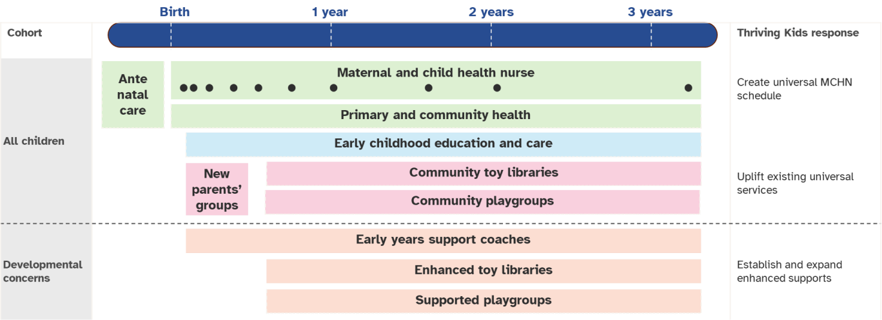
It is here that the DSS children and families funding can appropriately integrate with the new
Thriving Kids program and investments in strengthening early childhood education and care (ECEC). For families to remain connected to support for the first three years of a child’s life, families need a strengthened maternal and child health nurse (through Thriving Kids/Health), universal quality ECEC (Education), and an uplift of existing universal parenting supports including toy libraries, parenting programs and play groups (Social Services).
Are there any other priorities or issues you think the department should be focussing on?
One cohort that was identified in the initial consultation that is missing is CALD families.
Consideration should be given to specifically mentioning these families under the improving family wellbeing priority.

Improving family wellbeing
Do the proposed focus areas – like supporting families at risk of child protection involvement and young parents – match the needs or priorities of your service?
The proposed focus areas match the needs and priorities of toy libraries.
We strongly agree with prioritising prevention and early intervention for children aged 0–5 and supporting young parents under 25. These groups frequently access toy libraries for developmental play resources, peer connection, and encouragement in their parenting role.
Young parents in particular tell us that toy libraries feel welcoming, accessible and non-judgemental – qualities that help build confidence and reduce barriers to engaging with more formal services when needed. These focus areas match both the needs we see in communities and the strengths of our service model.
Many families who use toy libraries are experiencing early stressors or social isolation—conditions that can place them at higher risk of child protection involvement. Because toy libraries are universal, low-stigma, and community-embedded, they often serve as a safe early touchpoint where concerns can be noticed, strengths can be built, and families can be connected to support long before issues escalate.

Case study: Domestic violence survivor
A mum fleeing domestic violence needed to move a considerable distance from her previous life. Having few supports in her new home, her new workplace suggested she joined the toy library. When she joined the toy library, they were able to welcome and support her while safeguarding her information and story, so she and her children had a safe place to find community and build a life in their new home.
Are there other groups in your community, or different approaches, that you think the department should consider to better support family wellbeing?
Prioritisation needs to include other marginalised groups and those with poor outcomes on key data such as child development and wellbeing (e.g. multicultural groups, rural and remote)
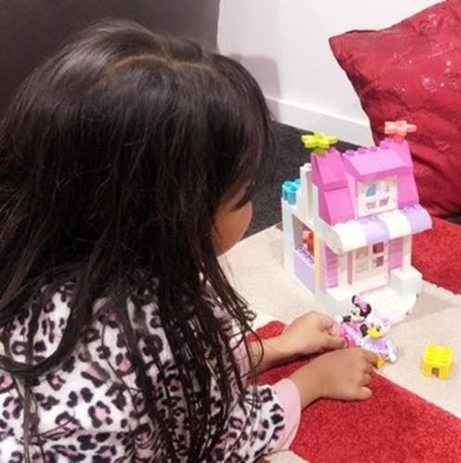
Case study: Aliya Alam
Member, Gosnells Toy Library (WA)
‘We moved to Australia in July 2023 from Pakistan. When we moved, I was pregnant and because of the transition my oldest was really upset.
We joined the toy library and then she was really happy, it was something new and exciting. It was a nice experience.
For just one membership we can borrow so many toys, and it brought life to my daughter again. It meant she could arrange play dates at her house because there were great toys to play with.
The toy library is such a happy place, so great for kids. Toy libraries are a great blessing.

Connected, co-located, and integrated services
What are other effective ways, beyond co-location, that you’ve seen work well to connect and coordinate services for families?
Beyond co-location, Toy Libraries Australia has seen that the most effective forms of coordination come from strong relationships and joint activities. When local practitioners, volunteers and community organisations know each other, maintain regular communication, and work together, families experience a smoother pathway even when services operate from different locations.
In many communities, especially rural areas, relational and flexible models can be more sustainable than formal co-location given venue availability – although we would love all toy libraries to be in integrated early childhood hubs!
Peer support is also an incredibly effective way to connect families to services. 1 in 5 families have spoken to someone at the toy library about connecting with other early years services. Given our strong volunteer workforce, most of these connections will be peer-to-peer advice.
Strengthening environments like toy libraries means parents and caregivers can use peer networks to increase awareness of available support and be empowered to seek the services they need. Peer support within toy libraries also offers continuity — families return regularly, allowing relationships to develop and remain stable as children move through different developmental stages and needs. These peer connections provide invaluable trusted, informal support, the type of encouragement and care that no formal program can replicate.
Evidence: Think Impact research
1 in 5 | toy library families have spoken to someone at the toy library about connecting to other early years services.
What would you highlight in a grant application to demonstrate a service is connected to the community it serves? What should applicants be assessed on?
Toy libraries would highlight that they are community-led organisations that are connected to the community through:
- Local governance and decision making led by parents, caregivers and community leaders
- Broad local volunteer involvement
- No two toy libraries are alike – the idea of a toy library is adapted by the community to address local needs and responding to and building upon local strengths
- Connections to local government and support from other local organisations.
Applicants should be assessed on how well they demonstrate genuine community-led practice (not just one-off consultation) and their previous experience working within the community. The proposed service should build belonging and strengthens local capacity—ensuring that programs are not only delivered to a community, but delivered with and for that community. There should also be a clear theory of change linking the activities undertaken to the desired community outcomes.

Responding to community need
Beyond locational disadvantage, what other factors should the department consider to make sure funding reflects the needs of communities?
Intersectionality: Beyond locational disadvantage, the department should consider factors that reveal the complex, layered realities of families’ lives. These include cultural and linguistic diversity, disability and developmental needs, availability of informal support networks, housing insecurity, and family isolation. Communities with high numbers of new parents, young parents, migrant and refugee families, or families experiencing cost-of-living pressures may have significant needs that are not captured purely by geographic indices.
Existing services: Some highly disadvantaged communities already have significant investment in children and family services. Funding should not duplicate existing services and should target communities missing out on services today.
Considering needs alone can lead to a deficit-based approach. Demonstration of community need should be paired with:
Building on community strengths and assets: funding should go to organisations that use the community strengths to build on current capacity to solve challenges. There is no point in funding services that the community does not have the capacity to support or interest in engaging with.
What’s the best way for organisations to show in grant applications, that their service is genuinely meeting the needs of the community?
Organisations can best demonstrate they are meeting community needs by showing clear evidence of ongoing, active engagement with families and local stakeholders and adapting their service to community needs. This might include regular feedback loops, co-design processes, partnerships with culturally specific organisations, and the involvement of parents, volunteers and people with lived experience in decision making. Demonstrating how services have adapted over time in response to emerging community needs is also a strong indicator of genuine connection.
Case study: Chris Guinane Knox Toy Library
‘I volunteered at the toy library due to a lack of other community engagement options for dads in our area. I tried to engage with the new parents’ group but got pushed out by a council worker who suggest it was really for mums.
After I joined the toy library, I jumped straight into committee and took over as President during COVID. My involvement has shown other dads that it is possible to be involved [in early years services] and to enjoy it.
As a dad, the toy library has given me a place to connect with my community.’
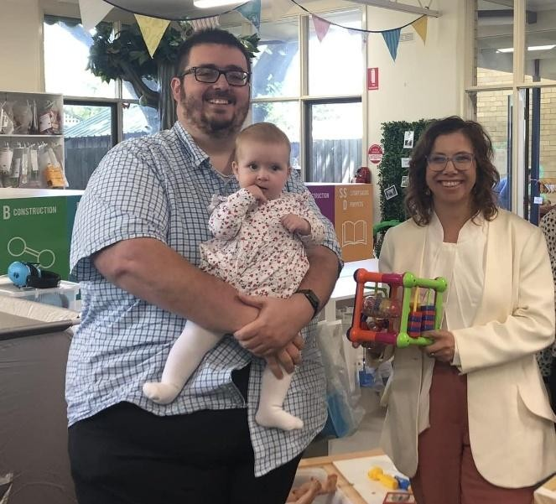
Grant applications could also include family satisfaction, user impact stories and case studies. When organisations can show that families consistently access their service, trust their staff or volunteers, and recommend them to others, it provides compelling evidence that the service is relevant, responsive and meaningfully embedded in the community.
Chris Guinane showing Minister Rishworth around
the Knox Toy Library in 2023

 | 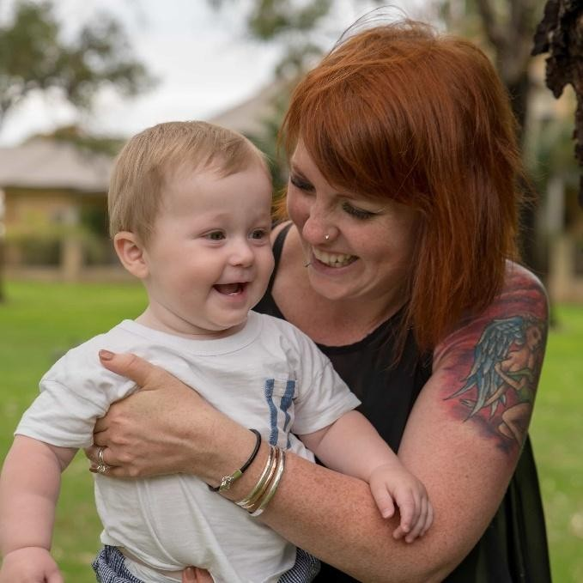  Chris Guinane showing Minister Rishworth around  the Knox Toy Library in 2023
  Case study: CJ Aston
  Tuart Forest Toy Library
  I grew up all over the world but now call Western Australia home, where I live with my FIFO-working husband and two kids. I have a 5-year-old and a 7-yearold who has autism (ASD) and ADHD.
  During the early days of the pandemic, I juggled my eldest’s assessments, a newborn, financial stress, and isolation — all while building a new house. The pressure felt overwhelming.
  At the time, I couldn’t shake a sense of disconnect and anger. I wanted to be everything for my kids but felt like I was failing them. One day, I realised I couldn’t remember the last time I felt okay. That’s when I broke down and decided to get help.
  My GP stepped in immediately, prescribing medication and connecting me with someone to unpack my thought patterns. Therapy was helpful, but it wasn’t until I joined my local toy library that I truly started to heal. They were my absolute lifeline.
  Toy library gave me a safe space where my kids could just be themselves, and a community of support wrapping around us as a family. Borrowing toys became a way to bond with my kids, and joining the committee reminded me of my skills outside motherhood. Being part of this community helped me rediscover myself.
  The four walls of the toy library and the people within it became my safe place and are an ongoing key to my mental health maintenance.’

Improving outcomes for Aboriginal and Torres Strait Islander children and families
What else should be built into the program design to help improve outcomes for Aboriginal and Torres Strait Islander children and families?
There is currently only one ACCO member toy library and more are unlikely to be established without the leadership of Toy Libraries Australia. We have started conversations, however, partnerships to establish ACCO toy libraries will likely take time.
The program should be designed with an allocation of funds that can be accessed by ACCOs across the contract period. For example, an ACCO toy library establishment fund, where funds are available to be allocated to ACCOs when they are ready, rather than all funds being allocated in the initial contracting process.
Measuring outcomes
What types of data would help your organisation better understand its impact and continuously improve its services?
For toy libraries to successfully play their role as an accessible soft entry point to the early years system we need to minimise barriers to uptake. This includes initially limiting data to collection to only what is absolutely required to run our toy lending services.
The families most in need of support sometimes will not access services that require collection of personal data. However, once families are engaged with toy libraries, we find them very keen to share their experience of the impact of toy libraries. This was demonstrated through recent toy library evaluation surveys. Based on the success of these surveys we are going to establish an annual toy library member survey to collect demographic and impact data of toy library members.
Being able to compare toy library members’ demographics with other services and identifying where families are accessing other support at a community level would help us understand gaps in our reach and who we should partner with.
Toy libraries already have good activity data collection, including the number of families using each toy library and how often they use the service.
What kinds of data or information would be most valuable for you to share, to show how your service is positively impacting children and families?
- Results from member surveys
- Evaluation results
- Social return on investment reports
- Case studies
If your organisation currently reports in the Data Exchange (DEX), what SCORE Circumstances domain is most relevant to the service you deliver?
We do not report on DEX for CAPS and we should not report via DEX as the administration burden and detail of information collected it is inappropriate for universal volunteer run services.
We report via DEX for ILC funding to make toy libraries inclusive for families with disabilities however toy libraries are funded to participate in this program and data is only captured for a small proportion of members.
The circumstances domain used in DEX for our ILC funding is ‘community participation and networks’. Other circumstances domains relevant to toy libraries are physical health, mental health, wellbeing and self-care, age-appropriate development, family functioning, and financial resilience.
What kinds of templates or guidance would help you prepare strong case studies that show the impact of your service?
We are experienced in communicating the impact of toy libraries through stories and case studies so do not require guidance.
What would be more helpful for us would be specific funding for evaluation and to develop the evidence base specifically for toy libraries.

Working together
Note: We have drawn on the work of the University of Oxford Government Outcomes Lab in our responses.
What does a relational contracting approach mean to you in practice? What criteria would you like to see included in a relational contract?
The way we have been working with the department for the last 3 years has the foundations of a relational contracting approach, including the flexibility for TLA to identify sector priorities and apply funding to these priorities.
In practice, we would like to see the following approach to relational contracting:
- Department offers the partner an opportunity to pilot a relational contracting approach with an indication of the funding level available.
- If the partner wishes to progress, initial joint discussions agree a shared purpose, principles and outcomes, documented in a short memorandum of understanding.
- Joint work proceeds to agree the governance mechanisms and decision-making structures.
- The partner proposes and refines with the department:
  - streams of activity to deliver on the outcomes
  - outcome measures for each activity stream
  - allocation of funding across streams and years
  - targets for each outcome measure based on funding allocations
- All the above are formalised in a five-year overarching contract.
- Each year the department prepares a summary of government priorities with suggestions on how the partner could contribute to achieving these priorities
- Each year, the partner prepares:
  - Review of the previous year – impact, activity, financials, learnings
  - Activity Work Plan and associated budget for the upcoming year – outlines the specific activities to be undertaken and how the funds will be spent.
- The department and partner meet to discuss the outcomes achieves in the previous year and confirm the activity and funding for the upcoming year.
Note: The allocation of funding across streams and years in the initial contract is used as a guide and can be easily adjusted by mutual agreement without changing the overarching contract.
- The partner and the department commit to external evaluation of both the activity and the relational contracting approach
What’s the best way for the department to decide which organisations should be offered a relational contract?
The department should offer relational contracts based on the following:
- Existing relationship: partner organisations should have a strong existing relationship with the department.
- Evolving needs: community needs may change or emerge over the contract period.
- Broad scope of activity: the funded activity is broad enough and the amount of funding large enough that resources could be meaningfully reallocated over time as community needs change. This could be reallocation across geographies or activities.
- Flexibility and responsiveness: the first contract period will require a trial and learn approach for both the department and partners. Selected partners will need decision making and governance mechanisms that can quickly respond to changes.
- Clear independent success measures: Success measures for the partner’s activities can be clearly articulated and can be measured independently of other services provided in the community.
- Principles aligned: The partner has a commitment to key relational principles of trust, transparency and continuous improvement.
Is your organisation interested in a relational contracting approach? Why/why not?
Yes.
  - Our understanding of how to maximise the impact of toy libraries is quickly evolving and maturing as we undertake larger projects and complete evaluation activities.
  - For new toy libraries, we focus resources where and when communities are ready which is not known in advance.
  - We have a national footprint, a streamlined governance structure, and an innovative leadership team with the capability to work in new ways.
  - We have a track record of working collaboratively and responsively with the department.

Other
Is there anything else you think the department should understand or consider about this proposed approach?

Existing services
Applications should also be required to demonstrate a ‘do no harm’ principle. We have experienced examples where philanthropic and government funded programs have rolled into a community without truly understanding what grass roots/volunteer-run services that already exist. Services similar to existing services should not be funded, unless they can demonstrate how it is complimentary to existing services.
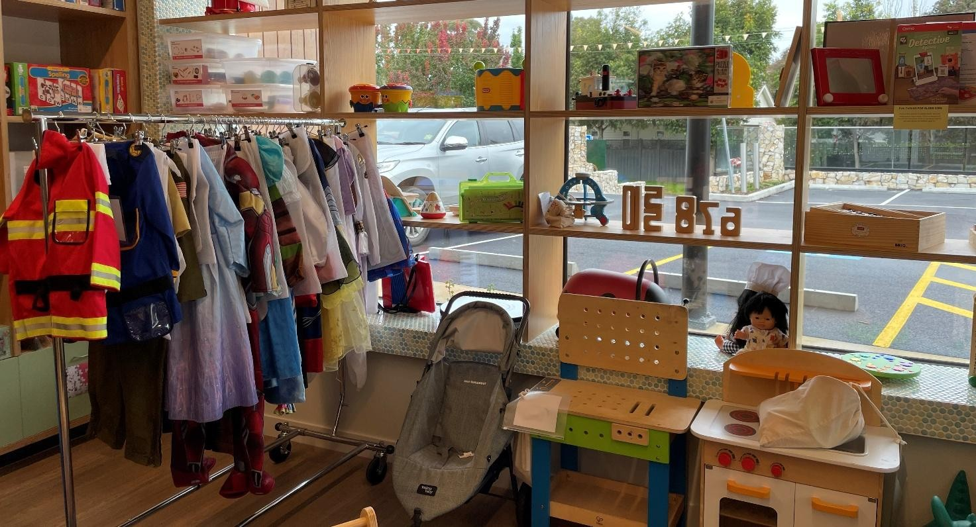
For example, a new toy library should not be funded in a community with an existing toy library if the proposed model of operation is not going to add new of different value to the community and not just end up in the closure of existing service.

Resourcing and upskilling of department staff
The department workforce needs to be resourced and upskilled for this approach to work. Community Grants Hub staff currently only play a compliance role, checking documentation provided meets the commitments made without really understanding the services provided or community’s needs.
Particularly for national stream 1 providers and partners with relational contracts, it will be critical that FAMs have a broader national perspective with a strong understanding of the policy and service delivery environment.

