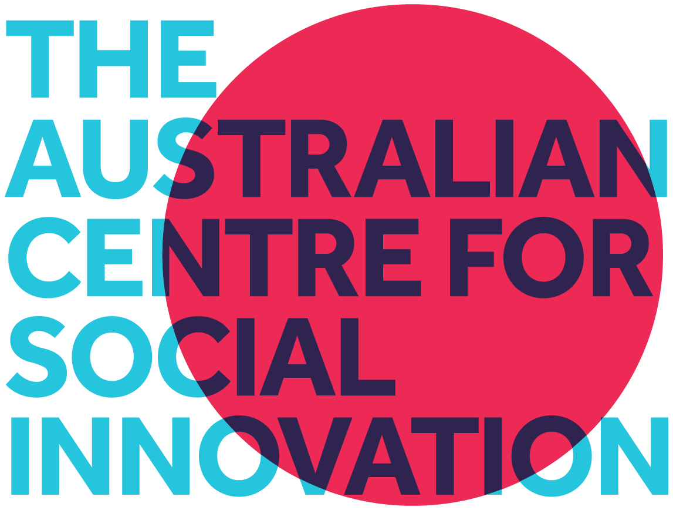
05 Dec 2025
Department of Social Services
families@dss.gov.au
Families
GPO Box 9820
Department of Social Services Canberra ACT 2601

Response to “A new approach to programs for families and children” discussion paper
Summary
The Department should prioritise long-term investment in peer-to-peer programs in order to strengthen prevention and early intervention in ways that are shaped by communities, and flexibly respond to local needs. Evidence shows that the unique nature of peer-to-peer programs mean they can achieve outcomes for children and families that conventional services struggle to achieve. Examples of peer-to-peer in this space include Family by Family and The Young Parent Program. Peer-to-peer programs work by increasing the capacity of support in our communities - mobilising the overlooked ‘workforce’ of people who have got through tough times and stand ready, willing and able to help others do the same - drawing on their own lived experience.
Peer-to-peer programs could support the Department to deliver across all priorities of this reform:
- Engaging families in early interventions that choose not to engage with other service types and reducing crisis service usage.
- Provide navigational, relational and preventative support that is complementary to service co-location and integration.
- Drawing on lived-experience to provide support to community members from community members in line with local community realities
- Providing effective supports for First Nations families including resourcing ACCOs to lead culturally grounded, community-led supports for First Nations families
Peer-to-peer programs would complement and strengthen professional service responses—helping integrate systems around what matters most to families. Investing in peer programs would reinforce the four priorities and ensure that reforms are grounded in the practical realities and strengths of families themselves.
This recommendation is made by The Australian Centre for Social Innovation which, over the last 15 years, has supported governments and NFPs in 5 countries to develop peer-to-peer programs in areas including early intervention, child protection, parenting, domestic family and sexual violence, caring and paediatric palliative care.

Contact us

T +61 8 7325 4994

E info@tacsi.org.au W www.tacsi.org.au Head office We acknowledge the traditional custodians and owners of the
Level 1, 279 Flinders Street lands in which we work and live on across Australia. We pay
Adelaide SA 5000, our respects to Elders of the past, present and emerging. We
are committed to collaboration that furthers
^{Australia} self-determination and creates a better future for all.

Question 1: Do you agree that the four priorities listed on page 4 are the right areas for investment to improve outcomes for children and families?
We agree with the priorities and also want to see peer-to-peer explicitly prioritised in the reform.
The current priorities do not exclude peer-to-peer programs, and peer-to-peer can help deliver on them (as detailed below); however without explicit prioritisation of peer-to-peer, communities and government risk missing out on the significant benefits of the approach.
Awareness of peer-to-peer models is not yet widespread in the child and family sector and because of this their take-up is unlikely to develop in response to the reform. However, explicit prioritisation by the government would accelerate take-up and benefits. TACSI are currently working with philanthropy to develop a national initiative to accelerate peer-to-peer take-up.
Examples of peer-to-peer programs for families and children
The Young Parent Project runs group learning sessions that build young parents’ preparedness, confidence and social connectedness, reducing the likelihood of future contact with crisis services by equipping them early to be prepared, feel more confident and increase their sense of social connectivity. A core part of the approach is the role of Peer Support Workers who have lived the experience of parenting under 25 who have faced similar challenges and judgement associated with early parenting.
The program reduces risk factors for child protection intervention, and increases resilience, parental confidence, and competence. The program is delivered by Junction Australia in South Australia, was co-designed by young parents, Junction with philanthropic support and is now funded to expand through the Commonwealth Outcomes Fund.
Family by Family, is a whole of family peer approach, connecting families who’ve come through tough times with those currently navigating similar challenges. Peer volunteer families are scaffolded through the support of Family and Kids Coaches. The program is voluntary and recruits in public locations such as shopping centres and parks as well as through referral pathways. Each site responds to its unique community needs and co-locates with diverse community stakeholders.

The Family by Family program was co-designed between families and TACSI and has been funded for delivery in South Australian through Communities for Children program and the South Australian Government since 2011. The program has also run in Mt Druitt, NSW and the UK. A recent and not-yet published quasi-experimental evaluation (attached to email, confidential) found that:
- Family by Family is engaging families with significantly higher and more complex needs than the general population. Reinforcing the importance of designing programs that are responsive, flexible and trauma-informed.
- Family by Family participation led to a relative 44% reduction in the risk of children being removed into out-of-home care over 24 months.
- Family by Family participation led to a relative 6% reduction in the risk of children presenting to a Hospital Emergency Department over 24 months.
TACSI have also recently supported the Department of Families, Fairness and Housing in Victoria, to co-design a new peer-to-peer program with parents which is now in the first stages of implementation.
What is peer-to-peer?
Peer-to-peer support mobilises an overlooked resource in our communities: people who have been through tough times, come out the other side, and are now willing, ready and able to help others do the same. It takes many forms, peer mentors, volunteer groups, peer support workers, in-community responses, but always rests on the same foundation: relationships of trust built on shared lived experience.
Because trust, mutuality and lived experience are the active ingredients of change, peer-to-peer programs consistently create outcomes that professionals alone struggle to achieve, and at relatively low cost. They increase social capital, strengthen family capability, build confidence and leadership, and reduce demand on acute and crisis services through early intervention, prevention and alternative pathways. These strengths make peer-to-peer particularly effective for:
- Supporting families to navigate the complex, relational, practical challenges they face.
- Supporting overburdened service systems to respond to escalating demand
- Strengthening the fabric of our communities
For a thorough introduction to peer-to-peer programs see TACSI’s 2023 paper ‘The Benefits are Mutual: Understanding the opportunities for peer-to-peer support to change lives, ease the demand on Australia’s stressed social service systems, and rebuild the fabric of our society.’ How peer-to-peer could support the Department to deliver on the four priorities
- Early intervention to improve family wellbeing : Our experience shows that engaging with a peer can be more attractive, and carry less stigma than engaging with a professional. Peer-to-peer programs can be an effective first step toward engaging with specialist professional services and evidence shows they can reduce engagement with crisis services.
“This is the first time I felt supported and not judged for my history, it has given me a chance at a new life “ - Seeking Family, Family by Family, Peer to Peer program
- Connected, co-located and integrated services: Peers who have been through tough times are uniquely equipped, through their lived experience, to offer first-hand guidance on navigating services, programs and community supports. In practice, they often operate as the connective tissue between services and families—a complement to co-located and integrated models that strengthens coordination and makes support easier to access.
“It’s like Family by Family, we connect like pieces of a puzzle and once we’re together we’re a complete picture” - Seeking Family, Family by Family, Peer to Peer program
- Services informed by, and responding to, community need: In peer-to-peer programs, community members are the front line of change. Peer-to-peer support reflects and responds to the cultures, languages and lived realities of local communities.
“During my link up… I have had the opportunity to talk to another adult about my worries, problems and challenges with regards to my family… this has helped me continue to build my confidence and work in my goal of joining community groups in my area and build friendships with other mums in a similar situation” - Seeking family, Family by Family, Peer to Peer program
- Improving outcomes for Aboriginal and Torres Strait Islander children and families: Our experience is that peer-to-peer programs can engage, and be delivered by First Nations families, especially when co-designed with First Nations Families. In the Family by Family program this has included both Aboriginal families choosing to engage with non-Aboriginal families for support outside of their community, and Aboriginal families supporting non-Aboriginal families. Two examples of Aboriginal focussed peer-to-peer programs TACSI supported the development of are Aboriginal Families Together delivered by Uniting in Dubbo and Nambucca and Mankuri-Apinthi delivered by KWY in Adelaide.

Question 2: What are other effective ways, beyond co-location, that you’ve seen work well to connect and coordinate services for families?

Our experience with multiple models shows that peer-to-peer support is an effective way to connect and coordinate services for families - a relational and preventative complement to co-location and integration.
Lived experience roles, such as peer volunteers, offer connection and coordination benefits that extend well beyond what co-location can achieve alone. Formal systems often rely on jargon, complex pathways and rigid processes that make engagement difficult for families, even when services sit side-by-side. Co-location can help services be more responsive to the holistic and intersecting needs of families, but it does not, on its own, make help-seeking easy or intuitive.
What we’ve seen work particularly well is the involvement of peer volunteers and workers who can “walk alongside” families through the entire service journey: supporting the initial step-up into services, helping families interpret and navigate processes, attending case conferences or service meetings with them, and providing step-down and ongoing community-based support.
Peers bring a deep understanding of not only how to navigate complex service systems, but a deep understanding of the emotional impacts that can be associated with seeking help from the system. By drawing in this knowledge and with empathy they are able to share as mentors to guide families through fragmented supports.
We have seen prevention occur in these everyday spaces—where families draw on neighbours, peers, schools, cultural groups and local networks for connection and support. Peers have played a pivotal role in these “in-between” moments where services don’t typically reach.
By supporting families to build and maintain their own relationships and social capital, peers create the kind of grounded, relational co-location that drives true early prevention before they ever need formal support.

Montgomerie A, Lynch J, Pilkington. (2025) Long-term outcomes for children in a family-led peer-to-peer support program: Quasi-experimental evaluation. Adelaide: BetterStart Group, The University of Adelaide.

