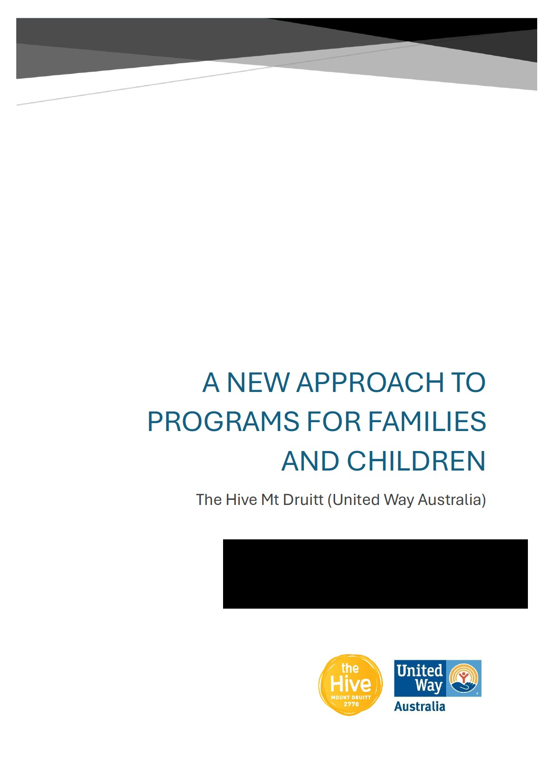

The Hive Mt Druitt
The Hive, Mt Druitt (United Way Australia) is a place-based, Collective Impact initiative operating in the suburbs of the Mt Druitt postcode in Western Sydney, NSW. Due to the significant impact of 10 years of work in Mt Druitt, in 2025 The Hive have commenced preliminary scoping work in the Campbelltown area to launch a second place-based initiative.
The Hive was established to address long term entrenched disadvantage and unchanging child outcomes in Mt Druitt despite long term financial investment. Our extensive consultation showed that while services were present in the community, they were difficult for families to navigate and access, and often disconnected from the needs of the community. The Hive is the backbone organisation for the Together in 2770 Collective Impact initiative which takes a placebased approach across 4 key suburbs in the 2770 postcode, listening and responding collaboratively to community needs.
The goal of The Hive is for all children in Mt Druitt to start school well, with equal opportunity to learn, be healthy and participate in quality community life. We believe that if we bring various parts of the system together, listen deeply to community concerns and work together on community informed solutions we can sustainably improve outcomes for children in this community. The Hive believe that to reach this goal an ecological approach is required, with direct support for children and families delivered alongside community development practices to support the environment in which families live. We endeavour to share our learnings with government of what has worked for families, and advocate for more equitable policies that make impact for those who need it most.
The Hive authentically listen and learn from local families about their experiences and then collaborate with local stakeholders to address these, create innovative solutions, and advocate to relevant systems to create meaningful change.
The Hive is guided in our early years work by evidence informed by the Australian Research Alliance for Children and Youth’s (ARACY) key intervention pathways for children aged 0-5 years, alongside community voice to promote innovative and community focused solutions to break cycles of disadvantage.
As one of Australia’s most established place-based collective impact initiatives, we welcome the opportunity for significant reform to the Family & Community Activity grant program to enable and encourage other organisations to work in ways that are collaborative and community led.

Overview
The Hive Mt Druitt welcome the reform to the Family and Community Activity program. The discussion paper highlights the recognition of the barriers this program has placed upon organisations seeking to do good work with children and families.
Minister Plibersek is leading a portfolio championing investment in communities for a shift in outcomes for children and families. For this reform to be successful, the department must consider not just changing reporting processes and promoting consultation with community members. The department must be prepared to invest their funding differently in ways that have strong evidence in shifting population level outcomes and addressing the ecosystem in which children and families live.
The department must consider:
- The community in which families live. This must be reflected in the vision, outcomes and granting guidelines to give attention and resource to the social determinants of child and family health and wellbeing.
- The cost of ‘integration, co-location and collaboration’ and community codesign. For these approaches to be meaningful and effective, organisations must receive funding to undertake this work alongside funding for program delivery.
- Funding approaches to support the ecological environment of children. Child & Family Hubs, Collective impact and Place-based initiatives should be promoted as effective and gold standard methods of working effectively in vulnerable communities and should be prioritised in grant funding allocation.
- Qualitative measurement of community led and codesigned programs. It is encouraging the department have highlighted a shift to a focus on impact rather than quantitative measures. These must be codesigned with organisations to best capture outcomes for their communities.
- Setting up relational contracting for success. Relational contracting is an effective method to engage with place-based initiatives and encourage the responsiveness of organisations to the changing needs of communities. In embracing the new approach DSS should ensure it invests in professional learning for its staff. The Hive and our Together in 2770 Collective would be willing to contribute, sharing our experiences and building common understanding with DSS officials.

Summary of recommendations
- Include ‘strong communities’ in the vision for the program in consideration of the places in which children grow, play and access services.

- Add a third Outcome to the program: ‘Communities are encouraged and equipped to help parents, caregivers and children to thrive’.

- Add a fourth segment under the work of Stream 2: ‘Services and ways of working that empower and strengthen communities’.

- Include funding for ‘glue’ or community engagement resources in contracts to enable organisations to engage effectively with families and partner organisations for consultation, codesign and collaboration.

- Include funding in contracts to enable meaningful community consultation and codesign work. Funding must be flexible, allow for changes in community priorities, and encourage innovative ways of working.

- Alter the wording of Priority 3 to: ‘Ensure services are informed by, and respond to, community needs, and empower the community to define and pursue its aspirations.’

- Design reporting for community engagement roles to be outcome focused not driven by KPI’s, to allow for staff to commit the time required to meaningfully engage in these activities.

- Consider funding for infrastructure in communities that are lacking in places to deliver essential services such as child and family hubs.

- Prioritise funding to organisations that are physically based or have history of place-based work within that funded community, rather than granting contracts to larger national organisations who do not have relationships in that community.

- Enforce an initial period of a grant to be dedicated to community consultation and codesign before programs are expected to be delivered.

- Explore alternate reporting processes or significant adjustments to the DEX platform to ensure it is capturing meaningful data for both the Department and the organisation.

- Connect organisations receiving relational contracting through periodic seminars or community of practices to share learnings if they are working on similar issues or in similar regions.

Responses to the discussion paper

Vision, Outcomes & Program Structure

Vision & Outcomes
The Hive Mt Druitt broadly support the new Vision and Outcomes suggested as part of this reform, valuing both investment in children and those who care for them. However, we wish to highlight the missing element of ‘community’ from the vision and outcomes. Child developmental delay and vulnerability is strongly correlated with locational disadvantage, and it is therefore essential to invest into the communities and environments in which children and families live and grow. The social determinants of health such as access to healthcare, transport, stable housing, employment opportunities and positive social environments impact the level to which children can grow to be healthy and resilient. This seems to align with the intention for the reform to be community informed and connected and therefore should be included in the vision or outcomes.
Recommendation 1: Include ‘strong communities’ in the vision for the program in consideration of the places in which children grow, play and access services.
Recommendation 2: Add a third Outcome to the program: ‘Communities are encouraged and equipped to help parents, caregivers and children to thrive’.

Funding Streams
The work of The Hive would fit under ‘Prevention and Early Intervention’ under the proposed reform. However, in our approach to conducting ‘early intervention’ for families, we consider the earliest forms of prevention through community development and place-based work. The Hive has a goal and vision to help children thrive, however recognise that children live in an ecosystem which includes their communities, and as such half The Hive’s staffing is for community development and engagement. This element is missing from the streams outlined in the consultation report. There needs to be an addition of the consideration of funding interventions that aren’t direct service delivery for children but invest in the social determinants of health and wellbeing for families.
Recommendation 3: Add a fourth segment under the work of Stream 2: ‘Services and ways of working that empower and strengthen communities’.
Examples of activities that could fit under this include:
o The Hive’s Early Childcare Educators Network: Providing quality training to early learning providers to increase the quality of services in vulnerable communities. o Community engagement staffing to resource organisations to engage with families and build meaningful partnerships with other local organisations. o Child and Family Hub’s to increase the support available place-based in disadvantaged communities.
The image below highlights The Hive’s model of working with investing in the suburbs families live, alongside our ‘postcode’ or early years work, and also our system advocacy work. We cannot separate children from their families nor should this funding.

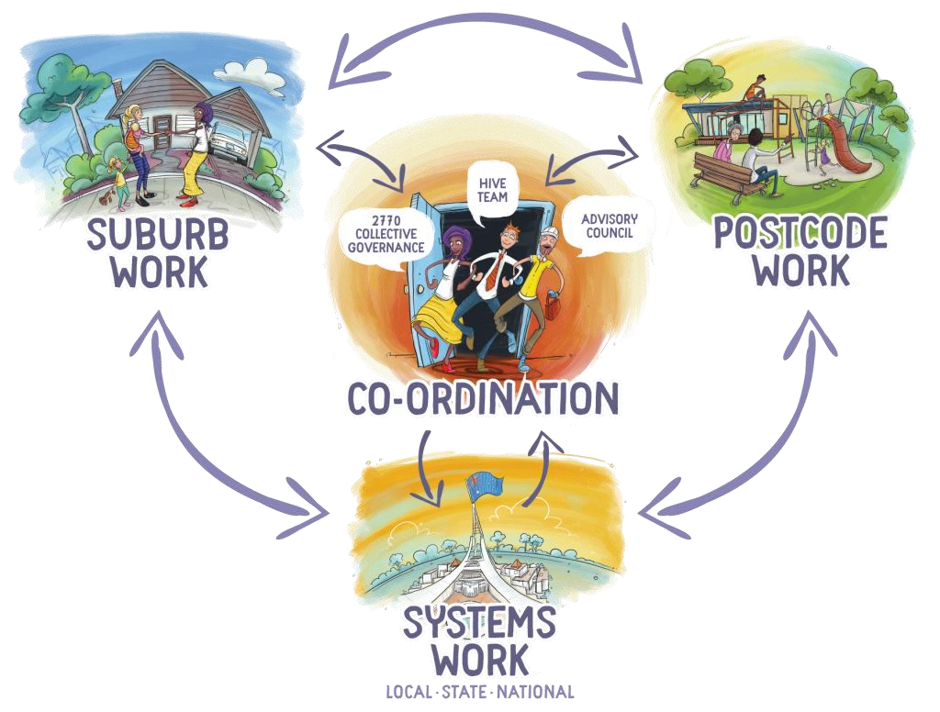

Other changes to the program for greater impact
The Hive are pleased to see the Department placing an emphasis on services to be ‘connected, co-located, and integrated’ as well as being ‘community informed’, however these principles need to be supported by funding the time and staff to do this work. To engage in this work meaningfully and impactfully, grants need to fund community engagement staff (often referred to as ‘the glue’), who can take time to listen deeply to community and collaborate with other local service providers. When done effectively, this can aid organisations in connecting with families that otherwise would face barriers in accessing support.
Recommendation 4: Include funding for ‘glue’ or community engagement resources in contracts to enable organisations to engage effectively with families and partner organisations for consultation, codesign and collaboration.
As a Collective Impact initiative, we are guided by the voices of families and community members in hearing the barriers they face and solutions that would make a difference in their context. This commitment to listening has resulted in programs informed and codesigned by community members. These programs remained intentionally flexible and were adapted over time as we learnt what worked and what didn’t, and as a result were highly effective in engaging families. These outcomes have been possible through philanthropic funding which supports flexible ways of working and listening to the unique needs of individual communities, with a focus on impact rather than meeting KPIs. This is a sentiment we hear often from organisations across the country, with those under primarily government funding contracts feeling constrained from being able to respond to community needs and pressured to meet quantitative reporting figures. We welcome the Departments intention with this reform, and would be encouraged if DSS funding mimicked the flexibility of philanthropic funding in this way.
Recommendation 5: Provide funding in contracts to enable meaningful community consultation and codesign work. Funding must be flexible, allow for changes in community priorities, and encourage innovative ways of working.

Prioritising investment

Feedback on the four priorities
The Hive are supportive of the four priority areas noted on page 4 of the discussion paper. We would encourage the expansion of ‘3. Ensure services are informed by, and respond to, community needs’ to place greater emphasis on partnership with community members and families to avoid tokenistic consultation and ‘community informed’ programs. Genuine community engagement and codesign at all opportunities are necessary for impactful investment.
Recommendation 6: Alter the wording of Priority 3 to: ‘Ensure services are informed by, and respond to, community needs, and empower the community to define and pursue its aspirations.
This sets the mandate for organizations to centre the voices of children and families in their service delivery and sets the expectation for government to fund the resources required to ensure programs are informed by community needs.

Other priorities and issues the department should be focusing on:
As previously mentioned in this submission, the department should be considering broader resources to be embedded in the community to support children and families beyond direct service delivery and established programs. Funding for direct supports such as case work and counselling is important, however an ecological approach is required to concurrently invest in the communities in which children and families reside.
There is frequent attention given to the question of how to reach ‘the hard to reach’ children and families. The approaches with greatest success are place-based and engaged services who are embedded within the local community. When workers are embedded in the community, there is trust built with the workers and the services and over time, families on the margins are more likely to feel confident to reach out and support.
For this to be successful, services must be funded to do this work which is often slower paced and intentional. Community engagement and navigator/linker roles are highly effective placebased resources building trust with families in their community and being present and available when support needs arise.
The department’s focus on outcomes rather than quantitative reporting provides an enabling environment to support this work.
See:
- ‘Understanding Linkers’ report by Paul Ramsay Foundation 2022
- ‘The ‘glue’: Enabling connected, quality services & supports for children and families’ by National child & Family Hubs Network 2025
Recommendation 7: Design reporting for community engagement roles to be outcome focused not driven by KPI’s, to allow for staff to commit the time required to meaningfully engage in these activities.

Connected, co-located, and integrated services
As a Collective Impact initiative The Hive prioritise time in place, being out in community building trust and working with families in places they feel safe. This includes early learning centres, community centres, schools, parks and playgrounds. The Hive advocate and coordinate with other organisations to bring their services into the local community to be more accessible for families. The Hive do not have a physical hub from which we deliver services, which does bring limitations, however the place-based nature of our work has our Linkers and community engagement workers utilising shared spaces and being present where families spend their time. Our approach encourages organisations to get out of their buildings to meet with families who otherwise would not feel confident walking through the door of a service, and as a result workers develop a deeper understanding of the context in which families reside.
We believe some of the most effective methods for connecting & coordinating services for families include:
- Collective Impact collaborations with a backbone organisation driving the collaboration and integration of services with a shared vision and understanding of the needs of the local families and children.
- Child and Family Hubs provide an opportunity to go beyond co-location of services, but bringing services together with an integrated alignment on their approach. Effective Hubs operate as multidisciplinary teams not just individual co-located services.
- Linker roles and relational models of casework to support families navigate silo’d and complex service systems without time restrictions or KPIs
- Funding for community engagement and backbone type staff to do the work of understanding needs of the community, build trust and collaborative relationships with local schools, ECECs, service providers and then collaboratively working together.
Recommendation 8: Consider funding for infrastructure in communities that are lacking in places to deliver essential services such as child and family hubs.
We acknowledge that a requirement for community connection may be a new element of grant funding applications, however this concept would be understood and embraced by organisations within the community sector. This must be prioritised as a requirement to ensure organisations are truly enmeshed within their communities.
Applicants for DSS grant funding could demonstrate their connection to the community in the following ways:
- How long has the organisation been operating within that community?
- What ‘community voice’ data can they offer that demonstrates the need for their service or programs?
- How much of their time is spent in their office building compared to out in the community talking to residents or delivering services in a place-based way?
- How do they regularly collect community voice and use this meaningfully in the design of their programs or service delivery?
Recommendation 9: Prioritise funding to organisations that are physically based or have history of place-based work within that funded community, rather than granting contracts to larger national organisations who do not have relationships in that community.

Responding to community need
Organisations may demonstrate their service is genuinely meeting the needs of the community through:
- Outlining their mechanisms for genuine engagement with residents and how they incorporate this feedback meaningfully
- Outlining their reflection process on community feedback to their service delivery to align with community needs and are communicating this back to community for sensechecking
- A governance or advisory model which includes other organisations and community members
- Investment in community leadership
- Demonstrate their impact through the shifting of perspectives or trends both quantitatively and qualitatively.
- Demonstrating the lack of other organisations in the community delivering these programs or services to avoid duplication
Funding should consider the resources required to deeply consult with community and build their trust, as well as the time this takes. A 5-year granting period is welcome, yet to be truly community informed the department should be open to a significant period of the grant be dedicated to listening, learning and codesign before program operations.
Recommendation 10: Enforce an initial period of a grant to be dedicated to community consultation and codesign before programs are expected to be delivered.

Measuring outcomes

Data to assist in understanding our impact
The Hive is committed to incorporating and embedding evaluation into our practice. The Hive publish a Measurement, Evaluation, and Learning (MEL) report biannually, with a shorter qualitative evaluation of one of our key pieces of work produced in the year in between. Our MEL incorporates both population and interventional level data, and qualitative data. We have also engaged in external university evaluations of projects within our work.
The Hive works to embed data collection into our day-to-day work. This is done by working with families to record and share their stories about particular areas of community concern, and qualitative data collection at each of our engagements through the week. The Hive works to utilise the population level data that is currently available, but would benefit from access to other data sources.
Data that would assist The Hive in understanding our impact could include:
- NSW Best Start Kindergarten assessment data. This yearly data could assist us in understanding any shifts in school readiness. The AEDC data is a useful indicator for us, however as it is released every 3 years, a more regular data point would be of assistance.
- Access to individual indicator data behind the AEDC domains would be beneficial for us to understand the areas of support children in our community need before starting
school. For example the ‘physical development’ domain captures gross motor skills, along with if a child appears under nourished, and each of these would require a different program to support.
- Preschool attendance data per suburb by year would be beneficial as this is captured in the Census, however as the census is only every 5 years, a whole generation of children passes in the early years space between each result.
- Waitlists for ECECs or other equivalent data would help us better understand the demand for early learning in our suburb and how we can better support families to access, the centres with significant waitlists and advocate for an increase in centres servicing our area.

Data The Hive believe would be valuable to share to demonstrate our positive impact on children & families:
We would welcome the opportunity to share a broader range of our data and information from The Hive’s work with DSS. It is difficult at times for us to explain our approach and impact without sharing the broader story, particularly without qualitative measures which highlight the deep transformative impact we have.
Data we would like to share with DSS is displayed in the image and following description below:
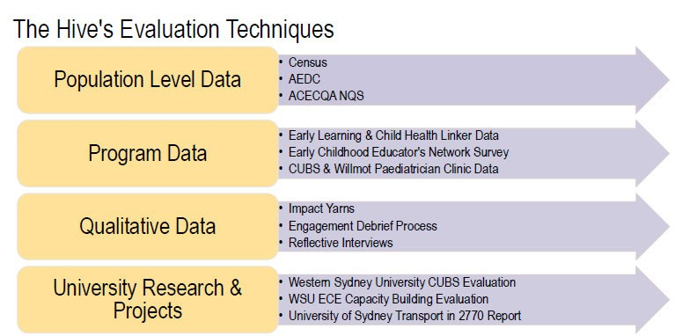

- Our Measurement, Evaluation & Learning (MEL) reports as the internal evaluation framework for The Hive. • Our qualitative data routinely collected.
  - Our Impact Yarns are interviews with community members exploring their experience of our work in the community and the impact they’ve felt it have. o Our Impact Stories are snapshots of stories from families we’ve supported through our early learning and child health linker work which outline the barriers faced and outcome once support was provided. o Our intentional ‘children’s voice’ work where we consult with children on how issues affect them
- Qualitative insights about our impacts across the ecosystem of Mt Druitt. Our work has had impact on individual children, their families, the health system, the early education and primary school system, physical infrastructure, and social activities for children and adults. We could share stories from our local partners, and how the perceptions of residents have shifted over time.
  - For example: The persisting narrative in one of our suburbs was there was youth crime and “nothing for children to do”. Our Collective collaborated and delivered school holiday programs and a range of child focused engagements, implemented place-based health services, and advocated to upgrade local playgrounds. The current narrative within community has shifted and we now hear that the suburb “is a great place to raise kids”.

DEX & SCORE Circumstances
The SCORE circumstance that The Hive have primarily reported on due to the existing constraints and area of interest in our contract has been the ‘Age Appropriate Development’ domain.
However, if the Department expanded its interest in the holistic nature of The Hive’s work, we could share on the four Community domains as these reflect our interest in change within the community to better support families.
In July 2025, The Hive held a webinar with DSS staffers sharing our concerns about the limitations of the DEX platform for capturing our work and the work of place-based, community led initiatives. We wish to note these concerns again in this submission and highlight how practitioners feel data being asked for them is not meaningful, time consuming and unethical as they are unsure of how data is being used and feel uncomfortable asking this from their participants. Practitioners also feel pressure to change their programs to meet DEX reporting requirements in ways that lessen the impact of the program or risk losing their funding.
Recommendation 11: Explore alternate reporting processes or significant adjustments to the DEX platform to ensure it is capturing meaningful data for both the Department and the organisation.

Working together
Understanding of relational contracting in practice:
The Hive would hope to see relational contracting to be:
- A contract manager who deeply understands our organisation, its methodology and rationale, and truly seeks to understand the why and the how we work, not just interesting in our outputs.
- Contact meetings where we can reflect and share on our learnings and stories and the priorities arising for local children and families.
- Seeking to understand and support the nuances in place-based work and how priorities and approaches may pivot depending on the needs of the community.
- Holding a focus on impact for children, families and communities rather than quantitative outputs.
- Understanding and supporting the need for the work to change in line with changing community priorities, especially over a 5-year contracting period.
- Support to find different ways to demonstrate the effectiveness/impact of the service and documenting the process agreed upon by the parties.
The Hive would hope that in this commitment to relational contracting, that those DSS staff being placed in these positions receive adequate training and support to enable their organisation partners to be adaptive and flexible.

Who should be offered a relational contract:
Those who could benefit from a relational contract include those working in a place-based or Collective impact way, as opposed to those delivering mainstream child and family programs. These ways of working seek to hold deep connections in complex communities and being informed by community voice. These ways of working require greater understanding and flexibility which can be difficult to communicate and negotiate in a standard contracting model and would benefit from a relational contract manager who understands and can support organisations through challenges and changes.
Recommendation 12: Connect organisations receiving relational contracting through periodic seminars or community of practices to share learnings if they are working on similar issues or in similar regions. Interest in a relational contracting approach
The Hive would be interested in engaging in a relational contracting approach. The Hive have struggled to capture the full impact of our work in our reporting under our DSS contract because it is difficult to quantitatively capture our work. Being place-based and responsive to community needs means our community engagement and early years work are intentionally intertwined and cannot be reported on in isolation. Having a qualitative way to demonstrate our impact and to have conversations with our manager who supports our approach in being responsive to community need and understanding that deep change takes time would be beneficial.

Conclusion
The Hive welcome the reform to the Family and Community Activity grant program. The streamlining of programs into a singular program will reduce reporting burdens on organisations. The emphasis on responding to community needs, codesign, collaboration and being integrated within a community is encouraging and is inline with other government priorities about place-based work. If grants incorporate funding for organisations to undertake this work the increase in positive outcomes will be significant. Relational contracting will benefit organisations working in a place-based way in understanding flexibility and adaptive approaches. The Hive hope the Department find our recommendations valuable in the next phase of the program reform and we welcome any opportunity to expand further.

