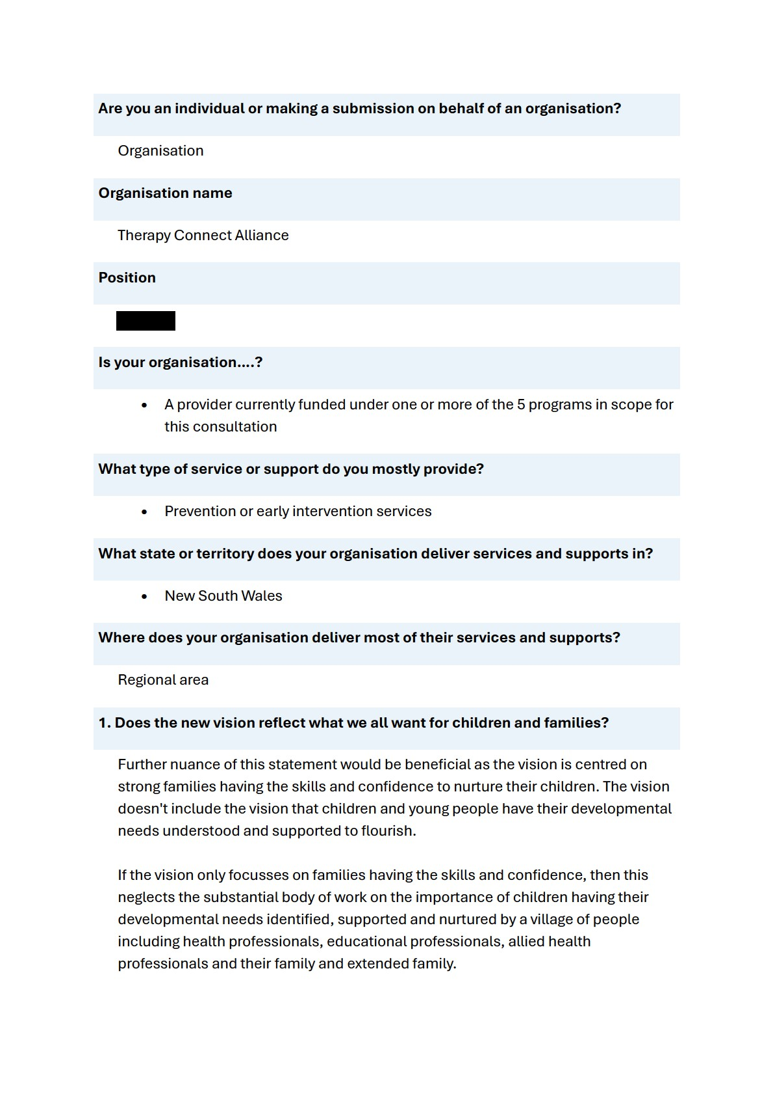
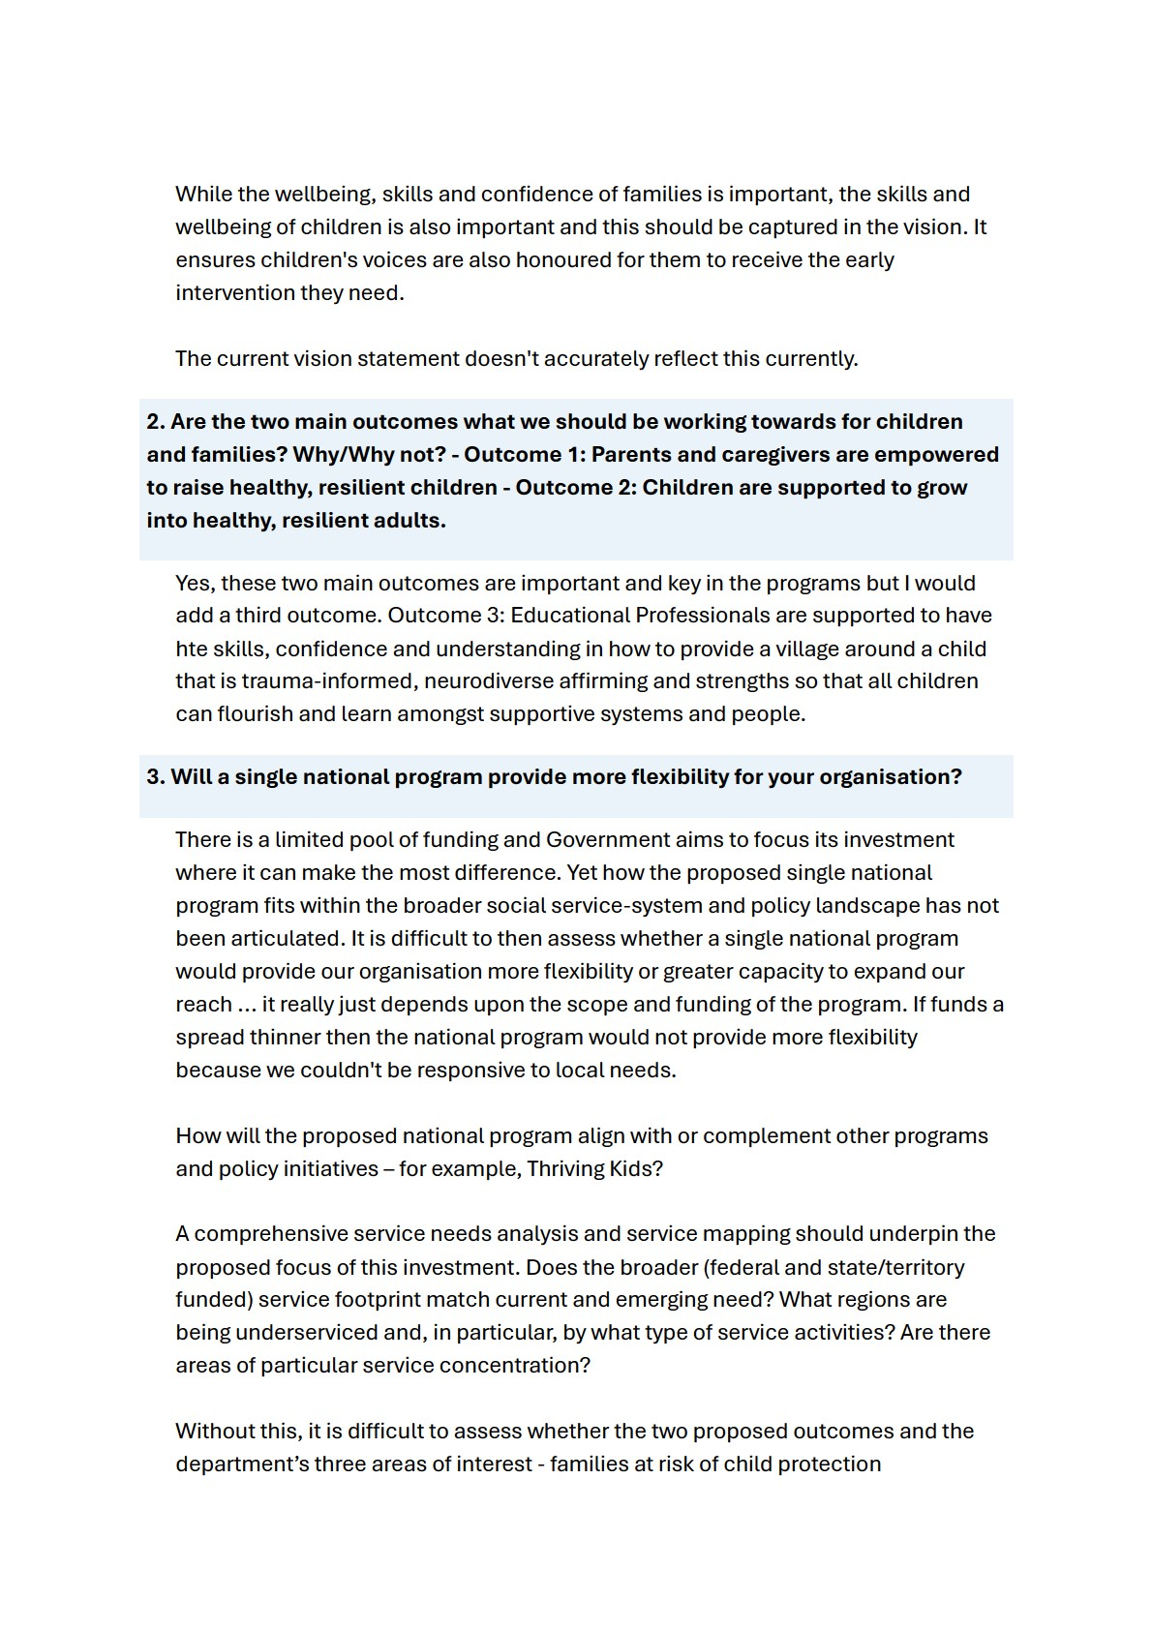
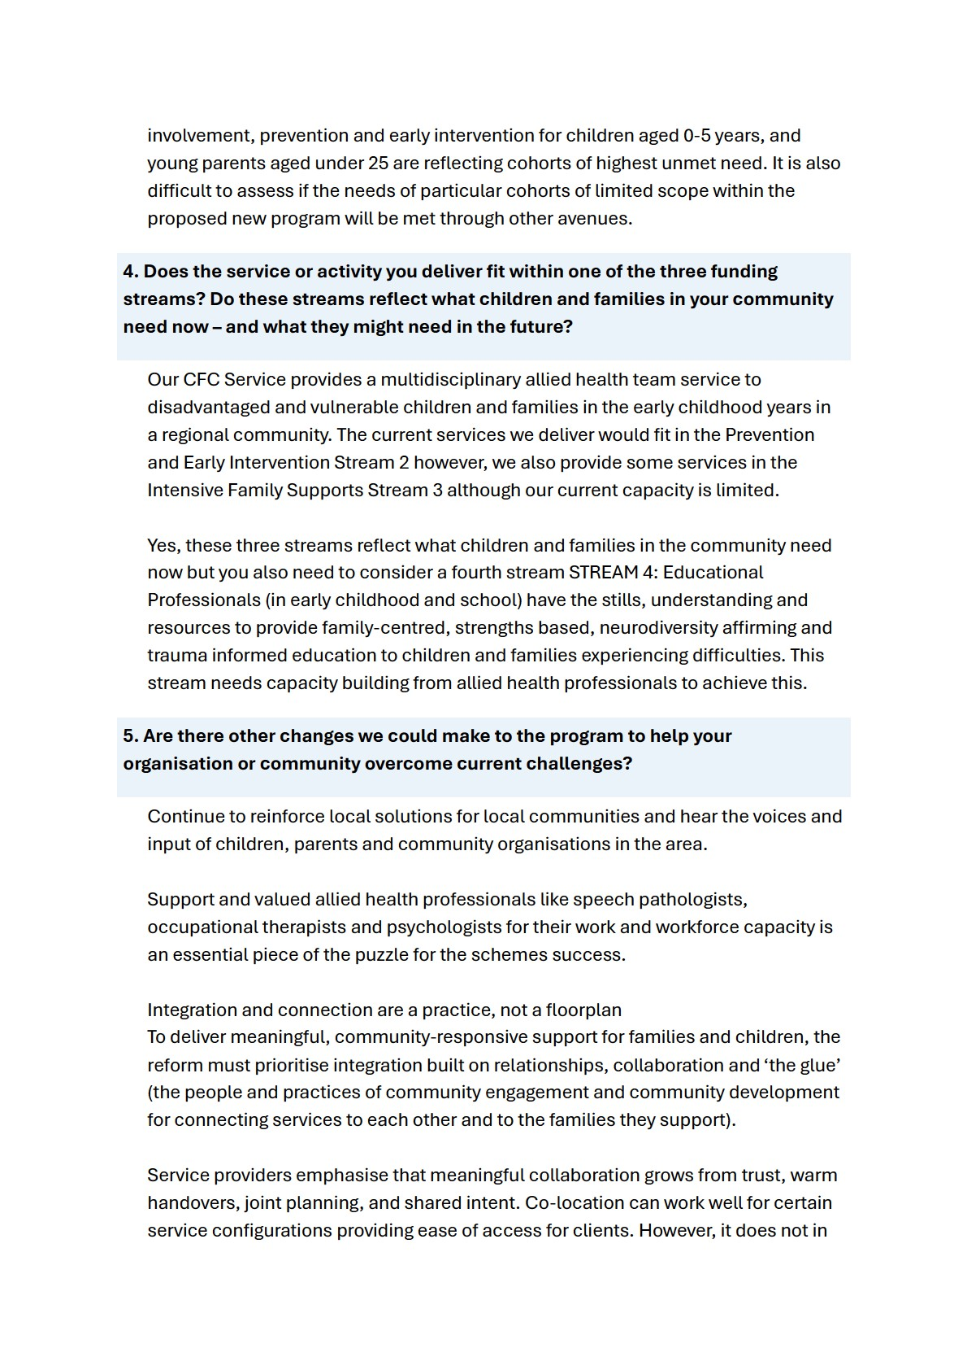

itself create coordinated service pathways and can introduce challenges around confidentiality, cultural safety, and accessibility, particularly in smaller or remote communities. Integration and connection are a practice, not a floorplan. The Operational Guidelines for the five current programs already require collaboration across government, non-government, and community services, reflecting a long-held understanding that integrated, place-responsive practice is central to good outcomes. Yet the system rarely funds the time, skills, and “glue” needed to make this integration real. Relationship-building is often treated as an invisible ingredient, despite it being indispensable for understanding local needs, strengthening cultural responsiveness, improving referral pathways, and reducing duplication.

For the reform to succeed, integration and relationship-building must be recognised not as an administrative ideal but as a funded practice. The new approach should prioritise community-embedded, relational work and ensure programs have the resources to build the partnerships that turn a collection of services into a connected ecosystem for families and children.

Reform design must reflect real family and service realities
The proposed three streams aim to bring structure to a proportionate universalist approach. Stream 1, described at Townhall meetings as comprised of online information and support services, is relatively straightforward. Access is available online to a wide network of people (noting, however, that one in five people across Australia are digitally excluded).

Streams 2 and 3 presuppose that clients will fit neatly into delineated services. The on-the-ground reality suggests otherwise, particularly in rural and regional communities where services operate as ‘one-stop shops’ out of necessity. Current programs effectively operate across the two streams and true to a proportionate universalist approach adjust service intensity and adapt service approach to meet increased client complexity. For example, a client facing complex challenges may be provided more counselling sessions than is standard (increased service intensity), or service staff might undertake safety planning for a client or offer case management to link a client in with other needed services, as well as providing their FaC service (noting that at times, the service provider may decide it is not safe and/or appropriate to proceed with service).

In the absence of broader system changes that alleviate financial stress and insecure housing, and a greater investment where there are service gaps outside the FaC Activity (e.g. allied health supports for children with developmental delays,

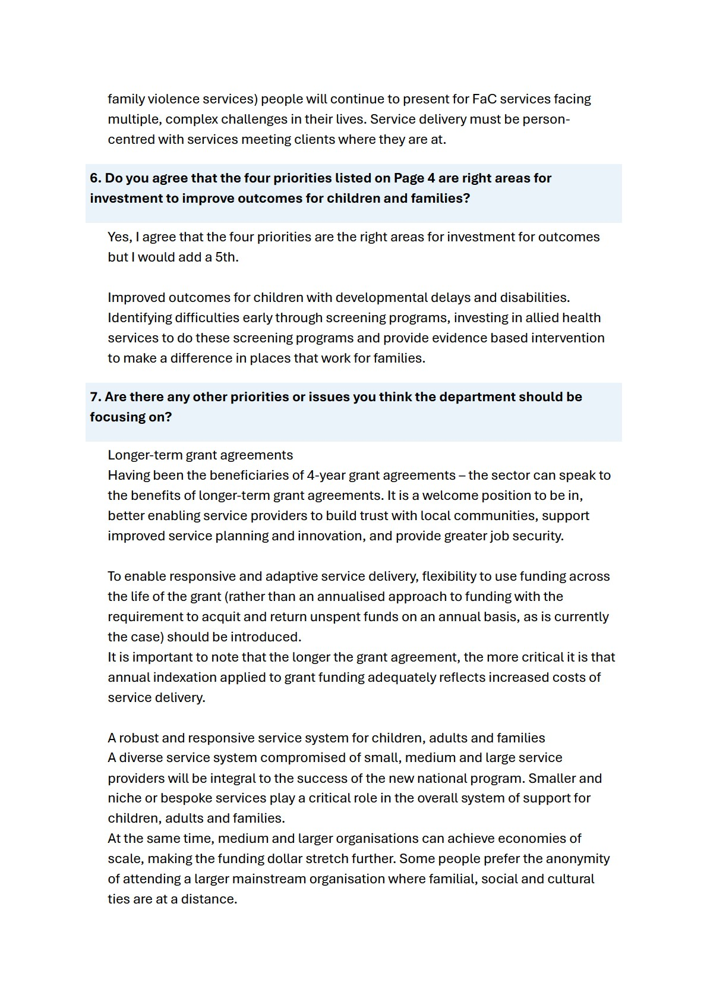
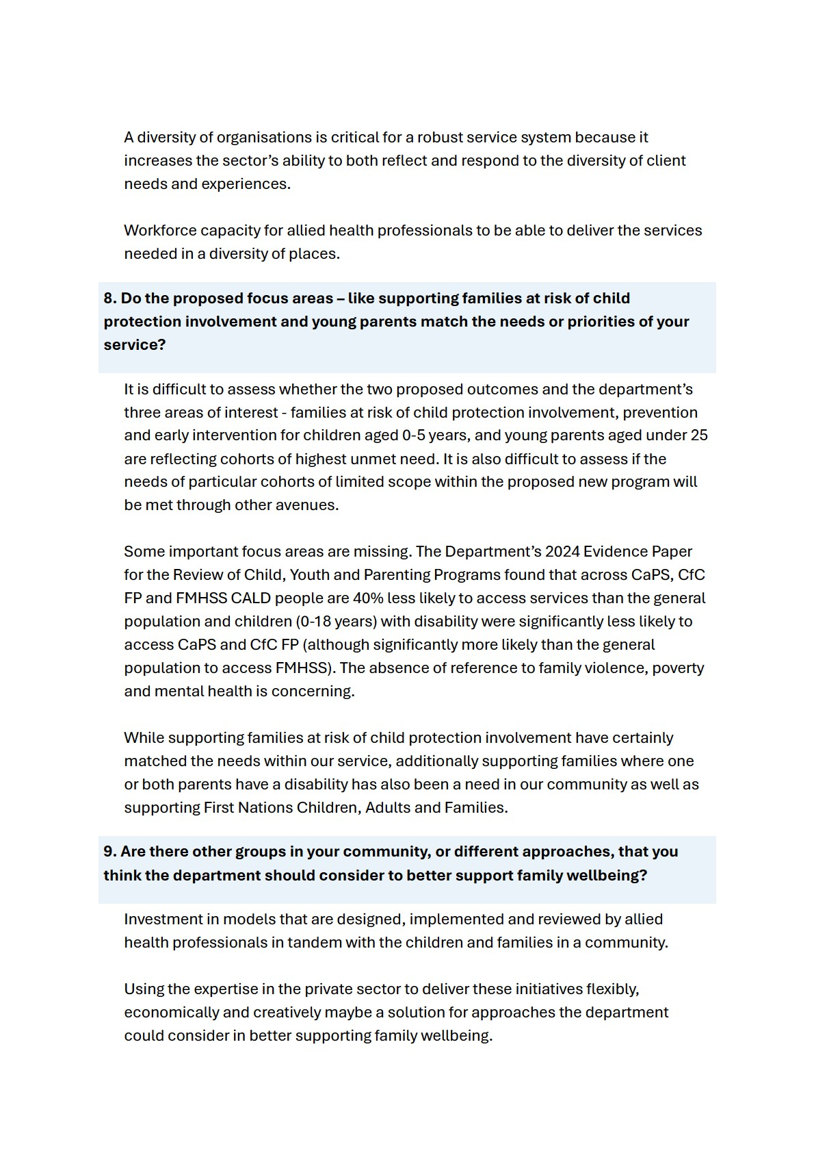
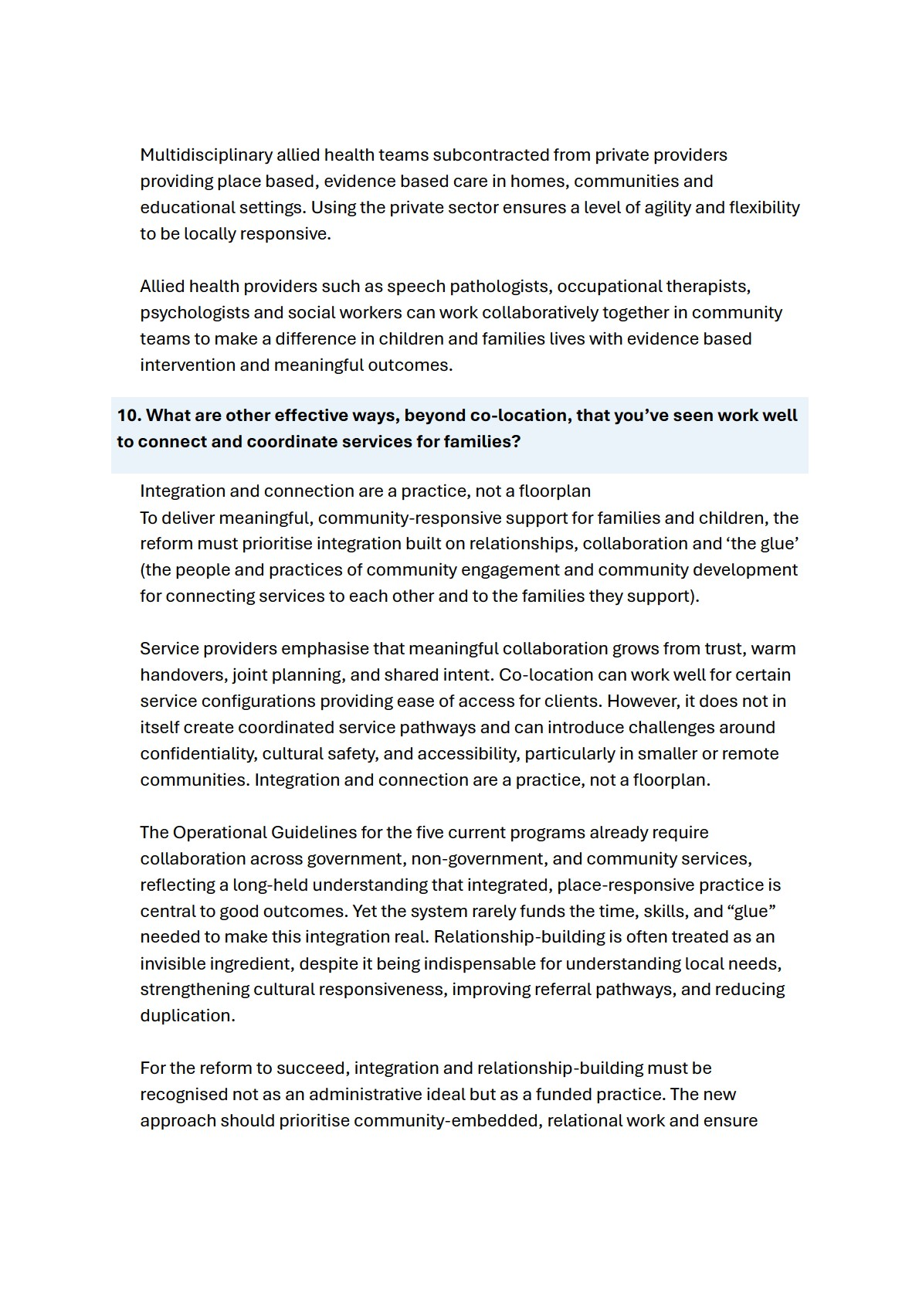
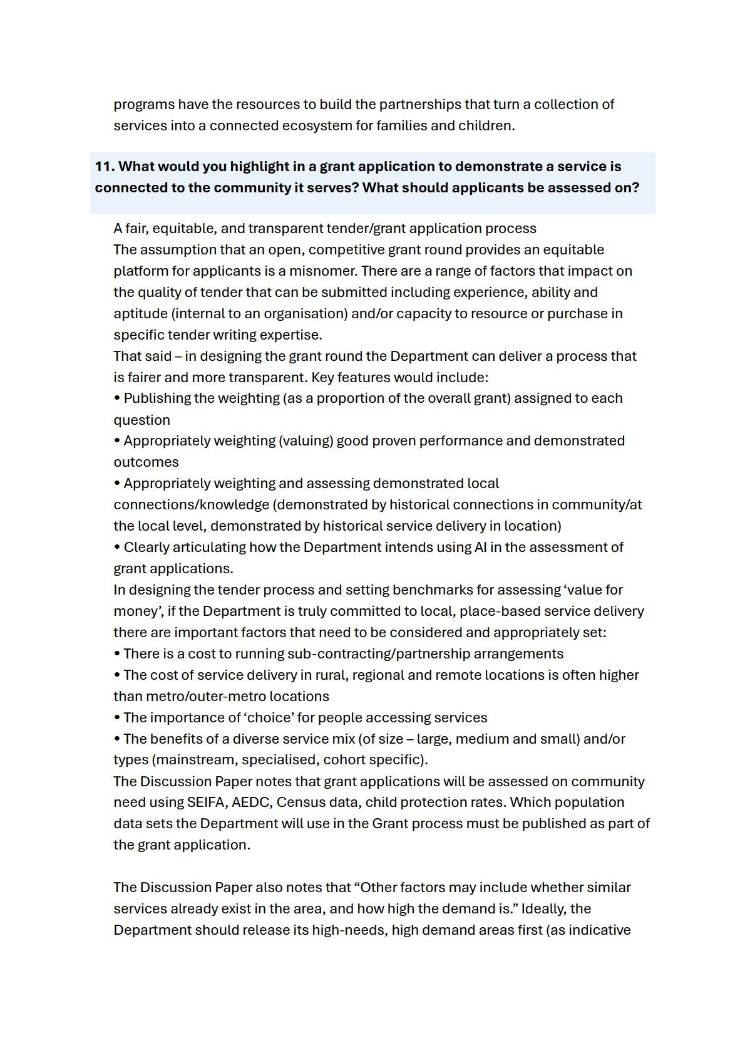
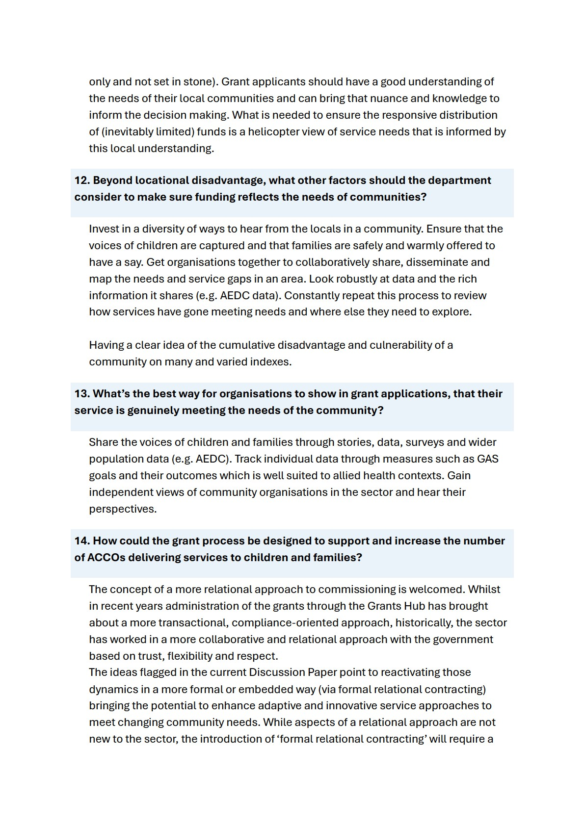

cultural shift – for the sector, but particularly for government. It will take time to change ways of thinking and doing.

The relationship between the department, through its funding arrangement managers (FAMs), and service providers is a lynchpin for enabling (or inhibiting) flexibility and local responsiveness. It will be particularly important to empower FAMs to employ a relational approach through capability building and appropriate delegation of power.
More detail on how government sees relational contracting working in practice is required. So too, is a staged plan for its implementation. If poorly implemented, relational contracting could have the unintended effect of reducing flexibility, increasing red tape and undermining relational approaches already in place (especially in the CfC FP model). The inherent power imbalance between funder and service provider, which can only be partially mitigated through contractual provisions, must be carefully managed.

Longer-term grant agreements
Having been the beneficiaries of 4-year grant agreements – the FRS sector can speak to the benefits of longer-term grant agreements. It is a welcome position to be in, better enabling service providers to build trust with local communities, support improved service planning and innovation, and provide greater job security.

To enable responsive and adaptive service delivery, flexibility to use funding across the life of the grant (rather than an annualised approach to funding with the requirement to acquit and return unspent funds on an annual basis, as is currently the case) should be introduced.
It is important to note that the longer the grant agreement, the more critical it is that annual indexation applied to grant funding adequately reflects increased costs of service delivery.

A robust and responsive service system for children, adults and families A diverse service system compromised of small, medium and large service providers will be integral to the success of the new national program. Smaller and niche or bespoke services play a critical role in the overall system of support for children, adults and families.

At the same time, medium and larger organisations can achieve economies of scale, making the funding dollar stretch further. Some people prefer the anonymity of attending a larger mainstream organisation where familial, social and cultural ties are at a distance.

A diversity of organisations is critical for a robust service system because it increases the sector’s ability to both reflect and respond to the diversity of client needs and experiences.

A fair, equitable, and transparent tender/grant application process
The assumption that an open, competitive grant round provides an equitable platform for applicants is a misnomer. There are a range of factors that impact on the quality of tender that can be submitted including experience, ability and aptitude (internal to an organisation) and/or capacity to resource or purchase in specific tender writing expertise.

That said – in designing the grant round the Department can deliver a process that is fairer and more transparent. Key features would include:
- Publishing the weighting (as a proportion of the overall grant) assigned to each question
- Appropriately weighting (valuing) good proven performance and demonstrated outcomes
- Appropriately weighting and assessing demonstrated local connections/knowledge (demonstrated by historical connections in community/at the local level, demonstrated by historical service delivery in location)
- Clearly articulating how the Department intends using AI in the assessment of grant applications.
In designing the tender process and setting benchmarks for assessing ‘value for money’, if the Department is truly committed to local, place-based service delivery there are important factors that need to be considered and appropriately set: • There is a cost to running sub-contracting/partnership arrangements
- The cost of service delivery in rural, regional and remote locations is often higher than metro/outer-metro locations
- The importance of ‘choice’ for people accessing services
- The benefits of a diverse service mix (of size – large, medium and small) and/or types (mainstream, specialised, cohort specific).
The Discussion Paper notes that grant applications will be assessed on community need using SEIFA, AEDC, Census data, child protection rates. Which population data sets the Department will use in the Grant process must be published as part of the grant application.

The Discussion Paper also notes that “Other factors may include whether similar services already exist in the area, and how high the demand is.” Ideally, the Department should release its high-needs, high demand areas first (as indicative

