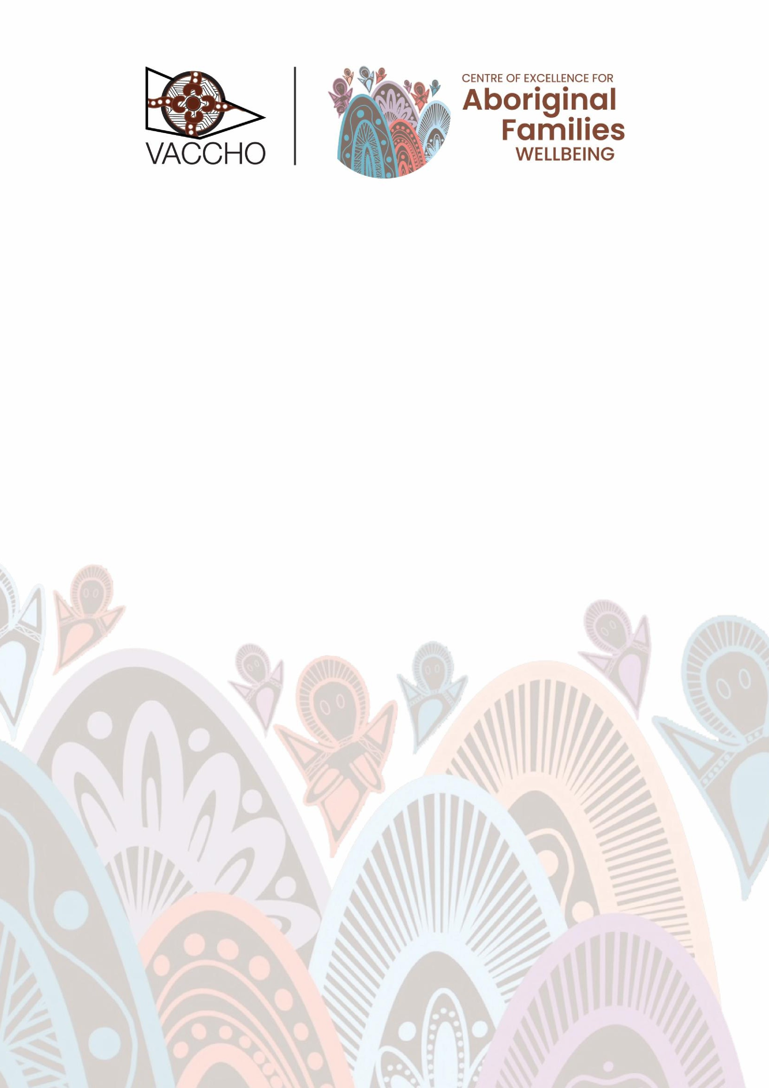

Victorian Aboriginal Community
Controlled Health Organisation

(
VACCHO
)

and The Centre of
Excellence for Aboriginal Families
Wellbeing submission on the
Department of Social Services
new approach to programs for
families and children

December 2025

Victorian Aboriginal Community Controlled Health Organisation
The Victorian Aboriginal Community Controlled Health Organisation (VACCHO) is the peak body for Aboriginal health and wellbeing in Victoria – the only organisation of its kind - with 34 Aboriginal Community Controlled Organisations (ACCOs) as Members. VACCHO trains, supports, and advocates with and for our Members and their Communities across Victoria. ACCOs deliver a suite of culturally safe and responsive frontline health and community care services for Aboriginal Communities. ACCOs have a proud, long history as sustainable, grassroot organisations that assist in building Aboriginal self-determination. They hold Aboriginal health in Aboriginal hands.

The Centre of Excellence for Aboriginal Families
Wellbeing
In 2023, VACCHO launched the Centre of Excellence for Aboriginal Families Wellbeing (the Centre). The Centre is dedicated to advancing the rights and social and emotional wellbeing of Aboriginal and Torres Strait Islander families across Victoria. We celebrate Aboriginal families’ enduring strength, resilience and cultural richness by honouring Aboriginal models of parenting and child-rearing. These practices have kept families safe and strong for more than 65,000 years – and our work seeks to continue this legacy. Our work focuses on Aboriginal families – not just children- acknowledging that Aboriginal families extend beyond the immediate nuclear unit to include extended family, clan and kinship networks, and the broader Community. The Centre works closely with VACCHO’s Balit Durn Durn Centre (Social Emotional Wellbeing), the Centre for Aboriginal Medical, Health and Wellbeing Research and the Centre of Excellence for Aboriginal Digital in Health (CEDAH).

Lack of dedicated funding to advance health and wellbeing outcomes for Aboriginal and Torres Strait Islander families
The Centre works to influence positive change for Aboriginal and Torres Strait Islander families in Vicotria through strengths-based research, programming, advocacy and collaboration. The work is done in partnership with Aboriginal and Torres Strait Islander communities. Mostly, we amplify the voices of Aboriginal families, empowering them to shape policies and practices that promote their social and wellbeing, self-determination and prosperity. The Centre is unfunded and is in its infancy of standing up, however aligns with the broader advocacy and strategic direction as VACCHO its mother organisation and the peak body for Aboriginal health and wellbeing in Victoria.

The Centre joins a landscape of many influential, groundbreaking and self-determined
Aboriginal organisations working to improve outcomes for Aboriginal and Torres Strait Islander children and families in Victoria. Our aim is to strengthen the sector’s collective aspiration: keeping families together, safe and strong.

About the Artwork
Empowering Generations: Celebrating the Strength of Aboriginal Families' by Djab Wurrung, Kirrae Wurrung and Peek Wurrung artist Tarni Jarvis.

This inspiring artwork brings to life Dr Aunty Jill Gallagher’s vision of the strength of generations spanning 65,000+ years. It represents and celebrates Aboriginal families, ancestors, Culture and future generations

Executive Summary
VACCHO and The Centre of Excellence for Aboriginal Families Wellbeing (The Centre) welcomes the opportunity to provide feedback on the Department of Social Services (DSS) new approach to programs. The Centre is fundamentally aligned with DSS vision, supporting Aboriginal and Torres Strait Islander children and families to be resilient, empowered, and able to thrive with strong social and emotional wellbeing, selfdetermination, and long-term prosperity. Despite this strong strategic alignment with state and federal government priorities and commitments, the Centre is unfunded. This limits the capacity for the Centre to strengthen outcomes for Aboriginal children and families across Victoria.

Whilst the new DSS approach identifies the necessity of support services for Aboriginal children and families and the streamlining of funding and reporting requirements, the approach should further clarify and demonstrate how the proposed program model will impact upon Aboriginal and Torres Strait Islander communities and Aboriginal Community Controlled Organisations.

This submission identifies five recommendations:
- Ensuring programs are aligned with Closing the Gap reforms and, Safe and
Supported Commitments

- Streamline State and Federal funding to improve clarity and efficiency

- Governments should adopt flexible funding arrangements, supporting the selfdetermination of Aboriginal and Torres Strait Islander communities

- Sustainable long-term funding, with workforce and infrastructure prioritised

- Protection of Indigenous Data Sovereignty and Evidence building.

Recommendations

Ensuring programs are aligned with Closing the Gap reforms and Safe and Supported commitments
The new DSS approach to programs for families and children should articulate alignment with the Closing the Gap priority reforms, sector strengthening plans (early childhood care and development; health) and Safe and Supported commitments, as well as other policy levers such as Voice, Treaty and Truth telling in Victoria. This requires strong partnership with Aboriginal communities, genuine consultation and co-design, and recognition of ACCOs as cultural authority service providers. Clearer articulation across government systems is required so that reform works together in alignment with existing frameworks and commitments and ensure that the new approach actively supports the empowerment of Aboriginal and Torres Strait Islander children and families. Without clear articulation and alignment with these central reforms and promises, the proposed program approach risks failing to improve health and wellbeing outcomes for Aboriginal children and families.

The holistic and interconnectedness of Closing the Gap and other policies are articulated at a high level, however silod government funding undermines the ability to realise the overarching intent.

Streamline State and Federal funding to improve clarity and efficiency
VACCHO supports the consolidation of five existing programs to address silos that often exist within systems funded by multiple streams and programs, however, notes the importance of fully integrating funding across all levels (commonwealth and jurisdiction, and across department portfolios e.g. health, family services and education). Without a coordinated, connected approach across all parts of Government (horizontal) and across levels (vertical), there is a lack of responsibility and accountability for Australia’s children. We are advocating for broader funding reform across all parts of the system – both state and federal government and across all departments within. By only reforming funding models within DSS, there is potential to increase administrative burden, risks duplicating functions, unnecessary competition for resources and missed opportunities to work collaboratively to improve outcomes for Aboriginal children and families.

Federated governance creates an uncertain and confusing funding environment for ACCOs to operate in with uncertainty over which jurisdiction is responsible for which aspect of the service system, and the health sector more broadly. This adds complexity in data collection, burdensome reporting and acquittal processes that divert limited resources away from program development and service delivery and into funding compliance. This complex, multi-agency funding environment creates a service system in which service delivery gaps persist as it is difficult to identify which agency will fund which component – be it physical infrastructure, workforce positions, program funding and evaluation, and brokerage to keep Community well.
Governments should adopt flexible funding and reporting arrangements, supporting the self-determination of Aboriginal and Torres Strait Islander communities
We support the proposed shift to reporting against funding contracts within the new program model. The approach highlights capturing qualitative data and the stories within services - a critical aspect to reflecting the complexity, strengths, and cultural realities of Aboriginal and Torres Strait Islander communities. We know that a narrow focus on quantitative indicators risks disregarding story driven ways of demonstrating impact. These are essential to how Aboriginal and Torres Strait Islander communities understand progress and assess outcomes.
However, funding contracts are often too restrictive in their scope, hindering ACCOs’ ability to develop programs that are self-determined, place-based and align with Aboriginal ways of knowing, being and doing. In theory, the Victorian and commonwealth governments have supported the Victorian ACCO Model - a holistic, community-controlled approach to health and wellbeing for the Victorian Aboriginal community, focused on culturally safe services and self-determination. However, the proposed reform should determine and incorporate more flexible and untied arrangements, where funding enables ACCOs to respond to Community priorities and needs, and provide holistic support without being constrained by prescriptive or burdensome acquittal or reporting requirements. This flexibility is essential in the proposed reform to ensure systems

support and enable self-determination and Community-led service design. Without flexibility ACCOs face challenges in adapting to and supporting the variable needs of their Communities.
Flexibility is required for measuring localised success and evidence building. Focusing only on the broader picture can overlook the impacts that are being made on the ground. Despite bottom-up approaches demonstrating success and positively impacting families and Communities, there are limitations and disconnect from scaling programs to national agendas.
Sustainable long-term funding, with workforce and infrastructure prioritised

Persistent short-term funding cycles aligning with the priorities of the government or relevant minister’s agenda impact on ACCO’s ability to provide high quality, consistent services for Aboriginal children and families in Victoria. Funding models are not designed to ensure program sustainability, and arguably organisational sustainability. Frequently ACCOs are provided with 12- or 24-month funding cycles which often focuses on outputs rather than outcomes. This progression of “short-term funding prevents providers from building capacity, developing trust with Communities, and designing and delivering culturally appropriate programs” that impart long-term positive change in the
Community. It is essential that long-term, sustainable funding is embedded within the new program approach to ensure ACCOs are properly resourced to deliver culturally safe services and drive meaningful, lasting improvements for Aboriginal and Torres Strait Islander children and families.

The “volume of small, short-term grants places organisations in a perpetual cycle of applying for, and reporting against grants that have often been provided for very specific purposes with limited, or no allowance made to cover the accompanying administrative requirements”. Short-term funding grants places a high administrative burden on ACCOs,

while placing undue pressure and uncertainty on the workforce. This often results in unnecessary staff turnover in pursuit of employment stability, resulting in workforce shortages that impact severely upon service wait lists, continuity of care and a program’s ability to run. These challenges are intensified in regional and rural areas, where the availability of the workforce is already stretched. The Department of Social Services should be acutely aware of the mechanisms and impacts of the suggested grant process and how it may impact ACCOs across states and territories.

Protecting and embedding Indigenous Data Sovereignty and evidence building
We emphasise that this program reform must embed a commitment to building the Aboriginal evidence base of what works best for Aboriginal families. Too often ACCOs are restricted in program development and response by the lack of data available, which restricts an ACCO’s ability to respond to Community needs. Targeted investment is required in resourcing ACCOs to build partnerships with research institutes and building

their capacity to carry out research and evaluation, including longitudinal studies into family wellbeing, to build the Aboriginal evidence base and demonstrate the strength of Aboriginal-led responses and outcomes.
Aligned with National Closing the Gap Priorities, the Australian Government must improve access for ACCOs and the Aboriginal community to the data that is about them. Building an Aboriginal evidence base, in line with the principles of Indigenous Data Sovereignty, forms an integral part of achieving Aboriginal self-determination. However, with current under-investment in research and evaluation, ACCOs remain limited in their ability to progress this work. The proposed funding reform must therefore include dedicated and sustained resourcing that empowers ACCOs to lead evidence building as a central driver for improved outcomes for Aboriginal children and families.

The Centre of Excellence for Aboriginal Digital in Health (CEADH) is dedicated to ensuring digital health technologies are culturally informed, meet consistent quality standards, and primarily benefit Aboriginal and Torres Strait Islander peoples. Under the auspices of VACCHO in consultation with Aboriginal and Torres Strait Islander peak bodies nationwide, CEADH champions Aboriginal-led recommendations for digital in health technologies, respecting the diversity of 250+ languages, Nations, clans, and communities across Australia.

CEADH aims to transform health service delivery for Aboriginal and Torres Strait Islander communities by advocating and developing culturally informed digital health solutions. Recognising the unique cultural, linguistic, and regional diversity of Aboriginal and Torres Strait Islander peoples, CEADH pursues a flexible, decentralised approach to technology integration in health care, ensuring that solutions are locally adaptable yet centrally informed.

VACCHO (2024). The Victorian ACCO Model - VACCHO. [online] VACCHO. Available at: https://www.vaccho.org.au/vicaccomodel/.
Secretariat of National Aboriginal and Islander Child Care (2024), Stronger ACCOs, Stronger Families. SNAICC.
Moran, M., Porter, D. and Curth-Bibb, J. (2016). The Impact of Funding Modalities on the Performance of Indigenous Organisations. Australian Journal of Public Administration, 75(3), p.359–372. doi:10.1111/1467-8500.12192.
VACCHO - Victorian Aboriginal Community Controlled Health Organisation Inc. (2024). Centre of Excellence for Aboriginal Digital in Health CEADH - VACCHO. [online] Available at: https://www.vaccho.org.au/centre-of-excellence-for-aboriginal-digital-in-health-ceadh/.

