Submission to


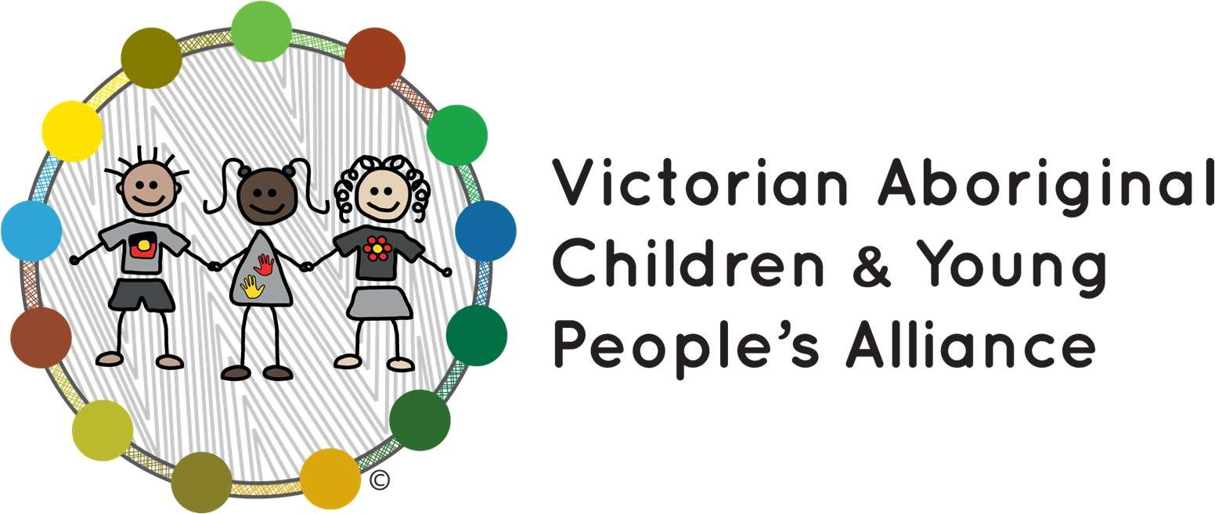
‘A new approach to programs for families and children’

Policy and Advocacy Team

December 2025

Artist’s Note
Tarsha Davis is a Kuku Yalanji and Palawa woman and multidisciplinary artist. “This artwork represents the Victorian Aboriginal Child and Young People’s Alliance (VACYPA) as an interconnected system, a network of organisations that are both distinct and mutually reinforcing, working together to support Aboriginal children, young people, and families across Victoria. The design acknowledges both the diversity and collective strength of VACYPA’s 15 organisation members. Each solid- fill circle in the base layer represents one of these organisations and their unique contributions to education, wellbeing, and cultural continuity.”



Acknowledgment of Country
The Victorian Aboriginal Children and Young People’s Alliance acknowledges the Traditional Owners of the lands on which we have prepared this submission, the Wurundjeri Woi-Wurrrung and the Bunurong Boonwurrung peoples of the Kulin Nations, as well as the traditional custodians of the lands where the membership resides and provide their services. Sovereignty was never ceded, and these will always be Aboriginal lands.







Introduc on

About VACYPA
The Victorian Aboriginal Children and Young People’s Alliance (VACYPA) is the collective voice of 15 Victorian Aboriginal Community Controlled Organisations (ACCOs), registered under the Children, Youth and Families Act 2005 (VIC), working together to empower Aboriginal families, children, and young people. It is our vision that all Aboriginal children and young people have every opportunity to thrive and be raised safely in Aboriginal families and communities.
VACYPA’s member ACCOs provide child and family services across 97.5% of Victoria, primarily in regional Victoria, with a combined annual revenue above $250 million and over 2,000 employed staff. In total, 72% of Aboriginal children in Victoria, 76% of Aboriginal children on Protection Orders and 73% of Aboriginal children in out-ofhome care live in areas covered by VACYPA’s member organisations.

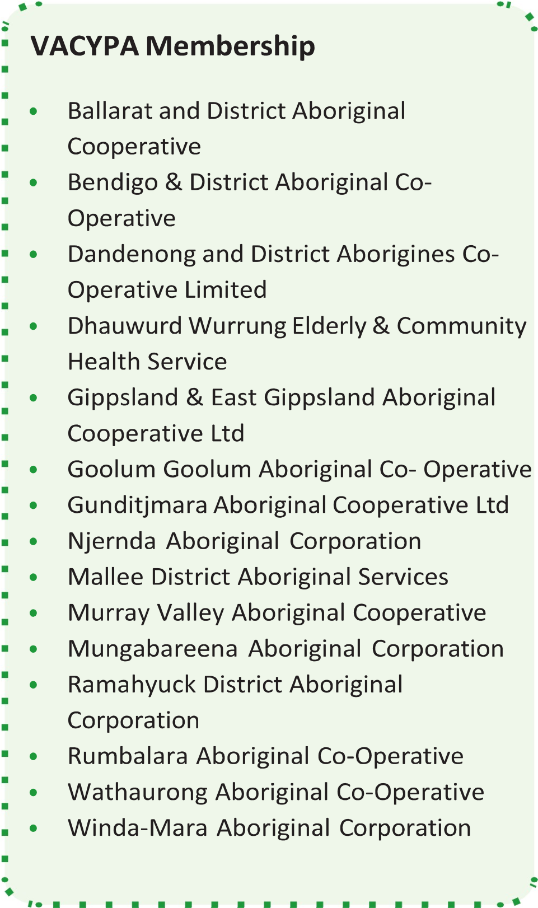
Purpose of this submission
We appreciate the opportunity to provide a submission to the Department of Social Services’ ‘A new approach to programs for families and children’ consultation.
Whilst not all VACYPA members deliver
Commonwealth-funded services, they deliver similar programs funded by the Victorian Government. Due to their regional locations, VACYPA’s member ACCOs are often the only Aboriginal child and family services provider in their region. Many aspire to expand the services they deliver to better meet the needs of their communities, but often face barriers associated with the design of government programs that don’t align with ACCO models of holistic, integrated care services that focus on outcomes over outputs.
This short submission expresses VACYPA’s support for the overarching approach outlined in the discussion paper, and comments on select discussion paper questions as set out below.

Overarching comments
VACYPA supports the stated aims of the new approach to programs for families and children, as set out in the discussion paper. The discussion paper states that the new program aims to:
- Fund a wide range of high-quality, evidence-informed services – from general community support to targeted help for children and families during times of crisis.
- Make grant and reporting processes simpler, so organisations can spend more time supporting families and less time filling out forms.
- Strengthen services for Aboriginal and Torres Strait Islander children and families.
VACYPA strongly supports the emphasis on services that span the full range of needs from general community support to targeted crisis support. ACCOs often describe themselves as supporting their children and families from birth to end of life. They deliver services that meet their communities’ needs at any stage of life, from bush kinders and playgroups to youth programs, language learning, school holiday programs, education support, parenting skills and family support, community cultural gatherings, health services, and services for elders. Following a public health approach, many of these services are preventative, supporting children and families to be strong in culture and community, recognised protective factors against the challenges that life brings. Others support those families needing additional support with disability, housing, financial, behavioural, and social and emotional wellbeing needs. And finally, many VACYPA members provide services for those children and families who need intensive family services and care services. This holistic approach that enables the ACCO to be a one-stop-shop for their community is a core element of what ACCOs do, guided always by the needs of their community.
However, these approaches have often been hampered by siloed government programs, lack of crossprogram coordination, and burdensome reporting that takes time away from service delivery. While ACCOs see their children and families for all that they are and need, program funding routinely seeks to categorise them based on narrow, point-in-time needs. ACCOs need to be able to wrap services around families quickly, and to scale up and down intensive, coordinated support to meet changing family. This is almost impossible in a system that prioritises targets and tick-boxes over outcomes. Complex and duplicative reporting requirements see many ACCOs wasting time trying to fit their outcomes into the particular style of reporting required under each grant rather than celebrating their successes and working on overcoming their challenges.
VACYPA’s 2023 reform agenda (available at www.vacypalliance.org) included a key priority that every Aboriginal family seeking support can access what they need directly from their local ACCO. Since colonisation, Aboriginal communities have advocated that Aboriginal ways of knowing, being and doing are best for Aboriginal people. We anticipate and hope that the reforms proposed by DSS will remove barriers to flexible, outcomes-based funding and recognise the value of locally-led, designed and delivered Aboriginal service models for Aboriginal children and families, which VACYPA whole-heartedly supports.

Responses to select discussion paper ques ons
In this short submission, VACYPA has chosen to respond to select questions from the discussion paper where we wish to express support or propose alternatives for consideration. Omission from this submission should not be interpreted as VACYPA supporting the premise of any question not addressed below. This targeted approach has been taken in the interests of time, available expertise, and recognising the currently limited delivery of Commonwealth-funded services by VACYPA members.
Does the new vision reflect what we all want for children and families?
VACYPA supports the stated vision that all children and young people are supported by strong families who have the skills and confidence to nurture them.
VACYPA recommends that DSS consider the addition of a reference to communities within this vision. It’s a well-known adage that it takes a village to raise a child, and supporting communities adds a further layer of support for the families within them. In Aboriginal communities, Aboriginal kinship care is a cultural practice that has existed since long before colonisation. It keeps families together, children on Country, and young people connected to community. VACYPA supports the Aboriginal and Torres Strait Islander Child Placement Principle (ATSICPP), which recognises that where Aboriginal children cannot stay with their family, the priority should be to place the child with extended family or other Aboriginal carers from the child’s community. This emphasises the importance of protecting both the cultural rights and identity of Aboriginal and Torres Strait Islander children, and the need for culturally safe and trauma-informed care. It maintains cultural connections and relationships, and recognises the fundamental role of community in Aboriginal and Torres Strait Islander culture and in the care of children and young people.
Families and parents do not exist in isolation. They exist within the arms of a community, one that shares historical, geographical, social, cultural and other ties with the family. VACYPA’s vision is that Aboriginal children and young people have every opportunity to thrive and be raised safely in Aboriginal families and communities. We are guided by the principle that Aboriginal communities are best placed to work with their families, children, and young people. This vision and principle both recognise the important role of community in Aboriginal ways of doing. Recognising, and funding community and cultural practices that strengthen the support networks around families and the children and young people in their care should be a principal element of the future vision for child and family services.
Are the two main outcomes what we should be working towards for children and families? Why/Why not? - Outcome 1: Parents and caregivers are empowered to raise healthy, resilient children - Outcome 2: Children are supported to grow into healthy, resilient adults.
VACYPA supports the proposed outcomes’ objectives to empower parents and caregivers, and support children.
The focus on health and resilience is narrow and is limited in its aspiration. While health and resilience are important, they are not the only factors that contribute to lifelong social and emotional wellbeing. VACYPA’s vision and that of its members is more ambitious – for a world in which Aboriginal children and young people have every opportunity to thrive. This goes beyond health and resilience and asks us to strive for an environment that also allows children to be and do their best, to find joy, experience love and connection, follow their dreams, and to live meaningful lives. DSS may wish to consider how it can reframe these outcomes to take a more ambitious approach that reflects what communities want for their children.

VACYPA notes that the outcomes do not include specific goals for Aboriginal and Torres Strait Islander communities. In the spirit of self-determination, VACYPA recommends that flexibility be provided within the program design for ACCOs and Aboriginal and Torres Strait Islander communities to identify the outcomes and measures of success that are meaningful to them. True self-determination requires that Indigenous peoples are able to make decisions on the matters that affect them, including their social, political, cultural and economic needs. This extends to determining what outcomes they wish to achieve for their communities, and how they
13
determine whether those have been achieved.
At a minimum, recognising the significantly greater barriers that Aboriginal and Torres Strait Islander children and their families face and the uniquely significant role that culture plays in their social and emotional wellbeing, VACYPA proposes that an additional outcome be included specific to Aboriginal and Torres Strait Islander children. This outcome could focus on recognising the importance of cultural connection to Aboriginal and Torres Strait Islander children, as a specific need that children and families programs should seek to address when supporting Aboriginal and Torres Strait Islander children. Culture is what makes Aboriginal and Torres Strait Islander families, children and young people strong, and programs that support cultural connection should be prioritised within the new approach.
Will a single national program provide more flexibility for your organisation?
Yes, ACCOs have been calling for program streamlining to enable self-determined, flexible use of funding to meet community need for many years. Flexible, outcomes-based, place-based funding is a core objective of VACYPA’s advocacy to enable ACCOs to deliver the support that each child and family needs in the way that works best for their community. Collapsing programs also helps to reduce the administrative burden on ACCOs applying for funding, who often have no dedicated resourcing to support grant application writing.
It is important to recognise that flexible funding must be supported by fit-for-purpose, consistent and well understand policies and procedures to enable it to work effectively in practice. VACYPA members have experienced issues where funding has initially been designed to be delivered flexibly, but this flexibility has been undermined in practice by insistence on standard reporting and other processes that are not adapted to the unique funding approach. Where there is a genuine intention to enable flexibility, it is important that appropriate and tailored guidance is provided to program-level staff implementing the program to ensure ‘on-the-ground’ practice reflects the policy intent of the program design.
Does the service or activity you deliver fit within one of the three funding streams? Do these streams reflect what children and families in your community need now – and what they might need in the future?
Many of the services delivered by VACYPA’s members currently fall within Stream 2 (Prevention and Early Intervention) and Stream 3 (Intensive Family Supports).
However, there is a significant need for increased funding in the prevention and early intervention space, particularly in local prevention programs. Across Australian states and territories, just 15.4% of children and families funding goes to prevention and early intervention-style services (such as family support services), while the remainder is spent on child protection systems and out-of-home-care (see SNAICC Family Matters Report 2024: https://www.snaicc.org.au/wp-content/uploads/2025/02/250207-FamilyMatters-Report-2024.pdf). While the proposed streams recognise the importance of universal services that are available to all families with no or limited restrictions on access at a national level (Stream 1), the proposed streams do not recognise the role of similar prevention services at a local level. While Stream 2 recognises programs that ‘support children and young people’s development and wellbeing’, which could be interpreted as preventative programs, it does not recognise the need for programs that support the wellbeing of families and communities more broadly. The references to families refer to early intervention (services that help ‘prevent problems early’) and ‘targeted help’. Neither of these clearly captures the types of community and family services that ACCOs deliver and aspire to deliver more of, that help to strengthen families and communities even where no problems have yet arisen.
These types of programs include community strengthening services such as cultural activities and events, mother’s and father’s or men’s and women’s groups, parenting programs with unrestricted access, sport and youth programs, and many other services. Many ACCOs began delivering these services to meet community need for more opportunities to strengthen cultural and community ties, and continue them because of the benefits they see in their children and families from bringing community together. They are rarely adequately funded and ACCOs have relied upon unstable funding sources and voluntary community effort to keep these critical services going.
VACYPA recommends explicit recognition of these local, place-based cultural and community prevention services within the streams, given the importance of cultural and community connection as protective factors against secondary and tertiary needs.
Do you agree that the four priorities listed on Page 4 are right areas for investment to improve outcomes for children and families?
VACYPA supports the four priorities listed in principle.
ACCOs have long advocated for early intervention and prevention as the keys to reducing the overrepresentation of Aboriginal and Torres Strait Islander peoples in tertiary systems such as child protection and youth justice. Investing in culture, community, families, and early childhood build the protective factors to prevent issues from arising before they start. Early intervention through services that address the challenges families may be experiencing as early as possible – such as housing, education, disability, alcohol and other drugs, family violence and other services – can support families before things get worse. According to the Productivity Commission’s Report on Government Services
(https://www.pc.gov.au/ongoing/report-on-government-services/), it costs over half a million dollars to house a child in residential care for a year, and well over a million to detain a child in a youth justice detention facility. If these funds were invested early in the child, their family, and their community, they could achieve far greater benefits than they do in the tertiary system.
Connected, co-located, and integrated services that work together to meet family needs is core to the ACCO model of service delivery. ACCOs exist through and for their communities, and seek to deliver what their communities need across all facets of their lives. In addition to providing a range of health, wellbeing, family, child, youth and elders services, they often perform the function of a local community hub as well, providing opportunities to engage early and often with families and children and support their needs across different programs and services. Government funding more often than not presents barriers to this model, seeing only one aspect of a child or family and limiting their funding to that, without thought for the benefits of integrating that service with others and investing in the infrastructure and implementation needs to make that connectivity possible in practice. VACYPA strongly supports approaches that reduce barriers to this integrated model of services that ACCOs have always known best serve their communities.
As community-controlled organisations, ACCOs are deeply connected to the experiences and needs of their communities. The third priority recognises what ACCOs have always known – that to best serve the community, you must listen to and respond to the needs of the community, you must be of and for it. This relational approach reflects Aboriginal ways of knowing, being and doing, and is the way ACCOs have always operated.
In relation to the fourth priority VACYPA notes that this seeks to increase the number of ACCOs delivering supports in locations with high First Nations populations. VACYPA has two suggestions in relation to this priority. Firstly, the objective should be to increase ACCO-delivered services, rather than the number of ACCOs delivering services. By their nature, ACCOs are established by their communities to meet community needs and often they will be the only ACCO in their location, or the only ACCO delivering particular types of services. Increasing the number of ACCOs delivering services should therefore not be the goal, but rather increasing the number of services being delivered by ACCOs (whether they be new ACCOs or those already delivering services).
Secondly, this priority should not be restricted to locations with high First Nations populations. This undermines the discrimination and disadvantage that Aboriginal and Torres Strait Islander peoples experience throughout Australia as a result of colonisation and ongoing dispossession. These experiences are not exclusive to, and may not even be greatest felt in, locations with high First Nations populations. Aboriginal and Torres Strait Islander children are overrepresented in tertiary systems across Australia and the prioritisation of services by ACCOs for Aboriginal and Torres Strait Islander children and families should be equally universal. Population density is not an appropriate measure of need – indeed, Aboriginal and Torres Strait Islander children in regional and remote areas or in areas where there are smaller populations may have less access to ACCO services currently, or to alternative culturally safe and appropriate services. For example, although Victoria has a reportedly low rate of identified Aboriginal and Torres Strait Islander people as a proportion of population, it has the second highest rate of overrepresentation of Aboriginal and Torres Strait Islander children in out of home care in Australia (see
SNAICC Family Matters Report 2024: https://www.snaicc.org.au/wp-content/uploads/2025/02/250207Family-Matters-Report-2024.pdf). Measures such as this are a much greater indicator of need than population alone, and should be used to inform investment decisions to ensure investment is reaching those families most in need of culturally safe and appropriate services.
VACYPA strongly believes that every Aboriginal and Torres Strait Islander child should have access to ACCO services. Currently, ACCOs receive just 6% of child protection-related expenditure, while Aboriginal and Torres Strait Islander children make up 41% of children in out-of-home-care and on long-term third-party parental responsibility orders (SNAICC Family Matters Report 2024: https://www.snaicc.org.au/wpcontent/uploads/2025/02/250207-Family-Matters-Report-2024.pdf). We know that ACCOs’ culturally grounded, integrated, community-led services achieve the best outcomes for Aboriginal and Torres Strait Islander children and this should be available wherever a child lives. In the absence of a more rigorous assessment of where investment should be prioritised, we recommend that DSS make this principle universal so that prioritisation is given for every Aboriginal and Torres Strait Islander child to have access to ACCO services.
Do the proposed focus areas – like supporting families at risk of child protection involvement and young parents match the needs or priorities of your service?
Yes, VACYPA supports the proposed focus areas, although it is unclear how these interact with the priorities beyond providing further explanation. It will be important to ensure that any prioritised services or models address the needs of the child, caregiver and family holistically. For example, prevention and early intervention support for children aged 0-5 years should not be restricted to services for the child, but should also include consideration of services for the caregiver or family. For example, if a child is displaying behavioural or learning difficulties that would benefit from early intervention, consideration should be given to whether the caregivers need additional support to provide a safe and appropriate learning environment for the child’s development, and what services can be provided to support those needs, not just the child’s immediate needs.
VACYPA notes that the proposed datasets to assess need are mainstream datasets that may not adequately reflect the additional need, bourn of dispossession and discrimination, experienced by Aboriginal and Torres Strait Islander communities. VACYPA recommends that specific datasets, including data on the National Agreement on Closing the Gap targets and outcomes, be added to ensure the assessment of need takes into account the vastly disproportionate need of Aboriginal and Torres Strait Islander communities in areas such as prevention of child protection and youth justice intervention, early childhood development, education outcomes, access to appropriate housing, and experiences of family violence and suicide. Investment decisions should take into account this disproportionality and the urgent need to take meaningful steps to close these gaps.
Are there other groups in your community, or different approaches, that you think the department should consider to better support family wellbeing?
While VACYPA applauds DSS’s proposed approach to streamlining select programs, VACYPA encourages the Commonwealth Government to consider cross-portfolio approaches to further streamline funding and achieve better outcomes for children and families. The protective factors that reduce child protection intervention – such as early childhood support, parenting support, family and community services, cultural connection, disability diagnoses and support, and support with alcohol and other drugs and family violence – apply equally to justice system contact, improving educational outcomes, improving engagement with work or further study, lifelong health and wellbeing, and economic development. Cross-

portfolio approaches to investing in these protective and preventative child and family services would maximise the impact they can have on outcomes across government.
What are other effective ways, beyond co-location, that you’ve seen work well to connect and coordinate services for families?
Beyond being co-located, ACCO services are community-controlled and place-based, usually servicing a distinct community or communities within a defined geographical area. Community control has many benefits for connecting and coordinating services for families. For example, in ACCOs many board members, executives and workers come from the communities the ACCO serves, helping to create connections for children and families receiving services and increasing the visibility and accessibility of the service within communities. This also contributes to trust between families and the ACCO and cultural safety, helping to break down barriers to seeking help (for example, many Aboriginal and Torres Strait Islander people may not seek early help from a mainstream service or a government department because of a lack of trust that they will be treated with respect and a lack of racism, and supported in a culturally safe way). Because they serve a defined and often close-knit community, ACCOs are also well placed to be able to identify those families who may need additional support or services and find creative ways to reach out to them.
Community control also drives accountability for ACCOs – they are accountable not just to government and other funders for the delivery of services and outcomes, but to the community itself. This keeps services grounded in genuine community need, allows local knowledge and expertise to inform service design, and ensures that community ways of knowing, being and doing are incorporated into the service delivery.
Beyond locational disadvantage, what other factors should the department consider to make sure funding reflects the needs of communities?
Four key additional factors the department should consider are:
- Disproportionate disadvantage: As noted in above, Aboriginal and Torres Strait Islander peoples are disproportionately overrepresented in key areas of need. This should be factored into investment decisions to ensure that ACCOs receive proportionate funding to meet the needs of their communities.
- Cultural safety: Aboriginal and Torres Strait Islander communities need access to culturally safe services to address their needs. Colonisation, ongoing racism, and enduring dispossession has vastly undermined Aboriginal and Torres Strait Islander peoples’ trust in government and mainstream service providers. These services rarely provide a safe space in which Aboriginal and Torres Strait Islander people feel they can express their needs and cultural identity, or receive the help they need. It is crucial that investment decisions consider the need to ensure culturally safe services delivered by an ACCO are available to Aboriginal and Torres Strait Islander peoples.
- Infrastructure: As local, community-based organisations, ACCOs rarely have access to capital or resourcing outside the funding they receive for service delivery. Child and family services funding rarely, if ever, includes funding for the infrastructure required to deliver the services – more often than not, ACCOs receive funding for one or two staffing positions for a service, without recognition that the ACCO must find a space to deliver the service in, and fund any other service resources from other sources. For this reason, many ACCOs are struggling to deliver services from inappropriate or inadequate facilities that are not fit for purpose and don’t meet the needs of the ACCO or their community. The department should consider the relative disadvantage ACCOs are at compared to larger organisations when it comes to infrastructure needs and availability, in assessing funding needs for a service.
- Workforce: Aboriginal communities are best served when supported by ACCOs with Aboriginal workforces who can provide the culturally appropriate services their community needs. ACCOs consistently seek to employ Aboriginals and Torres Strait Islander peoples wherever possible, but are often limited by both program limitations and other issues. Some programs require workers to have particular qualifications, significantly limiting the workforce pool available. Other limitations include geographical challenges for regional ACCOs, lack of sufficient funding to provide wage parity compared to other roles or organisations, short-term funding cycles that only enable ACCOs to offer short-term contracts, and lack of funding to offer relocation expenses or training and development opportunities to upskill workers to meet the needs of the role or enable career progression. These issues impact recruitment, retention and workforce wellbeing, and often mean that ACCOs struggle to fill roles and are not able to employ as many Aboriginal and Torres Strait Islander workers as they would like to. DSS should include greater, longer-term workforce funding in funding contracts to provide for better pay, access to learning and development, and to recognise the other costs associated with recruiting and retaining a qualified, appropriate Aboriginal and Torres Strait Islander workforce for ACCOs.
What else should be built into the program design to help improve outcomes for Aboriginal and Torres Strait Islander children and families?
While VACYPA supports the overarching objectives of the new approach, the model has been designed for mainstream communities rather than Aboriginal and Torres Strait Islander children and families.
In addition to the proposed adjustments VACYPA has recommended throughout this submission, to ensure the program design is fit-for-purpose for Aboriginal and Torres Strait Islander communities it must explicitly provide for self-determination in the program design. The right of Aboriginal and Torres Strait Islander peoples to control their own lives is central to improving outcomes and a core value of VACYPA. It is also recognised by the National Agreement on Closing the Gap, and the United Nations Declaration on the Rights of Indigenous Peoples.
Aboriginal and Torres Strait Islander communities have been holding, caring for and supporting their children to thrive for tens of thousands of years. The crimes of colonisation disrupted the relationships, structures and systems of governance that had always guided and shaped Aboriginal and Torres Strait Islander families. Aboriginal and Torres Strait Islander families know what their children need, but have not been able to exercise their right to self-determine their own approaches under colonisation and have instead endured the systematic removal of children from their families, communities, Country and culture.
Genuine self-determination is critical to improving outcomes for Aboriginal and Torres Strait Islander children and families. This should be embedded in outcomes-based program design that allows ACCOs the flexibility to design and deliver the services their local communities need, based in Aboriginal ways of knowing, being and doing. Self-determination also means allowing Aboriginal and Torres Strait Islander communities and ACCOs to identify and report on the outcomes and measures of success that are meaningful to them. This should be explicitly included in the program design, as well as in all aspects of the program’s delivery.
In designing for self-determination, government must acknowledge that to design services requires resourcing in itself. Governments cannot and should not assume that ACCOs have the capacity to design services within their current resourcing – most ACCOs have few or no policy and program design staff and rely on executive managers to develop funding submissions. Government has historically held the resourcing for program design, and shifting to self-determined models requires government to recognise that it must also shift program design resourcing. If government is genuinely committed to achieving Closing the Gap outcomes and supporting self-determination, government must make funding available to ACCOs for service design and development.





