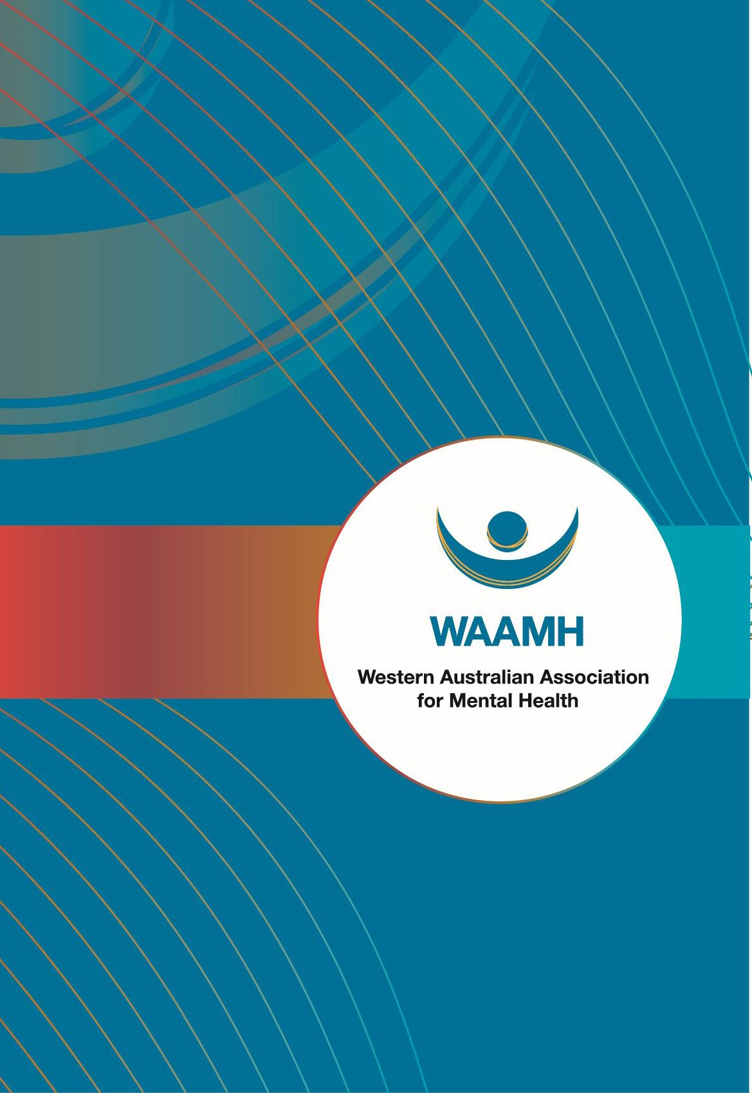

Response to the
Department of Social
Services Discussion Paper
:
A New
Approach to Programs for Families and
Children

December 5 2025

Contents
1. Introduction 3
2. Overview 3
3. Our approach 4
4. Issues identified 4
4.1 Lack of detail about how the reforms will be implemented in WA and how they will work in practice 4
4.2 Time frame for development and implementation is too short 5
4.3 Impact of the intensification of competitive tendering process on collaborative relationships at the local level 6
4.4 Concern about the potential loss of a specialist focus on mental health and a shift away from the provision of early intervention support 6
4.5 Implications for staff and clients of the program 7
4.6 Implications for the mental health system, particularly in local places in regional WA 8
5. Conclusion and recommendation 8
Acknowledgement of Country 9
Acknowledgement of Lived & Living Experience 9
About WAAMH 9

Introduction
The WA Association for Mental Health (WAAMH) appreciates the opportunity to respond to the
Department of Social Services (DSS) Discussion paper: A New approach to programs for families and children.
As the peak body for the non-government community mental health services sector WAAMH plays a leadership and advocacy role in representing the needs and interests of non-government organisations providing mental health support and services throughout WA, as well as people with lived and living experience, and other groups and organisations with an interest in mental health and wellbeing.
WAAMH’s members provide a wide range of community supports and psychosocial services and supports to assist people live well in the community.
Our work is informed by trauma-informed, recovery-oriented, person-centred, rights-based and social determinants approaches.
WAAMH is major provider of mental health training and workforce development programs. We also undertake policy and research work with non-government agencies, government departments and academic and other researchers to inform public policy and drive systemic change and reform of the mental health system.
WAAMH delivers specific projects relevant to the sector, for example undertaking fidelity reviews for the Individual Placement and Support employment program delivered in Headspace sites and adult mental health services across Australia. WAAMH also collaborates extensively with Federal and State government departments and non-government agencies, and national and state based peak bodies representing mental health and other community service sectors.
For further information about WAAMH’s response please contact

Overview
WAAMH’s response to the DSS Discussion Paper identifies six (6) issues for consideration by DSS in its planning and implementation of the proposed reforms to Family Mental Health Support Service (FMHSS).
- Lack of detail about how the reforms will be implemented in WA and how they will work in practice.
- Time frame for development and implementation is too short
- Impact of the intensification of competitive tendering process on collaborative relationships at the local level
- Concern about the potential loss of a specialist focus on mental health and a shift away from the provision of early intervention support
- Implications for staff and clients of the program
- Implications for the mental health system, particularly in local places in regional WA.
WAAMH recommends that DSS establish a broadly based Advisory structure in WA to provide the
Department with local advice and guidance about the planning and implementation of reforms to the
FMHSS and advice about issues and challenges affecting the reforms being made to the FMHSS in WA. In WAAMH’s view this group should include representatives from current funded FMHSS services, peak bodies, including WAAMH, CoMHWA and WACOSS, the WA Mental Health Commission, family and parent representatives with lived or living experience and other relevant stakeholders.
WAAMH is willing to be consulted on any matters discussed in this response.

Our approach
WAAMH’s response to the Discussion paper focuses specifically on the Family Mental Health Support Services program (FMHSS) and is informed by:
- our experience as the peak body for the non-government community mental health sector in Western Australia (WA)
- our reading of the DSS Discussion Paper and the Evidence Summary
- attendance at a Town Hall meeting
- discussion with several member agencies currently delivering services under the Family Mental Health Support Services (FMHSS) program
- the experience that WAAMH and its members have of Federal Government programs
- review of documents relevant to the reform process.

Issues identified

Lack of detail about how the reforms will be implemented in WA and how they will work in practice.
WAAMH is concerned about the lack of detail about how the reforms will be implemented across Western Australia (WA) and what the reform will look like in practice for the delivery of services and support to families and children.
While we understand the rationale for the transition from four distinct programs to one program a range of unanswered questions have been raised with us:
- Will there be a process of co-designing the implementation and roll out of the reforms to the FMHSS in WA that involves agencies currently providing services, peaks bodies like WAAMH & Consumers of Mental Health WA (CoMHWA) and other key stakeholders, including people with lived experience and families? What level of engagement will WA based stakeholders have in the planning and implementation of the reforms in WA, particularly across regional WA?
- Given their significant role in the funding of mental health services what role are the WA Mental Health Commission, the WA Primary Health Alliance and the WA Children’s Commissioner playing in the implementation of the reforms?
- How will the transition from four distinct programs to one program operate in practice in WA, particularly in regional WA, given the size and unique nature of WA? How will the crossover between programs operate in practice?
- Does a formal plan exist for the implementation and roll out of the reform of the FHMSS? If so, who was involved in its development and when will it be released for stakeholders?
- How will the fidelity and specialist nature of the FMHSS be retained and strengthened under the reforms?
- Will the current arrangement of ‘place-based delivery’ of the FMHSS by locally based services be retained or will a model of one large provider contracted to deliver services in a particular location be the preferred approach?
- How will existing agencies manage and support existing and new clients during the transition from the FMHSS to a single program?
- Will there be an additional funding allocation for the increased contracting of ACCO’s or will that be drawn from the same funding amount as is currently allocated to the 4 programs?
- How will the reforms to the FMHSS be implemented in a way that supports and strengthens the mental health ‘ecosystem’ in local areas where the program currently operates in WA, rather than be implemented in a way that undermines and fragments the existing mental health system in local communities, as is sometimes an unintended consequence of new Federal programs.

Time frame for development and implementation is too short
WAAMH is concerned that the time frame for planning, implementation and roll out of the reforms is too short, particularly given the lack of detail provided in the Discussion paper and the Town Hall meetings.
Clearly much more planning is required before any competitive tendering process can begin. Tender processes, including the preparation and release of tender documents, preparation of proposals, review of proposals, selection of successful respondents and negotiation of contracts are time consuming.
It will likely mean that successful and unsuccessful tenderers will have a short window of opportunity to prepare before current contracts end and/or new contracts commence. For any current service providers who are unsuccessful in securing a new contract they will likely have a relatively short period to transition clients out of their services to a new service that may not yet be operational and support staff who will be without a job.
Agencies require much more clarity from DSS about the timeframe and process for all these activities.

Impact of the intensification of competitive tendering process on collaborative relationships at the local level
Currently, the FMHSS services operate as a critical part of a local ecosystem of mental health services, which includes public services provided by state governments (such as CAMHS services), mental health and generic community services provided by non-government agencies, and services provided by the private sector, including GPs and psychologists and specialist practitioners in private practice.
Competitive tendering process pit agencies against one another to secure funding and have a significant impact on the existing service system. One consequence of competitive process is that they undermine local collaboration, local relationships and linkages and create tensions and disruption that have short term and longer-term implications for the local service ecosystem. Competitive tendering processes create an increased risk of the disruption of established place-based responses and local relationships and linkages and often result in short-term and even longer-term fragmentation of services.
There is also the risk with competitive process that the agency who wins a contract may not have a local presence or local relationships. This is particularly the case where the successful tenderer is an agency contracted to provide services locally who has no history of working in a particular local community. This often happens in competitive tendering where a large national or state-based provider, with no established presence in a particular community, is the successful tenderer.

Concern about the potential loss of a specialist focus on mental health and a shift away from the provision of early intervention support
WAAMH has concerns about the collapsing of FMHSS into one program with what we understand is the same level of funding.
It is unclear what the unintended impact might be for the FMHSS program of the move from four specialist programs to one single program, particularly if there is no additional or protected funding for family mental health support and services.
The FMHSS program is unique in that it has a specialist focus on the mental health of families and children in their local communities. One concern about the proposed reform is that the specialist and local (place-based) focus of the FMHSS on the mental health of families and children may be eroded, albeit unintentionally, over time, or the expertise developed by the agencies currently funded may be lost.
This could occur in several ways. Through the tender process the amount of funding allocated to deliver family mental health support may be less or eroded over time. Existing providers who have developed specialist expertise and local relationships and linkages may choose not to tender or may be unsuccessful in their tender and be replaced by agencies with less or limited specialist expertise in working with the mental health of families and children.
Where the successful provider(s) is not a specialist mental health provider, or an agency is contracted to provide services across several programs, it is possible that over time the specialist mental health focus may become less important and/or the funding allocated to mental health support or staffing levels of workers with specialist mental health expertise and knowledge are reduced.
Another concern is that the reforms may unintentionally shift the focus away from early intervention support, which is viewed as a strength of the program. For example, the Federal Government has revised the scope of the Medicare Mental Health Centres to strengthen their focus on people with more acute mental health issues, even though that was not what was originally planned.
Several of the current services wondered whether there may be a shift away from the early intervention focus of the FMHSS program to focus on families and children with more acute or crisis needs.
There is concern that expanding the scope of the program may result in the program being expected to deliver more support than it is capable of, resulting in a loss of focus on prevention and early intervention support.
Several agencies indicated that the primary client cohort for their service is in the 7-13 years aged group, however they pointed out that the Discussion Paper said that the primary target for the new program is children aged 0-5 years, which are not the primary cohort accessing the FMHSS in several agencies consulted. The representatives of the agencies noted that the Discussion Paper indicated that the Department would continue funding services that support children through childhood and adolescence to address challenges and transitions that occur after the age of five. However, they wondered whether by making explicit that the target group is 0-5 years, the DSS is indicating a shift in the program’s focus away from the older cohort.

Implications for staff and clients of the program
The proposed reforms are likely to have significant implications for staff of existing services and any newly funded services, as well as the people who the FMHSS exists to serve.
Existing service providers of FMHSS are likely to have relatively short notice of whether they will retain or lose their existing contract. This will have significant implications.
- Existing service providers who have to re-tender for their contract will need to support their staff and prepare them for the possibility of the loss of the contract, and ultimately the loss of their jobs. Even if existing services are successful in re-contracting to deliver the FMHSS they may have already lost experienced staff and will have to recruit new staff in a difficult labor market, particularly in the regions. This will add significantly to the cost and administrative burden for

agencies who may have to retrench staff and then reappoint those or new staff and upskill new staff.
- Retention of staff will prove more difficult. For existing services who have to re-tender for FMHSS services the uncertainty about future funding will create difficulties for the retention of existing staff who are likely to look for other jobs which provide greater security. This means the potential loss of experienced staff with specialist skills in the mental health of families and children.
- Recruiting staff to the regions will become more difficult. Because of severe housing shortages in most regional areas, many mental health and community services are currently unable to recruit staff from outside the region who do not have access to housing in the region. For example, recruiting staff from the metropolitan area is difficult in many regions because there is little housing available locally or it is unaffordable. This situation will have a significant impact on any new service provider looking to attract and recruit staff in regional locations. For example, staff roles may go unfilled, and services may have to be rationed or reduced.
Neither the Discussion paper nor the town hall meeting indicated whether there has been any involvement of families and people with lived experiences in shaping the proposed reforms.

Implications for the mental health system, particularly in local places in regional WA
As mentioned, the FMHSS services operate as a critical part of the mental health ‘ecosystem’ in local communities and places. Where they exist, particularly in WA regional areas, they are often one of few services with specialist expertise to support families and children with their mental health concerns.
The FMHSS are embedded in local mental health systems and have established relationships and linkages with mental health services, as well as schools, early learning centres, community services and other local services. These relationships and linkages may be lost if existing providers choose not to retender or are unsuccessful with their tender, or they may take considerable time to re-establish if a new provider is contracted.
As such, any changes to the FMHSS have significant implications for the overall mental health system in local areas, particularly in regional locations where FMHSS services currently exist. Hence, it is important for DSS to understand the local and regional implications of the decisions they make about the FMHSS as they will affect not just the services funded under the FMHSS, but the mental health system as whole.

Conclusion and recommendation
WAAMH believes that DSS should establish a broadly based Advisory Structure in WA to provide the
Department with local advice and guidance about the planning and implementation of reforms to the FMHSS and advice about issues and challenges affecting the reforms being made to the FMHSS.
In WAAMH’s view that should include representatives from current funded FMHSS services, peak bodies including WAAMH, Consumers of Mental Health WA (CoMHWA) and WACOSS, the WA Mental Health Commission, family and parent representatives with lived or living experience and other relevant stakeholders.

Acknowledgement of Country
The Western Australian Association for Mental Health (WAAMH) acknowledges the traditional custodians of the land on which this submission was developed, the Whadjuk people of the Noongar Nation. We acknowledge their continuing and unbroken connection to land, sea and community. We pay our respect to their culture and Elders and acknowledge their ongoing contribution to Western Australian society and culture.

Acknowledgement of Lived & Living Experience
WAAMH also acknowledges the individual and collective expertise of people with a living or lived experience of mental health, alcohol and other drug issues, as well as the families and carers who provide support and have a lived or living experience.

About WAAMH
WAAMH is the peak body for the community managed (non-government) mental health sector in Western Australia, with organisational and individual members across metropolitan and regional WA. WAAMH has been engaged in the mental health sector for nearly 60 years.
WAAMH’s membership comprises community managed organisations providing mental health services, programs or support in community settings, as well as individuals and families with lived experience of mental health issues and suicide, with whom WAAMH engages in genuine partnership. Community-managed organisations provide a critical network of services to support people affected by mental ill-health and their families and help them live meaningful lives in their communities.

The WA Mental Health Commission provides a minimum 9 months’ notice to services whose contract will not be renewed. The services funded under the FMHSS will have much less notice than that and that will present significant challenges, additional cost and administrative burden for services whose contracts are not renewed.

