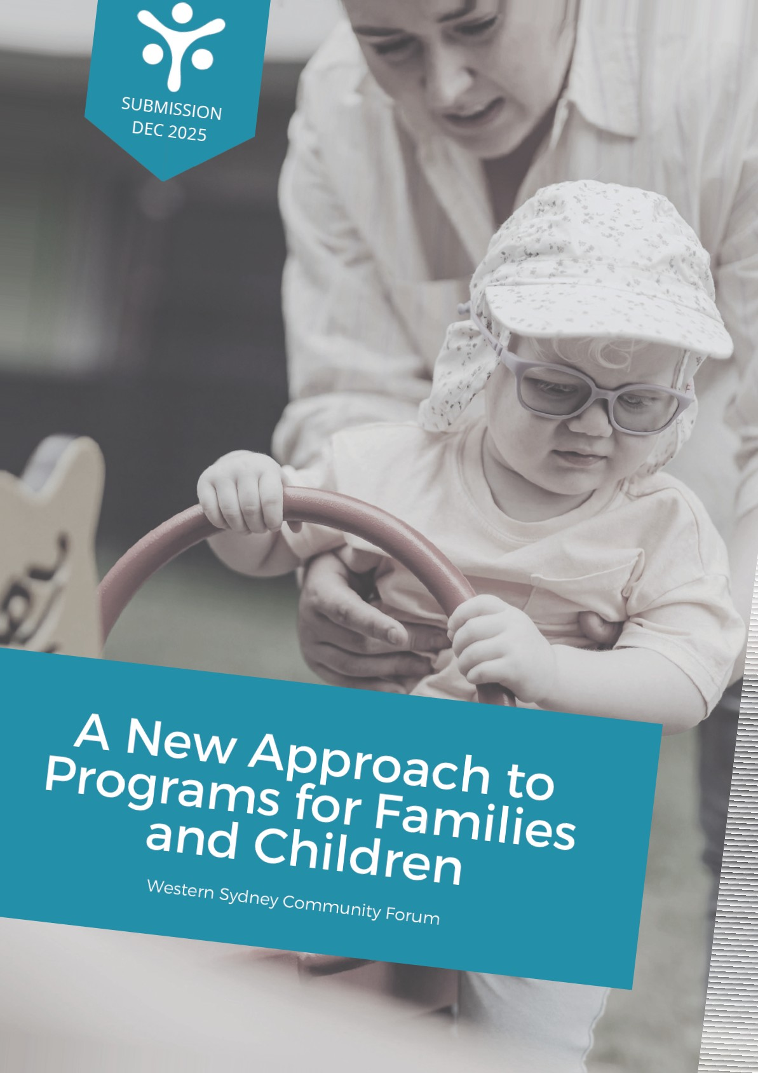
ACKNOWLEDGEMENT

Western Sydney Community Forum acknowledges

First Nations peoples as the sovereign Traditional Owners and Custodians of the unceded lands and waters on which we work and live.
We pay respect to Elders past and present.
We respectfully recognise all Aboriginal and Torres Strait Islander peoples, their cultures and their heritage.
We acknowledge past and present injustices and commit to walking alongside First Nations peoples.
western sydney
community forum
Western Sydney Community Forum

4 December 2025
Department of Social Services fa mil iesOß.sgov au
Dear Colleagues,
Please find attached Western Sydney Community Forum's submission regarding a new approach to programs for families and children.
Thank you for the opportunity to contribute and we look forward to further information and collaboration on progressing this important work.
For further information, please do not hesitate to contact Anita Hanna, Director Policy and Programs, on 02 9687 9669 or anita.hanna@wscf.org.au.
Yours sincerely,

3

ABOUT US
Western Sydney is home to around 2.6 million people. One in ten Australians live in Western Sydney. Nationally, it is one of the fastesV growing regions, with an estimated population of 3.2 million by 2036.
The region encompasses the 13 local government areas of Blacktown,
Blue Mountains, Camden, Campbelltown, Canterbury Bankstown, Cumberland, Fairfield, Hawkesbury, Liverpool, Parramatta, Penrith, The Hills and Wollondilly
It is the Australian urban area with the highest of First Nations people. Almost half the population spéaks a.language other than English at home. There are concentrated areas where people experience disproportionate levels of systemic socio-economic barriers to access, when compared to the metropolitan.
Western dne9 Community Forum is the regional peak social development has led and shaped social policy and service delivery in the region for almost 50 years, representing a vast population and a community services industry that annually invests billions in the Western Sydney community and economy. We have over 4,000 members, subscribers and service users and a reach of about 400,000 each year.

BACKGROUND


This submission responds to the
Australian Government Department of Social Services' proposal to develop a new, single national program to support children and families. Under the proposed changes, this new program will replace five existing programs. Through these changes, the Department of Social Services aims to support providers to deliver flexible and responsive services by funding a wide range of high-quality services and simplifying grant and reporting processes, as well as maximise outcomes for children and families. The Department of Social Services has recently sought feedback from the community services industry on the proposed changes to its approach to programs for families and children.
Western Sydney Community Forum welcomes the Government's proposal and the opportunity to contribute to this consultation process.
This is an important and timely opportunity to address the fragmentation and duplication of a layered service system that creates complex service pathways for communities. There is a pressing need to build on the capacity of the existing independent local service system, who experience ongoing resourcing challenges in responding to the needs of children and families at the local level.
Supporting children and families is a core priority of many community and human services organisations in Western Sydney. Ensuring that the approach to programs for families and children supports these organisations is critical, with data showing that between 2023-2024, three out of the five LCAs in NSW with both the highest number of children reported in concern and in risk of serious harm reports, and the highest number of children and young people in out-ofhome care were located in Western Sydney (Department of Communities and Justice, 2025).
Our submission draws on the expertise and insights of various individuals and organisations working for the communities of Western Sydney. Western Sydney Community Forum thanks those stakeholders for their input and support.
5

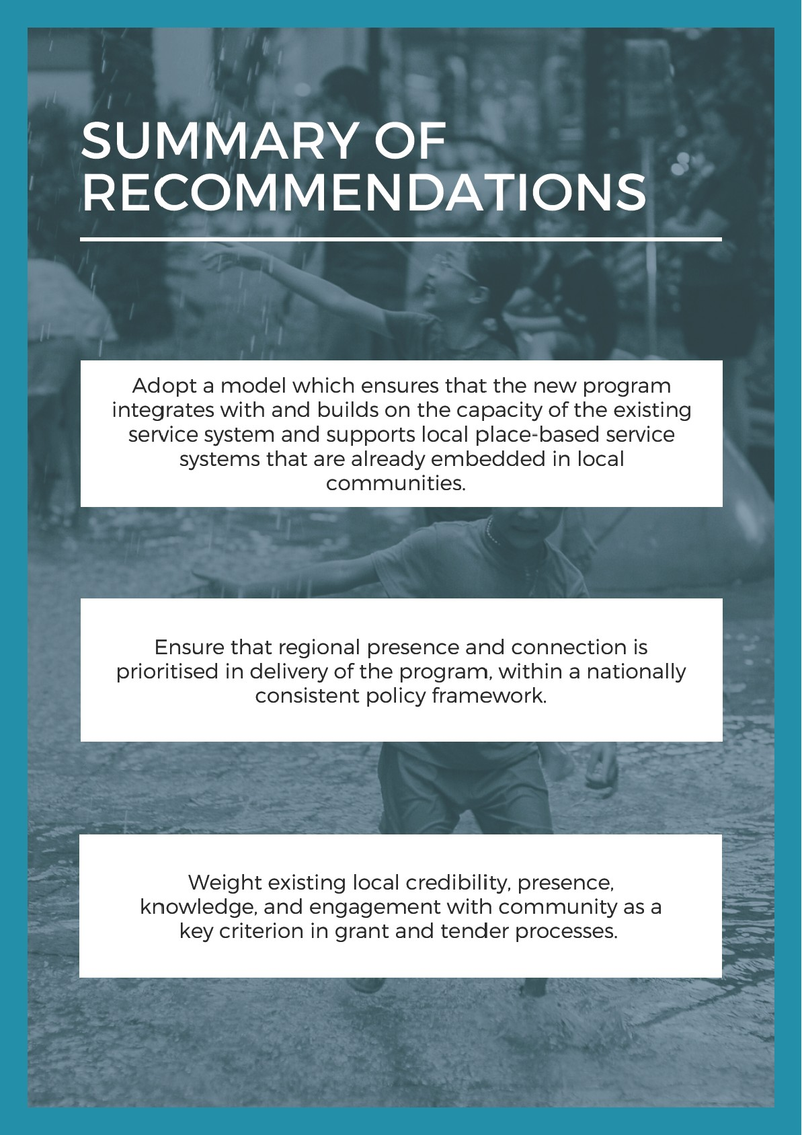
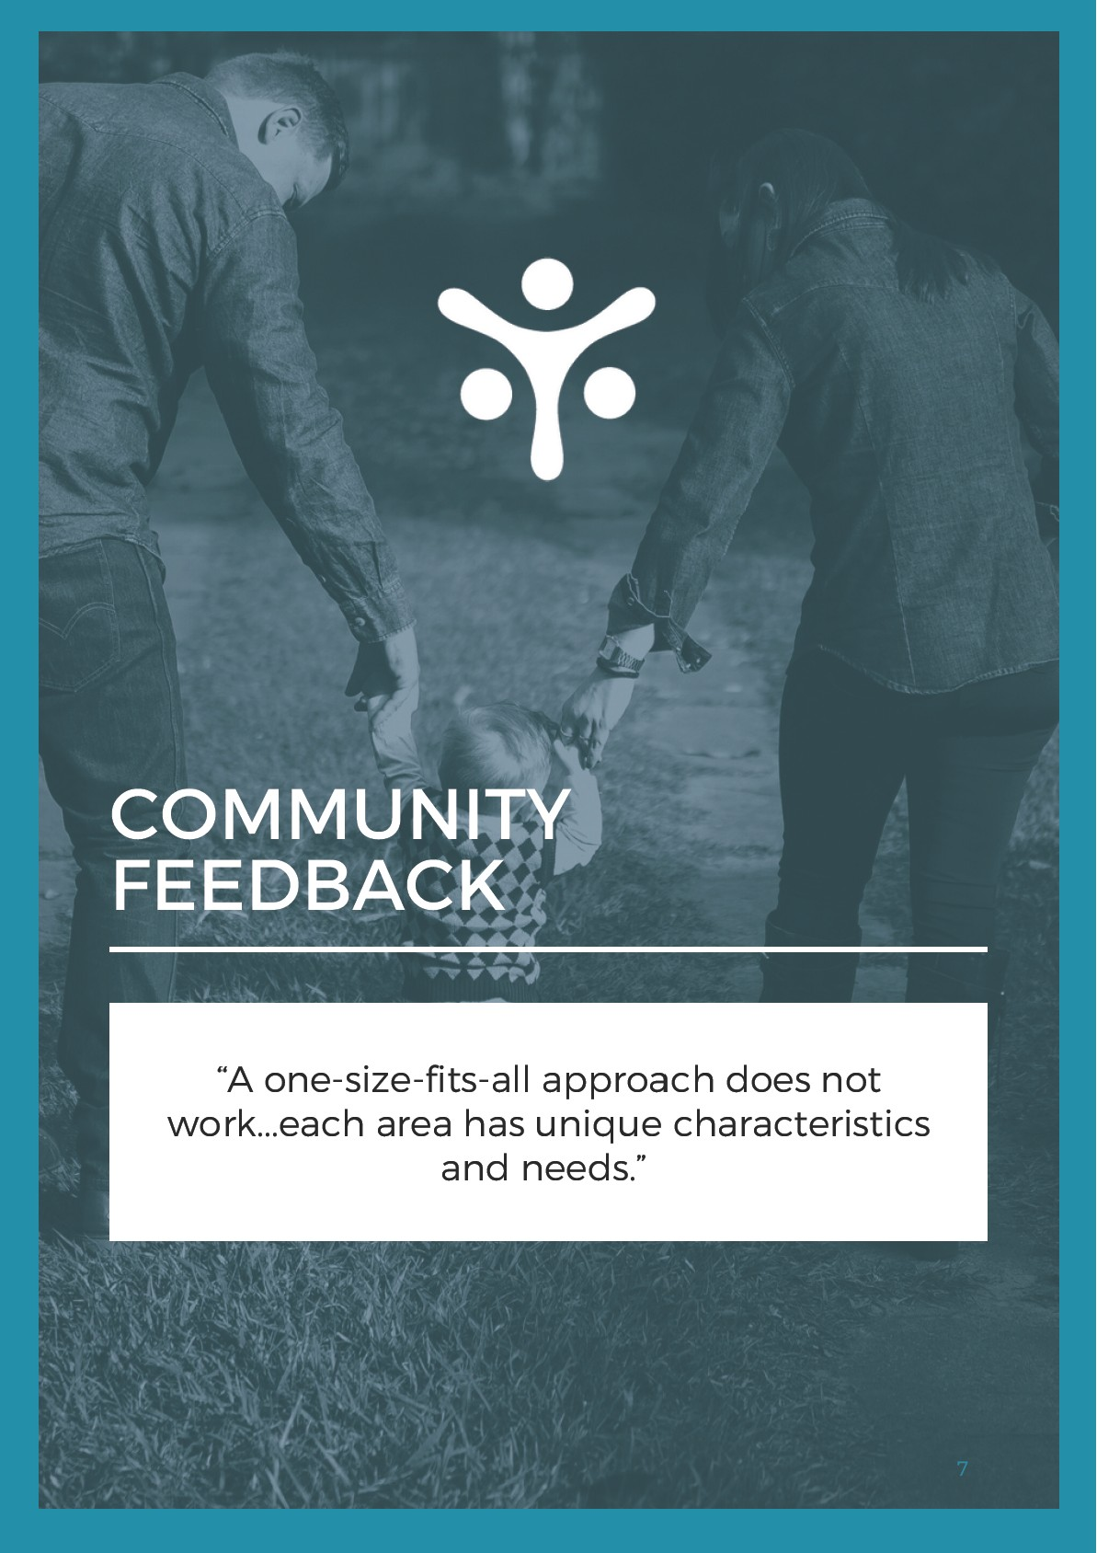

RECOMMENDATION
ONE

ADOPT A MODEL WHICH ENSURES THAT THE NEW PROCRAM INTEGRATES WITH AND BUILDS ON THE CAPACITY OF THE EXISTINC SERVICE SYSTEM AND SUPPORTS LOCAL PLACE-BASED SERVICE
SYSTEMS THAT ARE ALREADY EMBEDDED IN LOCAL COMMUNITIES.

As outlined in the Department of Social Services' discussion paper, the key aims of the Australian Government's new approach to programs for families and children focus on facilitating the delivery of supports which are evidenceinformed, based on community need, and enable flexible and responsive service delivery. In order to meet these aims, it is recommended that the new national program adopts a model which ensures that the program integrates with and builds on the capacity of the existing service system and supports local trusted placebased organisations which are embedded within their communities.
There is a consistently growing body of evidence which demonstrates the importance and effectiveness of developing and building the capacity of place-based service systems. For instance, in a recent scoping review examining best practices for placemaking, infrastructure and service delivery to improve health and social equity, it was found that a range of interventions using integrated, place-based models of service delivery demonstrated positive outcomes (Reid et al., 2025).
The key factors associated with success in these initiatives were sustained community leadership, adequate long-term funding arrangements, cross-sector collaboration, and evidence-based adaption to community needs. These findings are reflected in the literature, in which wrap-around and placebased services have been identified as an effective model of service delivery across multiple contexts (Alderton et al., 2022; Baxter et al., 2018; Department of Social Services, 2024; Ceatches et al., 2023).
For instance, the report consolidating feedback from consultations on the design and delivery of foundational supports for children with developmental concern, delay and/or disability revealed that there was consistent feed back from community and other stakeholders supporting place-based hubs and integrated supports to support children and their families (The Social Deck, 2025b). Those highlighted included community hubs, neighbourhood centres, libraries, and other community places (The Social Deck, 202%).
8
This echoes the findings from the 2025 Productivity Roundtables, which supported the adoption of placebased approaches with joint local decision-making and bottom-up development (Department of Social Services, 2025a). Similarly, feedback from stakeholders in Western Sydney has also consistently underscored the value of local place-based organisations to identify and respond to community needs through collaboration with the community.
Ensuring that local wraparound supports for families and children are able to respond flexibly across different intersecting areas including disability, health and mental health to provide information, advice, referrals and programs has been identified as critical. In these occurrences, placebased service models create bridges between fragmented service systems, providing pathways and soft entry points for services users to address a range of challenges that are often complex and have compounding impacts (Ourplace, 2023).
This contributes to a more efficient approach to human service delivery, facilitating better outcomes for both service users and service providers. Equally, it results in better value and efficiencies for Government funders and decision makers.
The current human services system has a deeply embedded network of place-based organisations already present within many communities, which have extensive experience in providing tangible assistance and supporting their local communities (Local Community Services Association, 2022). However, the disconnect between Commonwealth and State funding for these services has resulted in parallel service systems, which perpetuate silos in service delivery and create further fragmentation at the local level of service delivery.
With the proposed development of a new program for families and children, it is critical that these existing resources are strengthened and supported. Furthermore, to ensure that service delivery and referral pathways are streamlined, coordination between Commonwealth, State and local levels of policy and delivery must be a key consideration to the approach to programs for families and children.
9

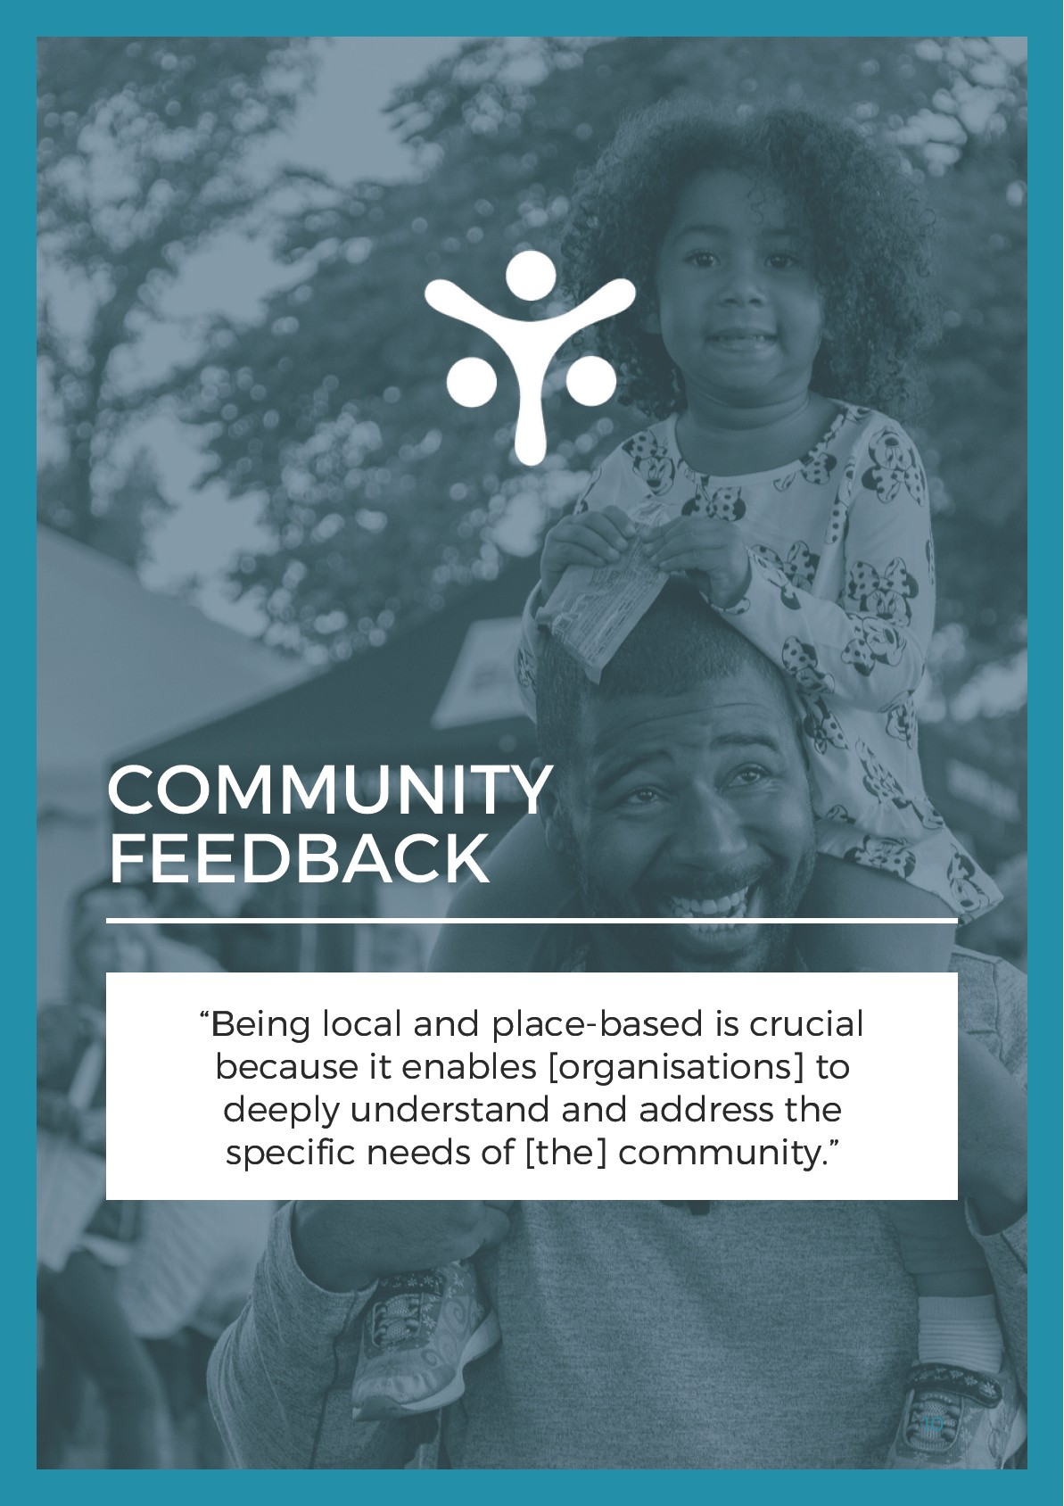

RECOMMENDATION
TWO

ENSURE THAT REGIONAL PRESENCE AND CONNECTION IS
PRIORITISED IN DELIVERY OF THE PROGRAM, WITHIN A NATIONALLY
CONSISTENT POLICY FRAMEWORK.

The Australian Government's approach to policy has prioritised the development of a nationally consistent and equitable framework in a range of different areas to promote efficiency, accountability, improve resource allocation and reduce inequity in service delivery across jurisdictions. Western Sydney Community Forum supports the implementation of this approach in relation to programs for families and children. This critical aim across all social policy areas within Government ensures that there is an equitable and consistent framework for all Australians, irrespective of who they are or where they live.
Furthermore, having a nationally consistent policy framework works to address persisting inequalities in regions that have previously been disadvantaged. For example, the Western Sydney region has a historical under-investment in social and community services, as well as infrastructure, when compared to the rest of Sydney. In many instances, the distribution of funds does not clearly correspond to either population numbers or needs-based planning.
However, a key risk emerging from this approach has been the nationalisation of delivery working to the detriment of delivering outcomes. A recent analysis by one of our member organisations on the allocations of a recent funding program found that the costs to the Government increased, while services being offered to Australian citizens decreased. It showed that in delivery, a national organisation had overhead costs of about 40 percent, while the integrated and embedded local trusted place-based organisation could deliver the same service with under 20 percent overhead costs. This demonstrates a greater cost benefit to Government, with operational savings being spent on direct services benefiting community members. Additionally, it should be noted that this locally embedded organisation continues to receive 100 percent of the demand from families, as it has established credibility, is well known, and accessible to the community.
Regional presence is critical for delivering services that reflect the unique social, cultural, and demographic characteristics of communities.

Local connection enhances trust, supports early identification of changing needs within a community and facilitates responsiveness to these needs. Although national programs and information services play a significant role in supporting children and families across Australia, it is critical to ensure that the delivery of services across the three proposed activity streams provides tailored and relevant person-centred supports which meet the diverse needs of individual communities.
When sharing feedback about the delivery of other programs in the human services sector, stakeholders raised concerns that national programs and information services did not address the specific circumstances of services users, or provide advice or referrals that were relevant, appropriate or available in their local area (The Social Deck, 2025a). Further limiting the applicability of these services in practice, it was reported that awareness and use of national information and advice services were lowered compared to other resources including local peer networks, local organisations, and other sources of information such as GPs and schools.
It is therefore recommended that the development of a nationally consistent policy framework for the delivery of the program prioritises regional presence and connection, ensuring that the distribution of services under the three proposed activity streams reflects this consideration.
12

CASE STUDY

CHILDREN AND PARENTINC SUPPORT IN AUBURN

The current Children and Parenting Support program (CaPS) is designed to provide support to children, focusing on early intervention and prevention services to improve children's development and wellbeing, adjunct care and early learning, and support for those in a parenting or carer role (Department of Social Services, 2025c). In line with this, the services that organisations provide under this program may include community playgroups, school readiness programs, parenting courses and home visits, counselling and support, care outside of school hours and peer support groups, and prevention and early intervention support.
In Auburn, which falls within the Cumberland City Council local government area, there are 12 organisations currently funded to provide support to the community under this program (Department of Social Services, 2025b). Of these, only one is delivered by a local, place-based organisation that is embedded in the community and has a physical location in Auburn. In addition to this, Toy Libraries Australia runs a toy library and a number of playgroups operate in Auburn under the umbrella of Playgroup Australia and Playgroup
Queensland. However, the majority of services available via CaPS in this area are national programs which provide support exclusively through telephone or online resources.
Digital equity is quantified by access to an internet connection, the use of different digital devices, and the frequency and intensity of technology use (Dastyari et al., 2024). Although the 2021 Census did not include data on internet access, the 2016 Census indicated that nearly 15% of households in the Cumberland area did not have internet access in their homes (Profile ID, 2021a). More recent data suggests that Cumberland is still experiencing significant digital inequity compared to the NSW state average (Australian Digital Inclusion Index, 2025).
In areas with high levels of diversity such those in Western Sydney, this digital inequity intersects with other barriers including the experience of multiple forms of disadvantage due to cultural, language or literacy barriers, which may further impede access to services intended to support children and families (Notley & Aziz, 2024). With 80% of the organisations funded under CaPS to deliver services in Auburn operating solely via digital means, vulnerable individuals already experiencing significant disadvantage may be further excluded from accessing these supports. Meanwhile, minimal funding is provided to the local trusted place-based organisation embedded in the community, where families often turn when experiencing vulnerability or crisis.
13

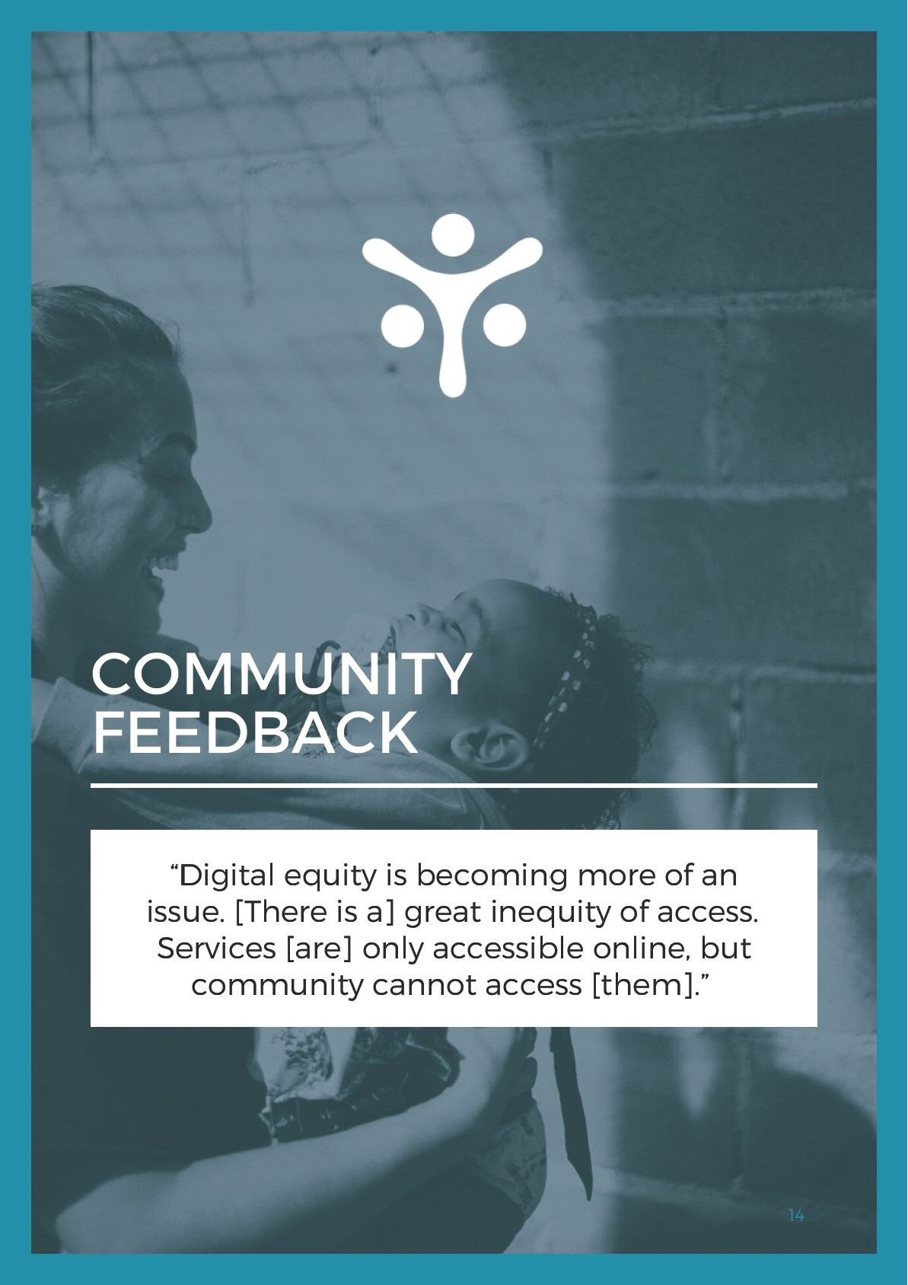

RECOMMENDATION
THREE

WEIGHT EXISTINC LOCAL CREDIBILITY, PRESENCE, KNOWLEDGE, AND
ENCACEMENT WITH COMMUNITY AS A KEY CRITERION IN CRANT AND

TENDER PROCESSES.
Prioritising local presence and community knowledge within grant applications and procurement assessment processes helps ensure that funded providers have the relationships, contextual understanding, and practical experience required to deliver effective, person-centred services within a community. This approach has been adopted by various funding bodies, and assists in adopting a more equitable process for small and medium sized providers, which tend to be the types of organisations embedded in communities.
Providers with established regional knowledge are better equipped to engage with diverse community grou ps, coordinate with local networks, and address structural barriers experienced by children and families with intersecting identities that may contribute to disadvantage and discrimination. This is particularly relevant to areas such as Western Sydney, which has a greater proportion of children and families, people with cultural and linguistic diversity, and people identifying as being Aboriginal and/or Torres Strait Islander (Profile ID, 2021b; Profile ID, 2021c, Profile ID, 2021d).
Embedding local presence and regional knowledge in the tender process therefore promotes the sustainability of service delivery, strengthens service integration, and supports high-quality outcomes across varied community contexts.
When service delivery is nationalised or being delivered by top-down organisations without local credibility and a strong presence in the community, there is a risk that the resulting services are not known or accepted by, accessible to, or appropriately delivered in a way that meets the needs of the children and families living in diverse communities throughout Australia.
Furthermore, anecdotal evidence from stakeholders indicates that organisations may be funded to provide services to a region that they have no direct links to, while situated in a separate geographic location. This then contributes to absenteeism and the underservicing of regions, despite having funding arrangements in place for services to provide support to those communities.
15
One way that the Government could address these issues while ensuring a fair and transparent procurement process, is to allocate a weighting to local presence and regional knowledge. Including criteria in grant applications requiring applicants to demonstrate their existing local credibility, presence, knowledge, and engagement with community is an important aspect of ensuring that services respond to community need and their unique contexts.
In addition to looking favourably at grant applications with strong local partnerships, co-location or integration with other services, and a diverse and active volunteer base, it is essential that local presence and regional knowledge of the community is weighted as a key consideration in grants and tender processes for funding.
Local governance that involves community leaders or people with lived experience is one key component of ensuring that services have local presence, however, Western Sydney Community Forum strongly advocates for the criteria to include having a physical location in the community or geographic area, as well as knowledge from consultation, connection and developing relationships with their community.
Inclusion of this criteria and weighting will build capacity in local communities and enable the Government to capitalise on regional presence and maximise outcomes for children and families within their local communities. Additionally, it supports multiple other domains by building community capacity and supporting the social infrastructure and fabric of communities across Australia.
16

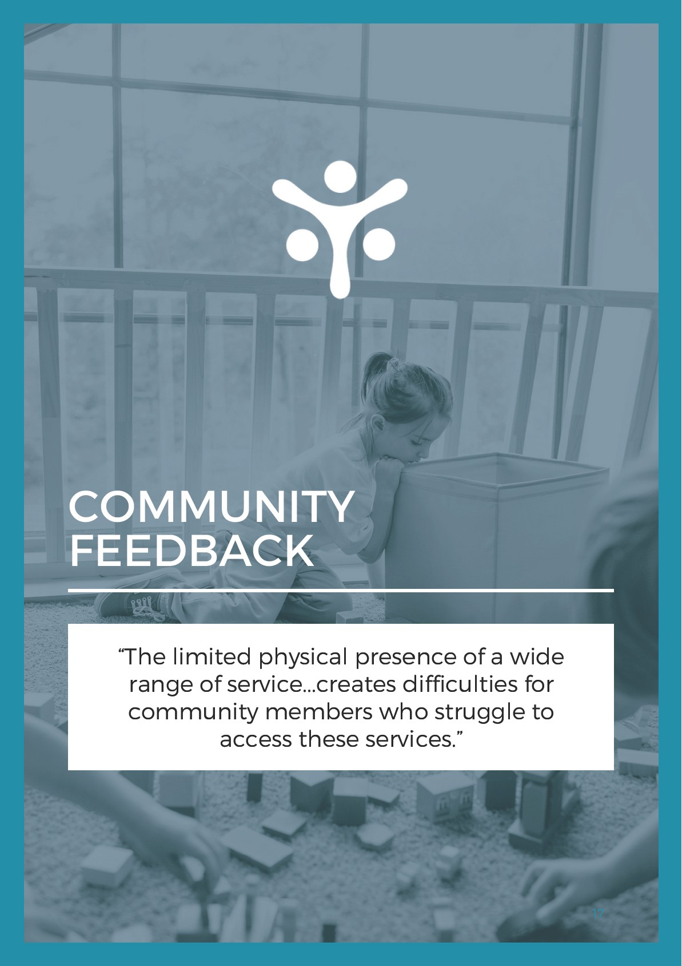

REFERENCES

Alderton, A., Villanueva, K., Davern, M., Reddel, T., Lata, L.N., Moloney, S., Cooder, H., Hewitt, T., DeSilva, A., Coffey, B., McShane, l. & Cigdem-Bayram, M. (2022). What works for place-based approaches in Victoria. Part 1: A review of the literature. [Prepared for the Victorian Department of Jobs, Precincts and Regions].
Australian Digital Inclusion Index. (2025). Total index.
Baxter, S.. Johnson, M., Chambers, D., Sutton, A., Coyder, E. & Booth, A. (2018). The effects of integrated care: A systematic review of UK and international evidence.
Dastyari, A, Itaoui, R., Hawkes, C. Notley, T. 2024. Digital equity and education: A NSW case study. Whitlam Institute and Centre for Western Sydney.
Department of Social Services. (2024). Supporting community change. Australian Government.
Department of Communities and Justice. (2025). Child protection and out-of-home care data: Local government area heat maps. NSW Government.
Department of Social Services. (2025a). A new approach to programs for families and children: Consultation summary. Australian Government.
Department of Social Services. (2025b). DSS grants service providers directory. Australian Government.
Department of Social Services. (2025c). Support for child and parent wellbeing. Australian Government.
Ceatches, L., Preston, C., & Putnis, A. (2023). Where are we? Place-based approaches to tackling community challenges in Australia. [Prepared for the Paul Ramsay Foundation].
Local Community Services Association. (2022). Neighbourhood & community centres in NSW. or LCSA census 2022, summary Report.
Notley, A, & Aziz, A. (2024). The unjust burden of digital inclusion for low-income migrant parents.
Ourplace. (2023). Wrap-around health and wellbeing services.
Profile ID. (2021a). Cumberland City: Internet connection.
Profile ID. (2021b). Western Sydney (LOA): Households with children.
Profile ID. (2021c). Western Sydney (LOA): Language used at home.
Profile ID. (2021d). Western Sydney (LOA): Population and dwellings.
18

Reid, A, Moxham, P., Sankovic, B., & Harris, P. (2025). Exploring best practices for placemaking, infrastructure and service delivery to improve health and social equity: Scoping review summary report. Centre for Health Equity Training, Research & Evaluation (CHETRE).
The Social Deck. (2025a). General supports: Consultation report. [Prepared for the Department of Social Services].
The Social Deck. (2025b). Supports for children under 9: Consultation report. [Prepared for the Department of Social Services].
19
