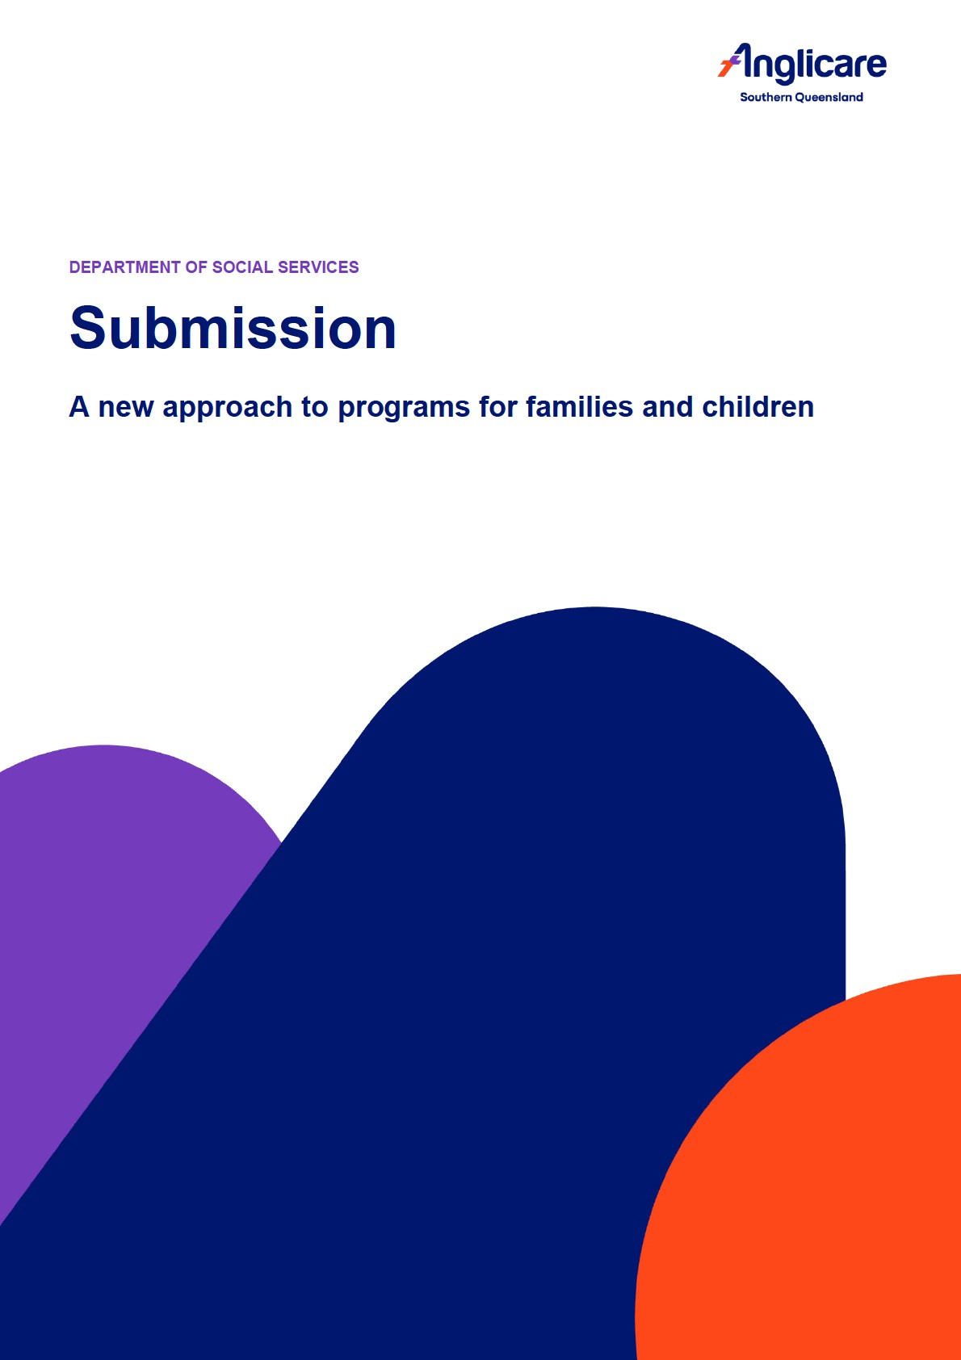

Acknowledgement of Country
Anglicare Southern Queensland acknowledges Aboriginal and Torres Strait Islander peoples as the first Australians and recognises their culture, history, diversity, and deep connection to the land. We acknowledge the Traditional Owners and Custodians of the land on which our service was founded and on which our sites are operating today.
We pay our respects to Aboriginal and Torres Strait Islander Elders both past and present, who have influenced and supported Anglicare Southern Queensland on its journey thus far. We also extend that respect to our
Aboriginal and Torres Strait Islander staff, clients and partners (past, present and future) and we hope we can work together to build a service that values and respects our First Nations people.
We acknowledge the past and present injustices that First Nations people have endured and seek to understand and reconcile these histories as foundational to moving forward together in unity.
Anglicare is committed to being more culturally responsive and inclusive of Aboriginal and Torres Strait Islander people and we are committed to embedding cultural capabilities across all facets of the organisation.

About Anglicare Southern Queensland
Anglicare Southern Queensland (Anglicare) has responded to the needs of our community through more than 150 years of delivering innovative, quality care services.
More than 3,000 Anglicare staff and volunteers operate across southern Queensland and in Townsville. Our comprehensive, integrated range of community services includes community aged care; residential aged care; and community support programs, including youth justice, child safety, disability support, counselling and education, mental health, homelessness, and chronic conditions. Our services are designed to ‘wrap around’ clients in a comprehensive way, recognising their health needs but also addressing the social needs which contribute to wellness.

This submission may be quoted in public documents.
Contact:

Author:

Effective date: 2/12/2025 Page ii 1300 610 610 | anglicaresq.org.au

Contents
Acknowledgement of Country ii
About Anglicare Southern Queensland ii
Introduction 1
Vision and outcomes 1
Program structure 2
Prioritising investment 2
Invest early to improve family wellbeing, break cycles of disadvantage and reduce the need for later interventions, like child protection 2
Prioritise connected, co-located and integrated services that work together to meet family needs 3
Ensure services are informed by and respond to community needs 3
Improve the outcomes for First Nations children and families by increasing the number of Aboriginal and Torres Strait Islander community-controlled organisations (ACCOs) delivering supports in locations with high First Nations populations 4
Measuring outcomes 4
Working together 4
In conclusion 5

Effective date: 2/12/2025 Page iii 1300 610 610 | anglicaresq.org.au

Introduction
Anglicare Southern Queensland (Anglicare) welcomes the opportunity to make a submission to the Department of
Social Services (DSS) consultation for the ‘A New Approach to Programs for Families and Children’ Discussion Paper.
Anglicare provides the following services across multiple regions:
- Family and Relationship Services (FaRS)
- Specialised Family Violence Services (SFVS)
- Family Mental Health Support Services (FMHSS)
- Children and Parenting Support (CAPS)
These programs have enabled us in the 2023-24 financial year to provide 2,431 parents and children with early intervention support and education; 2,353 family law, family, and relationship counselling sessions; and to support 865 adults and young people with alcohol and drug counselling treatment sessions. We also supported 1,097 adults to cease their use of domestic and family violence; and helped 265 victim–survivors and their children to recover from their experiences of family violence through 1,937 sessions of counselling.
Our submission addresses key questions in the DSS Discussion Paper, and draws upon the expertise and experience of senior staff in our Social and Community Services area, which is part of the Children, Youth & Families portfolio.
Overall, Anglicare staff are positive about the opportunities that the new program approach provides to more effectively support children, young people, and families of all shapes and sizes, to achieve a better life. The following discussion, however, highlights important considerations in the further development and implementation of the new approach.

Vision and outcomes
Anglicare supports the intent of the new vision and outcomes.
We have, however, a number of comments for consideration. We suggest that:
- the role of the environment in which children are raised should be called out more explicitly. This acknowledges the influence of more systemic issues such as housing and food insecurity, and the role that DSS programs play in addressing the impacts of these issues on individuals and families.
- the diversity of what constitutes a family in contemporary Australian society is acknowledged more directly. Individuals and households without children, for example, also play a critical role in creating a safe and healthy community for children and young people, and thus early intervention or specialised support for these individuals and groups should also be acknowledged as valuable.

Given the above considerations, we suggest the changes below:

Our
recommendations

•

Families of all kinds are empowered to build home environments that are safe, nurturing and
accepting.

•

Children are supported to grow into healthy, resilient adults.

Program structure
Anglicare currently offers services under two of the proposed new streams in Southern Queensland, and has a strong commitment to the value of both of these program streams for children, young people and families:
- Stream 2: Prevention and early intervention
- Stream 3: Intensive family supports
We support in principle the concept of a single national program. At its best, this structure has the potential to reduce artificial boundaries that can exist between multiple smaller programs, and offer the flexibility for families to be able to move in and out of programs, across streams, as necessary: that is, a ‘no wrong door’ and ‘step-up/stepdown’ approach that is not constrained by inflexible guidelines.
We note, however, that there is currently insufficient detail available to determine whether the proposed structure will be able to address practical challenges, such as monitoring service availability in different areas and/or for different cohorts, in order to deliver the intended outcomes.

Prioritising investment
We provide some considerations regarding each of the Australian Government’s priorities below:

Invest early to improve family wellbeing, break cycles of disadvantage and reduce the need for later interventions, like child protection
Anglicare has a deep commitment to prevention and early intervention, and our staff strongly support a child- and young person-centric approach.
For a very significant number of Australian children and young people, this needs to include explicit recognition of the myriad ways that trauma impacts their lives, including mental and physical health, family and community relationships and wellbeing, and education opportunities. These effects are pervasive enough that the right of children and young people to live trauma-free should be a priority, with easy integration of Streams 2 and 3 that enables personalised service delivery that meets the needs of individual children, young people and families.

Prioritise connected, co-located and integrated services that work together to meet family needs
We strongly support the benefits of program co-location where possible. Anglicare has established our own informal ‘hubs’, and these have proven to be very effective in enabling smooth transitions, flexibility, and costeffective activity across our own programs. They are also an effective structure for enabling strong relationships and collaboration with the local community. Physical visibility is particularly advantageous.
Co-location within or between organisations however may not always be practical, and the key criteria should be evidence of strong working relationships. For example, by working closely with clients, Anglicare staff will identify mental health issues early, and then refer out to other agencies using referral pathways built on local connections and networks.
Evidence of the extent to which services are enmeshed in local communities is important. This may include participation in community-based inter-agency meetings, local events, and active connections with organisations in other sectors, such as business, health, education, and community (such as neighbourhood centres); and across different levels of government, including local government.

Ensure services are informed by and respond to community needs
All services need to be flexible in addressing community needs. Emerging patterns of mental health issues (including gender dysphoria), drug and alcohol use, and the incidence of domestic and family violence, for example, require services to respond appropriately as need develops.
Funding also needs to reflect this agility, with easy integration of funding for Streams 2 and 3, as mentioned above, required to enable human services organisations to proactively address emerging community need.
The use of SEIFA and other data to identify communities most in need of services is a valuable strategy. It is important however that such tools not be used in isolation from consultation and the evidence provided by services on the ground. The nature of funding contracts, combined with organisational footprints, can mean that service gaps arise in unexpected locations. Organisations may also be funded for services in areas where they offer outreach but have no physical presence. This is particularly the case in larger SA2 regions, which cover enormous areas and where services may be quite distant from remote populations. In itself, this does not mean that service providers are disconnected from local need, but does suggest that active engagement in regional networks etc with other service providers assumes an even greater importance.
In terms of addressing community need for Culturally and Linguistically Diverse (CALD) individuals and families, Anglicare staff note that the Departmental definition used for CALD populations can impose limitations on data collection relevant to this group. The English-speaking children of CALD migrants, sometimes described in scholarly literature as ‘Generation 1.5’, are not captured as CALD in the Department’s definition. Anglicare currently provides two sets of reporting data to the Department to better represent our practice, given the heightened cultural and linguistic needs of this group. We recommend that the existing definition be reviewed to better capture the extent of the often complex service needs of ‘Generation 1.5’.

Improve the outcomes for First Nations children and families by increasing the number of Aboriginal and Torres Strait Islander community-controlled organisations (ACCOs) delivering supports in locations with high First Nations populations
Anglicare is fully supportive of this priority and has strong relationships with a number of ACCOs in Southern Queensland.
We believe that the priority should be framed however in terms of empowering and properly resourcing ACCOs to deliver the best outcomes for First Nations children and families, rather than focusing strictly on increased numbers of ACCOs. This includes assisting organisations to build strong local connections between ACCOs and mainstream organisations.
We also note the importance of client choice. In certain locations, some Aboriginal and Torres Strait Islander clients prefer to establish or maintain a relationship with Anglicare’s Identified staff, rather than seek services from a local ACCO. This can be due to existing strong relationships with Anglicare, and/or local community or family sensitivities attached to the ACCO.
While reiterating our support, therefore, for the increased resourcing and numbers of ACCOs and the importance of empowering ACCOs to serve their local communities, we also advocate for the primacy of individual client choice.

Measuring outcomes
We consider the following points are important inclusions for the new program in terms of measuring outcomes:
- We support transparency and simple channels for data sharing across service providers to support collective learning.
- Anglicare sets our own targets for particular cohorts based on our knowledge of local need. We find this strategy a helpful and practical way to ensure that we are maintaining a proper focus on specific groups.
Anglicare’s current data collection processes demonstrate the number of Aboriginal and Torres Strait Islander families we support, for example, in relation to the target set for this group.
- Funding should recognise and include provision for the staff time needed to meet reporting obligations. Qualitative reporting, while very valuable, is particularly time-intensive and can raise ethical issues. Anglicare has been submitting case studies with our Activity Workplan Reports since these were introduced to demonstrate our practice and outcomes. If these were to be introduced more broadly, case study templates and associated guidelines would ensure consistency of qualitative reporting across all providers, and make clear Departmental expectations in this area.
- Importantly, timely, ongoing evaluation of the new program approach from its earliest implementation is essential to determine whether it is achieving the desired outcomes.

Working together
Anglicare requires further information about the nature of the relational contracting arrangement envisaged by the Department as a basis for decision-making on this issue.
More generally, we wish to make the following points about working collaboratively and effectively:
- Government investment in relationship building is key. This involves both investment in Departmental staff who have a mandate to build and sustain strong relationships with service providers; and in the focused attention required to establish and maintain clear, transparent communication channels between the Department and the sector.
- Collaboration is more effective in an environment where organisations are not afraid to ‘fail forward’ — that is, to broach new ideas and try new initiatives without fear of Departmental sanctions if they do not succeed. This also builds a culture of continuous improvement within organisations and across the sector.
- Service providers that can demonstrate a track record of working collaboratively with other organisations already have proven ability to work in partnership.

In conclusion
As noted in the introduction to this submission, Anglicare broadly supports the new, more integrated approach to supporting children and families, with consideration of the issues raised above.
We look forward to the release of additional detail and the opportunity to provide further input to the program as the new approach is firmed up.

Williamson, F. (2012). Generation 1.5: the LBOTE blindspot. Journal of Academic Language and Learning, 6(2), A1A13.

