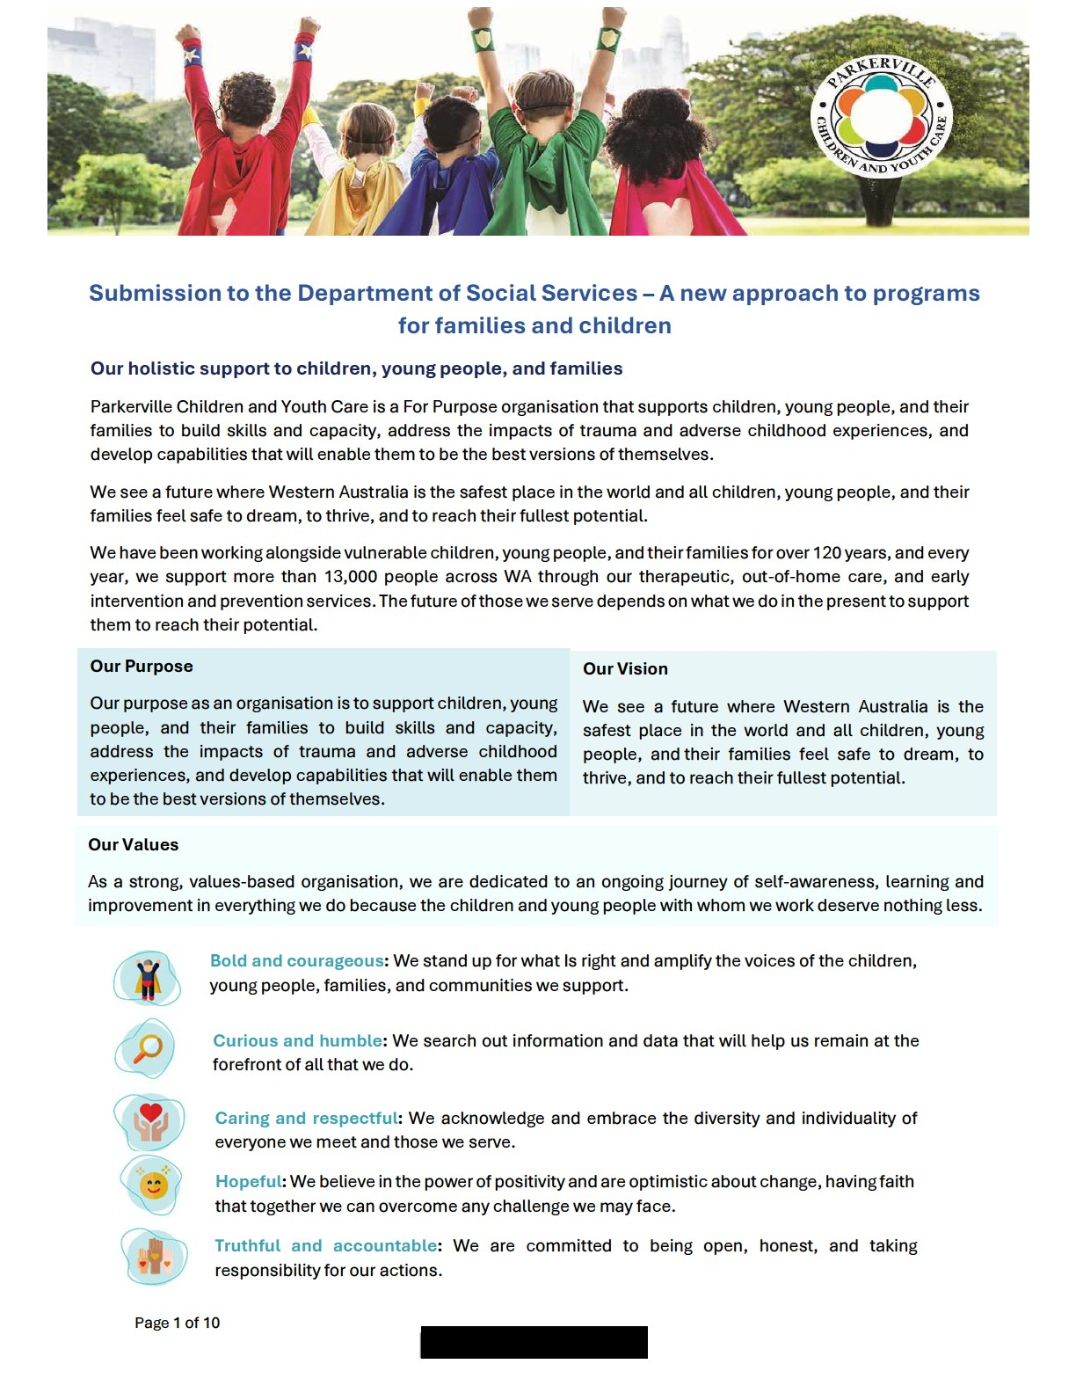

Parkerville CYC’s services
Therapeutic Services

- Multi-agency Investigation and Support Team (MIST): co-located, multi-disciplinary, trauma-informed model to reduce harmful impacts of trauma from abuse. It is WA’s first truly integrated child sexual abuse (CSA) response, with Child Advocacy Centres in Armadale (2011), Midland (2019), and Rockingham (2024). MIST’s core principle is to reduce instances of children having to tell and re-tell their story, and coordinate services (including Police) to wrap around the child and family, through collaboration and knowledge-sharing.
CSATS: We provide a Child Sexual Abuse Therapeutic Service (CSATS) in a regional area of WA.
PACTS: We also provide a Parents and Children’s Therapeutic Service (PACTS) in a northern Perth suburb. 84% of children and young people receiving a service had experienced child sexual abuse.
Out of Home Care
- Parkerville CYC have had children in our care for the entirety of our 122-year history. We are implementing an innovative, award-winning new model, Our Way Home:
radically personalised shared care, that focuses on the needs and desires of each child, and deliberately seeking to establish, maintain and deepen connections between children and their families. We care for children through a mixed provision across family group homes, foster care, and temporary care homes.
Early Intervention, Prevention and Youth Services
- Child and Parent Centres (CPCs): Parkerville runs two CPCs in Perth, servicing 12 primary schools in vulnerable communities. CPCs work to create an entry point into the school system and help with school readiness, but importantly they focus on increasing family capacity and help them provide appropriate developmental experiences.
- Kids’ Hub: multi-disciplinary approach to providing comprehensive mental health/wellbeing services for children aged 0-12 years, targeting mild to moderate emerging complexity. This service is a collaboration with Koya Aboriginal Corporation, Pregnancy to Parenthood, Lifespan Psychology Services, and MIFWA.
- Family Support Network: early intervention program that connects families with coordinated services to strengthen child safety and prevent entry into out-of-home care.
- Intensive Family Support Service: in partnership with Koya Aboriginal Corporation, this service will provide practical, in-home support to families who are engaged with the Department of Communities (Child Protection), where children are either at significant risk of entering out-of-home care or are working towards reunification with their families.
- Education Employment and Training Program (EET): For young people at extreme educational risk due to trauma, mental health, family issues.
- Support and Community Services (SACS): For families with children aged 4-14 that are experiencing homelessness, or at risk of homelessness and living in supported accommodation.
- Moving Out, Moving On (MOMO): service for young people aged 15-21 who are experiencing homelessness, or at significant risk of homelessness or transience.
- Reconnect: a diversion and early intervention service for families with young people (12-18) at risk of homelessness or family breakdown.
- Young Women’s Program: medium-term accommodation and support for young women (including those with children) aged 16-25 experiencing or at risk of homelessness, or who need help to live independently.
- Ruby’s Reunification Program: seeks to prevent youth homelessness through part-time accommodation, whilst engaging and supporting the family with counselling and practical support. It aims to foster hope for staying together or reunification, and keep young people out of the youth (and ultimately adult) homelessness sector.

Page 2 of 10 Parkerville Children and Youth Care

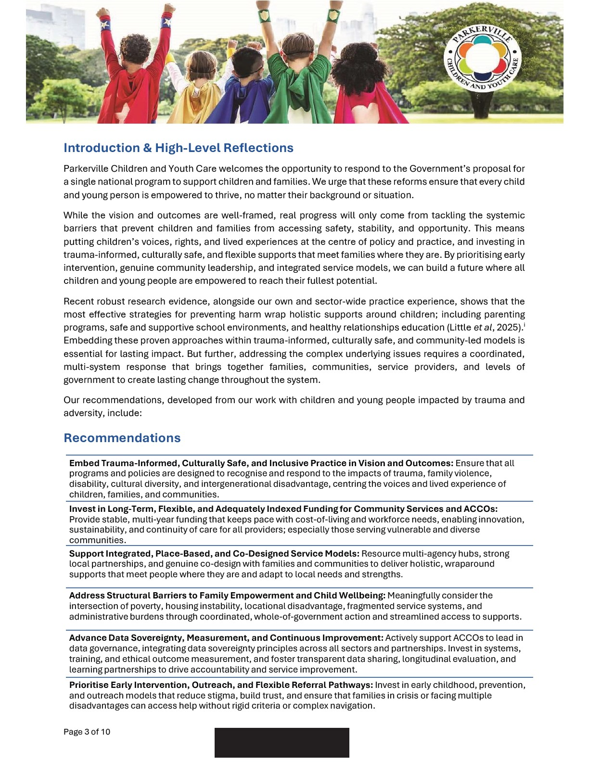

Vision and Outcomes
Does the new vision reflect what we all want for children and families?
The vision that “All children and young people are supported by strong families who have the skills and confidence to nurture them” is strongly aligned with Parkerville CYC’s purpose and values, which emphasise holistic, trauma-informed support and capacity-building for children, young people, and families. The vision is also consistent with sector recommendations for empowering families and supporting children to thrive.
However, for this vision to be truly realised, it must be grounded in a recognition of the structural and systemic barriers that many families face. Factors such as poverty, housing instability, family violence, and service system complexity can undermine even the most committed parents’ ability to nurture and support their children. Achieving this vision will require sustained investment in trauma-informed, flexible, and accessible supports that meet families where they are and address the root causes of disadvantage, as well as clear alignment and integration with broader government strategies and initiatives; in recognition that this is a multi-system challenge demanding a coordinated, multi-system response.
Reflections on the two main outcomes
The two outcomes - empowering parents and caregivers to raise healthy, resilient children, and supporting children to grow into healthy, resilient adults - are a strong baseline and reflect what we should aspire to for all families. However, achieving these outcomes requires a deeper understanding of the structural and systemic barriers that prevent many parents from being truly ‘empowered’. Several key barriers and considerations emerge:
- Poverty, Housing Instability, and Homelessness
  - Lack of safe, stable housing is a fundamental barrier to parental empowerment. Families experiencing homelessness or housing insecurity face constant instability, which undermines their ability to provide nurturing environments and access essential services. Trauma, poverty, family and domestic violence (FDV), and child abuse are both causes and consequences of homelessness. Parents in these circumstances are often forced to focus on immediate survival, leaving little capacity to engage with services or support their children’s development.
  - Systemic failures in housing allocation, such as rigid eligibility criteria, long waitlists, and zoning restrictions, mean families may be unable to access safe housing when fleeing violence or facing crisis. This perpetuates instability and trauma, making empowerment unattainable for many.
- Service System Complexity and Inflexibility
  - Fragmented and siloed services create barriers for families navigating support systems. Parkerville’s experience shows that families in crisis often cannot meet rigid appointment criteria or navigate complex referral pathways, especially when dealing with trauma, transience, or multiple disadvantages.
  - Waitlists and under-resourcing in child development, mental health, and allied health services mean that early intervention opportunities are frequently missed. Parents may be unable to access assessments or therapies for their children, particularly in regional and remote areas, further entrenching disadvantage.
- Social Isolation and Lack of Community Connection
- Social isolation, especially among culturally and linguistically diverse (CALD) families, Aboriginal families, and those experiencing homelessness, limits parents’ ability to build supportive networks and access help. Parkerville’s services often act as the only trusted point of contact for families who distrust government or mainstream services.
- Service criteria and program design can inadvertently disconnect families from culture, community, and extended support networks.
4. Intergenerational Trauma and Family Violence
- FDV is a leading cause of homelessness and family breakdown; with profound impacts on children’s development and parents’ ability to provide safe, nurturing environments. Many parents fear disclosing violence due to concerns about child removal, housing insecurity, or community reprisals.
- Intergenerational trauma, including the impacts of child abuse, neglect, and systemic disadvantage, can undermine parental confidence and capacity, making empowerment a distant goal without trauma-informed, wraparound support.
- Barriers to Early Intervention and Education
  - Access to early childhood education and intervention is not universal. Children in out-of-home care, those affected by homelessness, and those with developmental delays often face significant barriers to participation in early learning, which is critical for long-term outcomes.
  - Locational disadvantage, with core services concentrated in metropolitan areas, means that families in regional and remote communities are less able to access supports, further entrenching inequity.
- Systemic Underfunding and Workforce Challenges
  - Short-term funding cycles, inadequate indexation, and insecure contracts in the not-for-profit sector undermine service stability and workforce retention. This impacts the quality and continuity of support available to families, and limits the sector’s ability to innovate and respond flexibly to community needs.
  - Administrative burdens and lack of recognition for outcomes measurement mean that organisations bear the cost of demonstrating impact, diverting resources from direct service delivery.

Program Structure
Will a single national program provide more flexibility for your organisation?
A single national program has the potential to offer greater flexibility, especially if it allows organisations to deliver services across multiple streams under one agreement. However, true flexibility depends on how the program addresses entrenched barriers such as short-term funding cycles, administrative burdens, and the need for trauma-informed, place-based models. Without tackling these systemic challenges, including locational disadvantage, workforce instability, and siloed service delivery, the promise of flexibility may be limited in practice for organisations working with highly vulnerable families.
Do the three funding streams reflect what children and families in your community need now - and in the future?
The streams (national programs, prevention/early intervention, intensive supports) broadly reflect the spectrum of needs Parkerville CYC encounters. Yet, the effectiveness of these streams will depend on their capacity to adapt to complex, intersecting needs such as homelessness, FDV, disability, and cultural diversity. To meaningfully meet current and future needs, the streams must be resourced to support integrated, wraparound approaches and allow for innovation and co-design with communities, especially those facing multiple disadvantages.
Are there other changes we could make to help overcome current challenges?
To overcome persistent challenges, the program should prioritise:
- Streamlining and integrating service systems to reduce complexity for families in crisis.
- Investing in long-term, stable funding and workforce development.
- Embedding trauma-informed, culturally safe, and flexible service models.
- Addressing locational disadvantage and ensuring equitable access to supports in regional/remote areas.
- Supporting genuine co-design and partnership with families and communities, including those with lived experience.

Prioritising Investment
Do you agree that the four priorities listed are the right areas for investment?
Yes, the four priorities - early investment, integrated services, community responsiveness, and improving outcomes for First Nations children - are essential foundations. However, without targeted funding for trauma-informed, culturally safe, and flexible service models, and without resourcing the not-for-profit sector for long-term stability and innovation, these priorities risk being aspirational rather than transformative.
Are there other priorities or issues the department should focus on?
Additional priorities should include:
- Tackling the unmet needs for families who fall between service eligibility criteria.
- Supporting children and families affected by disability, neurodiversity, and mental health challenges.
- Investing in workforce development and sustainable funding for community organisations.
- Embedding genuine co-design with families and communities, including those with lived experience and especially with children and young people themselves, to ensure that investment is responsive and effective.

Improving Family Wellbeing
Do the proposed focus areas match the needs or priorities of your service?
Yes, these focus areas are highly relevant and reflect the needs Parkerville CYC encounters daily. However, improving family wellbeing requires more than targeted support for specific groups; it demands a holistic, trauma-informed approach that addresses the underlying drivers of disadvantage. Many families face intersecting challenges that cannot be resolved by single interventions or siloed programs. Flexible, wraparound supports and place-based models are essential to reach those who are most vulnerable and to build lasting wellbeing.
Are there other groups or approaches to better support family wellbeing?
The department should also consider:
- Approaches that build community connection, reduce stigma, and empower families through co-design and genuine partnership.
- Investment in early intervention, integrated service hubs, and outreach models that meet families where they are and respond to their unique circumstances.

Connected, Co-located, and Integrated Services
Other effective ways to connect and coordinate services for families?
Beyond co-location, Parkerville’s practice demonstrates that genuine service integration requires deep cross-agency partnership, shared governance, and a relentless focus on the needs of children and families.
Our Multi-agency Investigation and Support Team (MIST) is a strong example of moving beyond simple colocation to true cross-agency collaboration. MIST brings together the WA Police and Parkerville therapeutic services in a single, trauma-informed model to support children and young people impacted by child sexual abuse. MIST is defined by agencies working together to share information, coordinate responses, and wrap support around the child and family. This reduces the need for children to retell their story, minimises trauma, and ensures that families receive holistic, timely support from all relevant services at the point of sexual abuse disclosure and onwards.
Similarly, our Child and Parent Centres (CPCs) exemplify integrated, holistic service delivery. CPCs co-locate allied agencies like child health nurses, OTs and speech therapists within school communities. This creates a welcoming entry point for families, making it easier to access a range of supports in one place. The CPC model is built on strong local partnerships and a shared commitment to building family capacity, improving school readiness, and addressing emerging needs early.
In both models, success relies on shared goals, open communication, and a willingness to adapt services to the unique needs of each family. Flexible outreach, integrated referral pathways, and ongoing co-design with families and communities are also critical. Fostering trust and collaboration across agencies ensures that families receive coordinated, wraparound support that is responsive, accessible, and effective.
What should applicants be assessed on?
To demonstrate genuine community connection, applicants should show:
- Evidence of co-design and ongoing consultation with families and community members.
- Culturally safe, inclusive, and trauma-informed approaches.
- Strong local partnerships and integrated service delivery.
- Responsiveness to local demographics, needs, and barriers; such as poverty, social isolation, and locational disadvantage.
- A proven track record of building trust and empowering families, especially those facing multiple disadvantages.
Assessment should prioritise the ability to deliver flexible, integrated supports that are shaped by and accountable to the communities that they serve.

Responding to Community Need
Beyond locational disadvantage, what other factors should be considered?
While locational disadvantage is a significant barrier, funding must also account for intersecting factors such as poverty, social isolation, cultural and linguistic diversity, disability, and the impacts of trauma and family violence. Parkerville’s experience shows that families facing multiple disadvantages often struggle to access support due to complex eligibility criteria, stigma, and lack of culturally safe services. Funding models should be flexible and responsive, prioritising communities with high levels of unmet need and supporting integrated, place-based approaches that can adapt to local circumstances.
Best way to show genuine community engagement in grant applications?
In our experience, demonstrating genuine community engagement in our grant applications means showing how we listen to, partner with, and are guided by the voices of children, families, and communities. We therefore advocate for:
- Ongoing co-design and consultation with families and community, including those with lived experience.
- Use of local data and evidence to identify and respond to emerging needs.
- Culturally safe, trauma-informed, and inclusive practices.
- Partnerships with local organisations and service providers to deliver holistic, wraparound support.
- Evidence of adapting services to address barriers such as poverty, social isolation, and systemic disadvantage.
Grant applications should highlight how services are shaped by and accountable to the communities that they serve, and how they build trust, capacity, and connection for those most at risk.

Improving Outcomes for Aboriginal and Torres Strait Islander Children and Families
To improve outcomes for Aboriginal and Torres Strait Islander children and families, government must move beyond simply increasing numbers of organisations, and instead focus on genuinely resourcing ACCOs with long-term, flexible funding, capacity-building, and leadership pathways. Program design should embed cultural safety, trauma-informed practice, and community-led governance, while addressing systemic barriers such as locational disadvantage, poverty, and intergenerational trauma.
Government must actively support and honour Aboriginal data sovereignty, ensuring that ACCOs have ownership, control, and stewardship over their data. This means integrating data sovereignty principles across all sectors and partnerships, so that non-ACCO organisations build understanding and capacity to uphold these principles collaboratively. Investment in systems, training, and policy frameworks should enable ACCOs to lead in data governance, with all partners respecting cultural protocols, privacy, and community-led decision-making.

Measuring Outcomes
What types of data would help your organisation understand impact and improve services?
Robust, real-time data on family needs, service uptake, and outcomes is essential for understanding impact and driving continuous improvement. Longitudinal data is particularly valuable for tracking the effects of early intervention and trauma-informed support over time. However, collecting and analysing quality data requires significant investment in systems, staff training, and collaborative partnerships with government and research institutions. Data sharing between providers and funders is also critical to build a comprehensive picture of outcomes and inform responsive service design.
What kinds of data/information are most valuable to share?
The data that matters most is the data that shows our real impact. Quantitative outcome data like improvements in safety, wellbeing, and resilience make our progress and accountability clear. But numbers alone cannot capture the full story, or represent what is meaningful for the people we serve. Qualitative data like de-identified case studies and direct feedback from children, young people, and families reveals the complex realities that they face: the intersections of challenge, the barriers created by systems, and the ways in which people demonstrate agency and resilience despite these obstacles.
Qualitative insights are an opportunity to highlight the nuances of how families experience adversity, navigate services, and define outcomes that matter to them in a way that quantitative measures often miss. By centring these voices and experiences, we ensure that our work is responsive and relevant to those that we support.
Collecting and sharing these stories must be done ethically and in a trauma-informed manner, with strict attention to privacy, consent, and the resources needed to do this work properly. Combining robust quantitative outcomes with rich qualitative insights enables us to demonstrate impact in a way that can build trust, and support continuous improvement across the sector, always keeping families’ priorities at the centre.
What SCORE Circumstances domain is most relevant?
Domains related to safety, wellbeing, resilience, and social connection are most relevant for Parkerville’s services, reflecting the holistic and trauma-informed nature of the support provided.
What templates/guidance would help prepare strong case studies?
As organisations build capacity to capture and share meaningful qualitative data, access to clear, ethical guidelines and practical templates for case study development is of significant benefit. These resources would help staff to apply trauma-informed approaches and uphold privacy protections when documenting the complex realities, agency, and resilience of children, young people, and families.
Including real examples of families’ experiences brings powerful insight, but it must be done with great care. Ethical considerations such as informed consent, safeguarding privacy, and respecting the dignity and wishes of those whose stories are shared are paramount. Broad guidelines can support organisations to navigate these responsibilities, ensuring that case studies centre outcomes valued by those we serve without compromising their wellbeing or trust.

Working Together
Responses to Relational Contracting Questions
We would see relational contracting as really about building genuine, trust-based partnerships between government and service providers; working together toward shared goals and long-term outcomes, instead of primarily compliance driven. What can help this approach to work is maintaining flexible, communicating openly, and being willing to collaborate and try new ideas along the way.
Organisations should be selected based on their expertise in trauma-informed, culturally safe, and integrated service delivery; strong local partnerships; and a proven ability to deliver positive outcomes for children and families. Valuing continuous improvement and responsiveness ensures that services remain relevant and effective.
Parkerville CYC supports relational contracting that enables flexibility, innovation, and respectful relationships with government. This approach allows us to focus on what works, adapt to emerging needs, and invest in ongoing improvement.

Other
Is there anything else the department should understand or consider?
Sustainable change requires long-term investment in trauma-informed, culturally safe, and flexible service models, as well as stable funding and workforce development for the not-for-profit sector. Policy and program design should embed genuine co-design with families and communities, prioritise early intervention, and ensure equitable access for those facing locational or systemic disadvantage. Transparent communication, continuous improvement, and a commitment to learning from lived experience are essential for building a system that truly empowers families and supports children to thrive.
Concluding Remarks
Parkerville Children and Youth Care welcomes the opportunity to contribute to this important consultation and affirms the collective responsibility to ensure that every child and young person is safe, supported, and able to flourish. The reforms outlined present a significant opportunity to move beyond aspiration and embed real, systemic change that is grounded in the lived experience of children, families, and communities. We urge government to act boldly: to invest in trauma-informed, culturally safe, and community-led approaches; to address the root causes of disadvantage; and to honour the voices and rights of children and young people in every aspect of policy and practice.
Parkerville looks forward to ongoing collaboration to realise this vision and strengthen the systems that support the wellbeing and potential of all children, young people, and families.

Chief Executive Officer
December 2025

Contact details
For further enquiries on this submission, please contact:

^{i} Little, M.T., et al (2025). “Interventions to prevent, reduce, and respond to violence against children and adolescents: a systematic review of systematic reviews to update the INSPIRE Framework,” The Lancet Child & Adolescent Health

