


A new approach to programs for families and children
One-page summary of the consultation outcomes
|DSS.gov.au
A new approach to programs for families and children
Consultation outcomes at a glance

Consultation was undertaken on DSS Engage between 3 November and 8 December 2025.
Who we heard from across Australia:
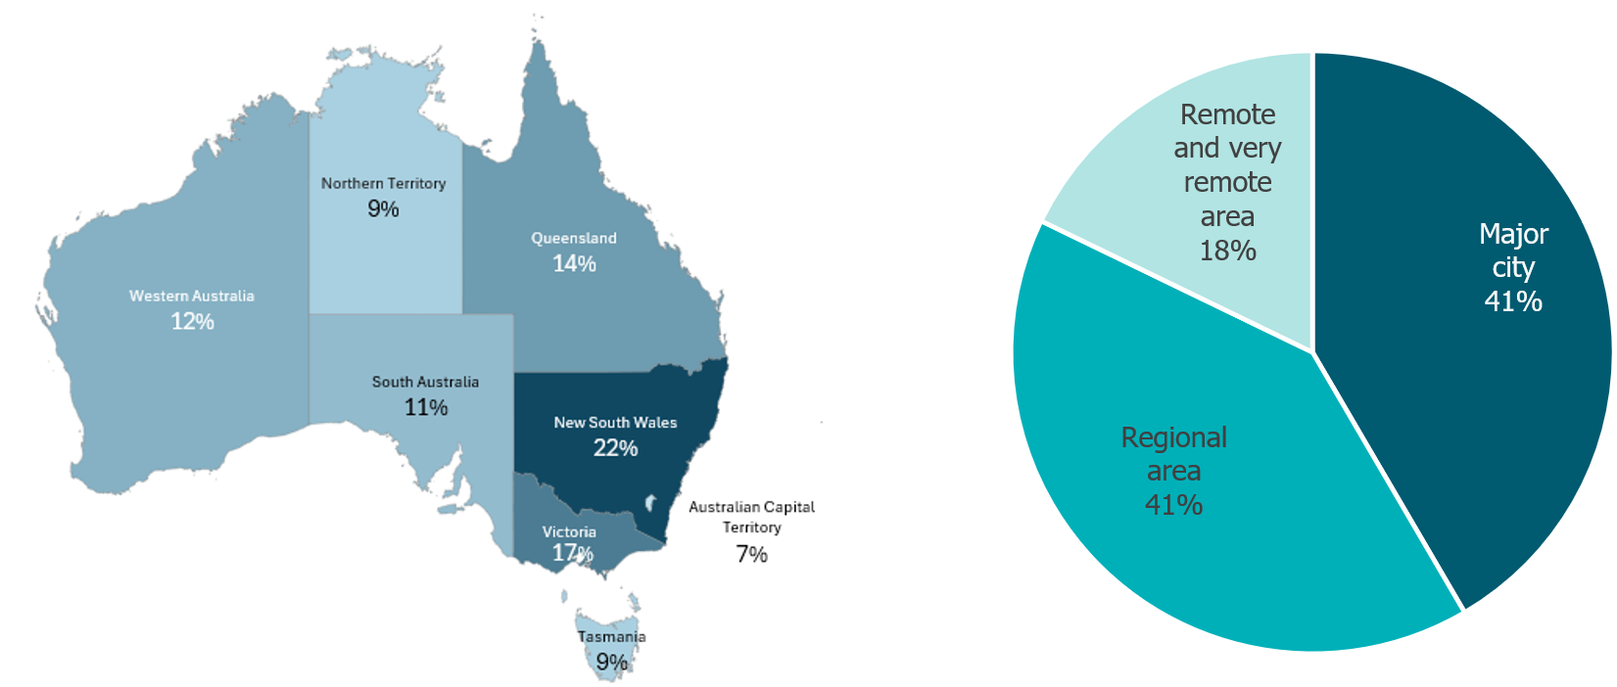
Overall, feedback from more than 1,000 respondents highlighted:
- Strong support for a single national program to improve child and family wellbeing.
- Agreement on the importance of outcomes-focused, evidence-informed, preventative and early intervention approaches.
- A clear priority to strengthen services for Aboriginal and Torres Strait Islander children and families.
- Calls for adequate and sustainable workforce funding.
- The need to align the program with broader government priorities, including family, domestic and sexual violence.
- The importance of cultural safety and data sovereignty in all data collection.
- Support for transitioning to relational contracting.

67% of survey respondents believed the new program will deliver better outcomes for families and children.

92% of survey respondents agreed focus on capturing qualitative data and information to show the real impact of services on children and families will make reporting easier and more efficient.

DSS3616

