


A new approach to programs for families and children
Consultation Report
|DSS.gov.au

Consultation Overview
On 23 October 2025, the Minister for Social Services, the Hon Tanya Plibersek MP, announced the start of public consultation on reforms to 5 Families and Children (FaC) Activity programs.
The consultation sought feedback on a proposal to create a new national program to support children and families, replacing the following 5 Australian Government programs:
- Children and Parenting Support (CaPS)
- Communities for Children Facilitating Partners (CfC FP)
- Family Mental Health Support Services (FMHSS)
- Family and Relationship Services (FaRS)
- Specialised Family Violence Services (SFVS)
Further detail on the proposed reforms is available on DSS Engage.
The Department of Social Services (the department) undertook consultation from 3 November 2025 to 8 December 2025. During this period:
- 241 submissions to the Discussion Paper were received online or via email (where consent to publish was provided, these are published on A new approach to programs for families and children submissions – engage.dss.gov.au).
- 144 people responded to the Pulse Survey.
- 772 people attended online or in-person consultation activities, including:
  - 1 online webinar
  - 5 online townhalls (2 general, 2 for First Nations providers, and 1 for regional and remote providers)
  - 8 public townhalls hosted by the department, held across all states and territories
  - 3 roundtables hosted by Minister Plibersek
  - 2 focused topic meetings hosted by the department.
This report summarises the outcomes of the consultation, including key feedback on the Discussion Paper.

Consultation Activity
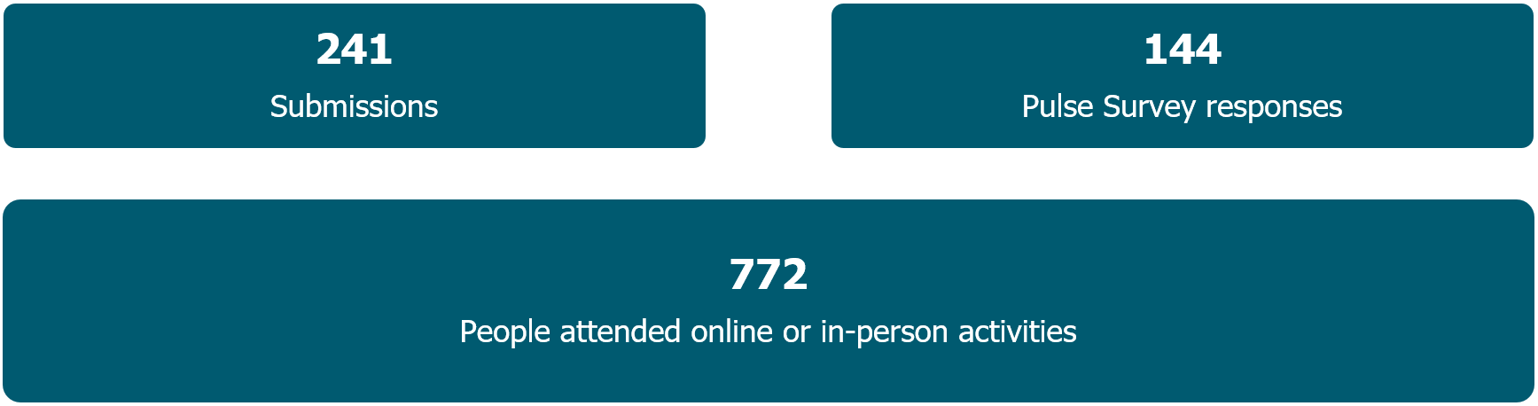
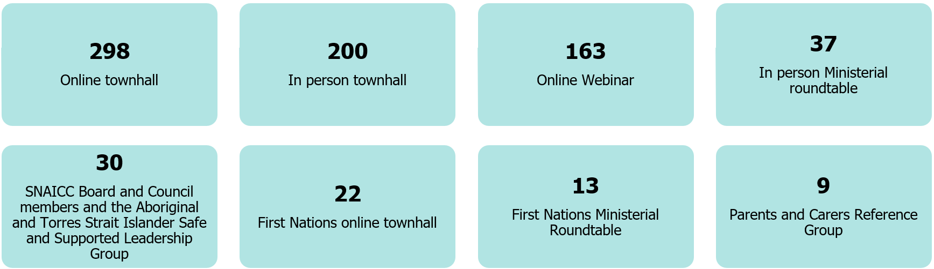
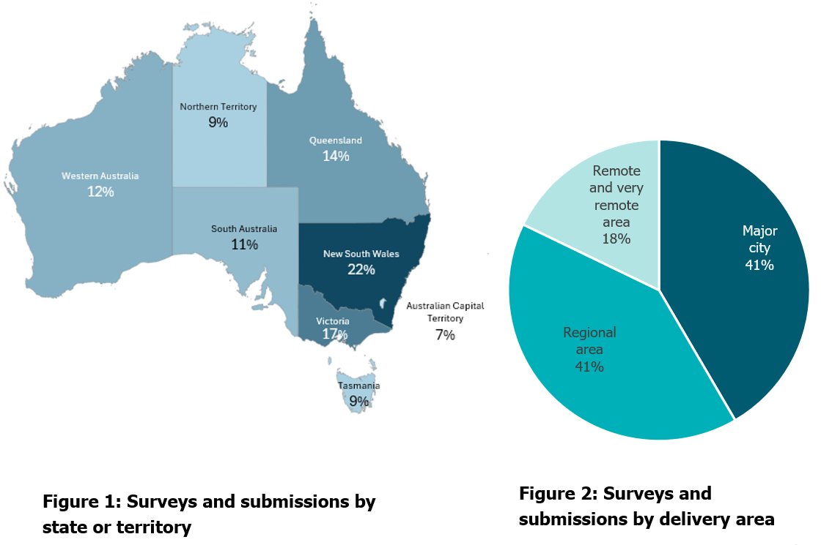

Executive Summary
In the consultation on a new approach to programs for families and children, respondents generally agreed that:
- the overall vision and intended outcomes are appropriate
- a focus on outcomes, evidence-informed practice, prevention and early intervention is worthwhile and welcome
- strengthening services for Aboriginal and Torres Strait Islander children and families must be a top priority
- priority focus groups in a new national program should remain broad
- collaboration and integrated service delivery by organisations needs to be resourced
- funding should be flexible to improve efficiency and respond to local needs
- grant administration and reporting should be simpler.
Respondents also said:
- Some terminology in the vision and outcomes could be clearer, more targeted, and measurable.
- Investment priorities should recognise additional cohorts, other key intervention points, and different approaches to integration.
- Co-location is not essential for integrated service delivery and is not always feasible or appropriate.
- Multiple approaches are needed to strengthen the role of Aboriginal Community-Controlled Organisations (ACCOs), including investment in co-design and shared decision-making.
- Investment is required to build and sustain a workforce capable of delivering evidence-informed services.
- It was important to recognise that service delivery costs are higher for rural, regional and remote communities.
- The reform process should avoid disadvantaging small or specialist service providers.
- Achieving the reform’s goals will require changes to how the department works with providers, and respondents indicated support for relational contracting.

Key Findings

Vision and Outcomes
The proposed vision and outcomes consulted on were:
- Vision: All children and young people are supported by strong families who have the skills and confidence to nurture them
- Outcome 1: Parents and caregivers are empowered to raise healthy, resilient children
- Outcome 2: Children are supported to grow into healthy, resilient adults.
Respondents broadly supported an evidence-informed shift from 5 programs to a single national program for families and children. The intent behind the proposed vision and outcomes was well supported, with strong agreement that families need access to a wide range of high-quality services.
Many respondents suggested refining some of the terminology to make the vision and outcomes clearer, more targeted, and measurable. The most consistent feedback emphasised the importance of a holistic approach, including the need to:
- Include reference to ‘community’ to reflect the broader networks that support families.
- Adopt a broad definition of family that recognises non-parent caregivers.
- Focus on overall wellbeing, not just physical health.
- Acknowledge the importance of cultural connection as a protective factor essential to identity and wellbeing.
“Using a frame of ‘what surrounds us, shapes us’ and emphasising that strong and supportive communities benefit us all helps to situate children in the context of not only the people, but the places and systems that influence their ability to thrive.” – Peak body (national)
Respondents told us that families and children need different kinds of support at different stages of their life. This includes ensuring appropriate support is available for those who have experienced trauma, or family, domestic and sexual violence.
“[DSS should] support all families, with additional, targeted support where needed. The focus on early parenting is important but should not limit support for families of all ages and at all stages. … It is essential to retain focus on the effects of family and domestic violence for individuals and families, including young adults using or experiencing violence, who would benefit from early intervention and support.” – Service provider (VIC)
Several respondents expressed concerns about using terms like ‘healthy’, ‘empowered’, or ‘resilient’ in the program’s outcomes, noting these concepts can be difficult to measure or influenced by factors outside the scope of current FaC programs. Respondents also suggested adding sub-outcomes to support clearer measurement and reporting.

Program Structure
Respondents strongly welcomed the focus on flexible, responsive grant funding that allows organisations to meet the needs of individual clients as well as the broader needs of their community.
“Genuine flexibility must be embedded, giving organisations greater scope in how they use funding (including surpluses) each financial year to respond to emerging community needs.” – Peak body (NSW)
Feedback on the three-stream approach to grant assessment was mixed. Many respondents saw value in having a single grant agreement that allows flexible service delivery across activity types. Others were concerned about applying for funding under a single stream while delivering services that cut across multiple streams.
Some respondents also raised concerns about the name of Stream 1 (National Programs and Information Services), noting it may give the impression that small or specialist organisations would be less competitive under the new program.
“…it may create the situation where smaller organisations like ACCOs and refugee-led organisations are simply “crowded-out” or compelled to minor agency roles in joint partnerships. Other specialist service providers that work with a specific priority population will likely be affected in a similar way.” – Service provider (NSW)

Prioritising Investment
The Discussion Paper sought feedback on 4 investment priorities for programs for families and children:
- Invest early to improve family wellbeing.
- Prioritise connected, co-located, and integrated services.
- Ensure services are informed by, and respond to, community need.
- Improve outcomes for Aboriginal and Torres Strait Islander children and families.
There was strong support for all 4 priorities, with respondents noting they align well with evidence on what works for families and children.
Respondents were particularly supportive of investing early to improve family wellbeing. They emphasised giving equal priority to prevention and early intervention, and many recommended explicitly recognising the needs of adolescents and school-aged children.
“…services for young people differ significantly from those designed for children, and as such, they must be recognised as a distinct cohort with unique needs and priorities.” – Peak body (multiple states)
Respondents strongly agreed that connected and integrated services are important, but most noted that collaboration does not require service providers to be physically co-located.
“Integration cannot be achieved through co-location alone. It requires trust, warm handovers, joint planning, and shared intent. Relationship-building is often invisible in budgets but indispensable for success” – Current service provider (national)
The Discussion Paper outlined that the new program will encourage service providers to work together to meet community need. Many submissions noted that genuine integration takes time and resourcing, and that providers need flexibility to use funding for non-client facing activities that support coordination and integrated service delivery.
“These conditions, also referred to as the ‘glue’, include people, systems and structures that hold services together with a shared purpose to reduce complexity for families and improve outcomes for children.” – Research organisation (national)
Respondents said that strong outcomes can be achieved when service providers are supported to deliver programs across multiple settings, including schools, community hubs and Primary Health Networks. Many also highlighted that online communities are an important setting and stressed the need for digital or hybrid service options to support after-hours access.
“For some members of the community, ‘virtual is a place’ – and a safe space.” – Peak body (national)
Across the consultation, respondents recognised that the proposed reforms offer an important opportunity to strengthen outcomes for First Nations families and children. Respondents, particularly ACCOs and First Nations organisations, advocated for a range of approaches to increase the number of services delivered by ACCOs.
“ACCOs should be made the preferred providers for all children and family services delivered to Aboriginal children and families under FaC” – Peak body (national, ACCO)
Respondents suggested this could include providing a quota or dedicated funding for ACCOs to support capability building.
“To genuinely support ACCOs to succeed and ensure their sustainability, there must be substantial and explicit funding for governance, backend development, operational infrastructure, and capacity building.” – A service provider (WA, non-Indigenous)
Beyond investing in ACCOs, there was a consistent message that capability uplift is required across the child and family sector, so all organisations deliver culturally safe and appropriate services.

Working Together
The Discussion Paper noted that the department will offer relational contracting in the new national program. Respondents welcomed the concept.
“[…] strongly interested in a relational contracting approach because it aligns with how effective child and family support works in the real world." – A not-for-profit organisation
Many said that they would like to receive more information from the department about how the approach could work.
" Relational contracting recognises that social impact is built on relationships, not just performance metrics." – Peak body (national)
Other respondents pointed out that relational contracting is only one model to achieve flexibility, and several respondents said that changes to the department’s relationships with service providers and contracting approach will take time, regardless of whether a relational contract is put in place.
"…building trust and embedding relational contracting models will take time and requires flexible options to meet providers where they are and develop a shared commitment by both parties. This can be challenging with staff turnover of contract managers, and requires a framework to support joint training, time and resource investment, and scalable to support providers and department teams simultaneously” – Peak body (national)

Measuring Outcomes
The Discussion Paper proposed streamlined reporting arrangements to make reporting simpler and less time-consuming under the new national program. There was strong support across the consultations for a focus on evidence-informed and data-driven practice. The renewed emphasis on qualitative reporting, including case studies, was also widely welcomed. Respondents agreed that while quantitative measures are important, they often do not capture the full picture of a client’s experience, and a mix of quantitative and qualitative data is needed to understand a service’s true impact.
"A significant proportion of our impact comes from system coordination, relationship building and collaboration across agencies - the 'glue' that enables families to actually access the right support at the right time. These outcomes are essential, but they are not easily captured through DEX." – Anonymous [a survey respondent]
Some respondents, particularly ACCOs, stressed the need to consider the varied capability of organisations to collect, analyse and report high-quality, evidence-informed data.
“Resourcing data experts in the cost-of-service delivery would also acknowledge the limited workforce of data professionals in our region. The data load for ACCOs has become increasingly resource intensive. Co-design of data collection with ACCOs would enable a better understanding of the data load and potentially embed more strategic ways of working.” – an ACCO (multiple states)
Several respondents stressed the importance of data sovereignty for Aboriginal and Torres Strait Islander organisations, families and communities, and some called for the department to work with ACCOs to design culturally safe measurement and reporting tools.
“We want to explore a way of reporting and record keeping that maintains custodianship of our stories for our families.” – Aboriginal leaders
Cultural safety was also raised in relation to Culturally and Linguistically Diverse (CALD) communities. Many respondents noted that the Data Exchange (DEX) does not appropriately capture CALD status due to the current definition. Views were also mixed on the appropriateness and usefulness of the Standard Client/Community Outcomes Reporting (SCORE) tool.
There was a strong interest from community sector organisations in receiving data and insights back from the department. Not only DEX data, but broader analytics such as information about the needs of local families and children to support service delivery. Respondents also called for greater transparency around how the department uses the data and reporting provided by organisations.
“DEX data, and Government’s analysis and interpretation of that data, needs to be openly shared with providers, in an authentic partnership, to most effectively harness the agility and innovation already embedded in the sector.” – Service provider (national)
Respondents asked for clear guidance – before the grant opportunity opens – on how organisations will be expected to demonstrate impact and show progress against outcomes.

Workforce
The Discussion Paper also invited feedback on any other issues the department should consider. Many respondents raised suggestions related to workforce funding. Some also offered specific recommendations on how flexible funding could be applied in practice.
“Recommend embedding interpreter, translation, and bilingual workforce costs within base funding rather than as optional extras.” – A not-for-profit organisation
Respondents often raised the need for funding to cover access enablers (such as transport and workforce costs) in rural, regional and remote communities so people can get the support they need. Other examples included allowing grant funding to be used for brokerage, partnership-building activities, and salary loadings.
“Travel, outreach, staff time, and workforce retention costs are significantly higher in rural regions. If funding formulas rely only on population numbers or standard outputs, communities most in need may be underfunded and underserved.” – Current service provider (NSW)
Some respondents who work with refugees, recently arrived families, CALD communities, the mental health sector, or people affected by domestic and family violence expressed concern that moving to a single national program could unintentionally weaken the specialist workforce.
“We would like to see an investment in workforce knowledge and skill development in recognition of the complexity of client circumstances supported by services and that services are faced with unprecedented social challenges such as housing, domestic and family violence systems abuse, neurodiversity, and impacts of social media and artificial intelligence. The circumstances and challenges for families is evolving faster than university degree curriculum.” – Service provider (VIC)

Next Steps
The Government is reviewing all feedback received during the consultation to help improve programs for families, children and young people, and to provide advice to government.
The Government will aim to update the sector on next steps in the coming months.
DSS3615

