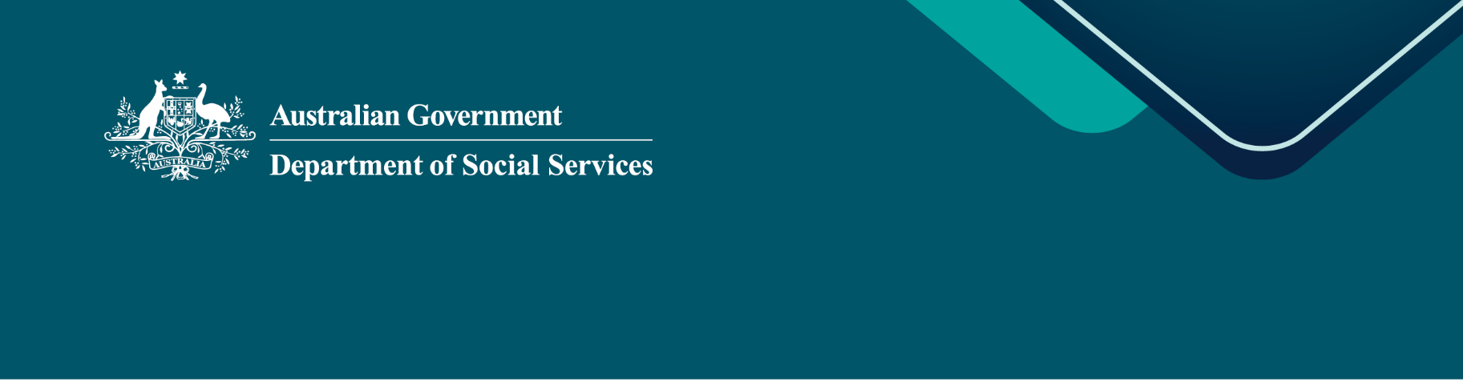
Second Action Plan consultations

National Plan to End Violence against Women and Children 2022–2032

Summary paper
Content note: Please be aware that this document contains information about violence and abuse.

 Shaping the next steps to end violence
We all want to live in a community where everyone is safe and respected – a community free from family, domestic and sexual violence (FDSV).
In 2026, consultations are taking place to inform the Second Action Plan under the National Plan to End Violence against Women and Children 2022–2032 (the National Plan).
The Second Action Plan is our roadmap for the next 5 years. It will address what needs to change and put practical actions in place so everyone can live safely.
It will involve the whole community. Ending violence requires a commitment from all of us—governments and services, employers, industries and communities.
This summary paper helps community members to provide input and ideas to shape how Australia addresses this issue over the next 5 years through the Second Action Plan (2027–2032).
A more detailed consultation paper is also available, outlining what the evidence tells us and including questions for stakeholders. That paper has been developed by ANROWS (Australia’s National Research Organisation for Women’s Safety).

About the National Plan
The National Plan is Australia’s national 10 year policy framework for ending violence against women and children and gender-based violence.
The National Plan is ambitious. We want to see FDSV eliminated within a generation. This involves a long-term direction for preventing violence, supporting victim-survivors, holding people who use violence to account, and helping people recover and heal.
The National Plan is delivered through action plans. The First Action Plan (2023–2027) was about making commitments in the National Plan a reality.

 What the evidence tells us
This brief summary is supported by the full evidence review in the ANROWS consultation paper.
Where progress has been made
- Most forms of violence have declined at the population level. Physical and emotional violence against both women and men has gone down in many areas.
- More visibility of the problem. More people are reporting it, asking for help and getting support from police.
- Community understanding is improving. Understanding and rejection of violence have been increasing.
- Rates of deaths from intimate partner violence have been declining over time.
- Workers outside of the FDSV specialist services are getting better at responding to FDSV. More cases are being taken to court, and more workers feel confident responding to physical and emotional abuse.
Where harms persist or are growing
- Sexual violence has increased since 2012. Stalking has also not declined since 2005.
- There are emerging forms of technology-facilitated abuse. Around half of all Australian adults report at least one experience in their lifetime.
- Online communities that promote misogyny (like the ‘manosphere’) are having a real influence on attitudes and behaviour. It is also reaching far too many young children.
- The number of children killed by a parent has stayed the same. Most of these deaths are linked to earlier domestic and family violence, showing chances to help were missed.
- Financial abuse and sexual abuse are not always recognised by services.
- Services are still not well connected and often focus more on adults than children and young people. This can make it harder for young people who have experienced violence to get the right support.
Where outcomes are not equal
- Aboriginal and Torres Strait Islander women continue to experience violence at much higher rates. Police, court and service responses too often fail to keep them safe.
- Women and the LGBTIQA+ community experience higher rates of sexual violence. Most violence is committed by men.
- People in rural and remote areas often find it harder to get support.
While progress has been made, it is not at the scale or pace women and children deserve.
The Second Action Plan is a chance to build on what works, address gaps, and connect systems more effectively. This includes listening to the lived experience of community members.
5 priority areas for the next plan
Drawing on the available evidence and emerging issues, 5 priority areas are proposed as the focus of this consultation. The areas overlap and connect. Together, they cover prevention, early intervention, response, and recovery and healing.
1. Victim-survivors of domestic, family and sexual violence
All victim-survivors should be able to access safety, support, justice, and help to recover, no matter where they live. In practice, support is not the same across Australia. People in rural and remote areas, and people facing extra barriers, often find it harder to get help.
Key opportunities for the Second Action Plan include:
- strengthen support so victim-survivors experience ‘no wrong door’ when seeking help
- respond to new forms of technology-facilitated abuse
- improve police and court responses to reduce further harm
- strengthen how coercive control is recognised and addressed
- address how systems, like financial and justice systems, can be used to harm
victim-survivors.
2. Prevention and early intervention
Ending violence in a generation is a bold and achievable goal. It means changing the gendered attitudes, behaviours, systems and structures that drive violence and addressing risk factors.
It also means acting earlier, before harm gets worse.
Key opportunities for the Second Action Plan include:
- challenge harmful attitudes, gender stereotypes and misogyny, online and offline
- keep respectful relationships education up to date for young people
- address risk factors like alcohol harm, gambling and adverse childhood experiences
- build the skills of communities and workers across sectors to recognise and respond earlier.
3. Children and young people in their own right
Children and young people are not just affected by violence between adults. They are
victim-survivors in their own right. They have their own experiences, needs and rights.
Policy and services must be able to recognise and respond to these distinct needs.
Key opportunities for the Second Action Plan include:
- involve children and young people in shaping policies and services that affect them
- support families, schools, early childhood and health settings to respond earlier
- address new harms including online exploitation, deepfakes and harmful sexual behaviours
- work with young people who use violence to support behaviour change.

4. People who use violence
People who use violence interact with many parts of the community and service system, including health services, workplaces, schools and justice settings, well before violence happens. Acting earlier at these contact points is important for both prevention and safety. People who use violence need to be held to account.
Key opportunities for the Second Action Plan include:
- create more pathways for early intervention and behaviour change
- help families, workplaces and communities recognise harmful behaviour
- strengthen culturally safe responses for First Nations and diverse communities
- hold people who use violence to account, with victim-survivor safety at the centre.
5. System integration and workforce
People affected by violence often have to deal with many services at once. These include health, housing, police, courts, schools, child protection and specialist services. The way these services work together makes a real difference to safety and recovery.
Key opportunities for the Second Action Plan include:
- improve how services and workforces share information and work together
- build workforce skills across specialist and other services
- support workers, including with the impact of vicarious trauma from working in this field
- build a workforce that is culturally capable and reflects the diversity of communities it serves.
Working together to end violence
Ending violence is a whole-of-community challenge. It needs action from government and services, and also from industries, employers, communities, families and individuals.
Views shared through this consultation will also help shape our work on related action plans. This includes:
- the First Action Plan under Our Ways – Strong Ways – Our Voices: National Aboriginal and Torres Strait Islander Plan to End Family, Domestic and Sexual Violence 2026-2036
- the Second Action Plan under Safe and Supported: The National Framework for Protecting Australia’s Children 2021-2031 (Safe and Supported)
- the Second Aboriginal and Torres Strait Islander Action Plan under Safe and Supported.
- the Second Action Plan under the National Strategy to Prevent and Respond to Child Sexual Abuse 2021-2030.
People are not being asked to share their views again across these other processes.

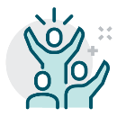 Your voice matters
We want to hear from you.
These consultations aim to identify local needs and what works. They will inform where we focus efforts over the next 5 years under the Second Action Plan.
This next plan must address new, growing challenges, such as technology-facilitated abuse and harmful online content.
Questions for you
The public survey has 6 questions to help inform the Second Action Plan. We want to hear from you.
- Prevention. What actions can governments, workplaces, industries, schools, families and individuals take to stop violence before it starts?
- Services and support. How can services and supports work better for people who have experienced, or are at risk of experiencing, family, domestic or sexual violence?
- Children and young people. How can communities and services best support children and young people to stay safe from violence?
- People who use violence. What more can be done across the community to promote healthy, safe relationships and strengthen accountability for people who use violence?
- Recovery and healing. What would make the biggest difference in helping people and families to recover and heal after being affected by family, domestic and sexual violence?
- Access to support. What makes it easier for people to access support or services related to family, domestic or sexual violence?


Have your say
You can share your ideas and take part in the consultations through surveys, written submissions and webinars.
Check our website for updates engage.dss.gov.au/second-action-plan

