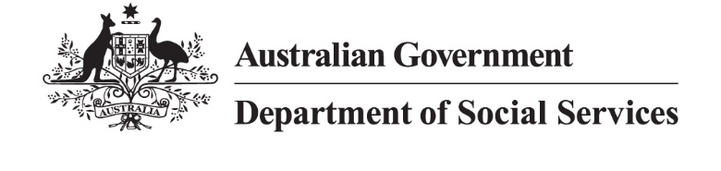

Video Transcript – 2AP Update for DSS Engage

[Speaker – Hon Tanya Plibersek MP, Minister for Social Services]
Thanks so much to everyone who has taken part so far in our consultations to help shape Australia's Second Action Plan to end family, domestic and sexual violence.
We're now more than halfway through this important national conversation. Over the past few months, the Assistant Minister, Ged Kearney and I have met with around 300 people, including, of course, victim survivors, advocates, experts, frontline workers, service providers and community leaders. And these conversations are helping us understand what's working, where the gaps remain and what needs to happen next. What we're hearing so far is that victim survivors have to remain at the centre of everything we do. Survivors need access to safe housing, legal supports, financial supports and specialist services that respond to their needs. We're also hearing that to prevent violence and respond effectively when it occurs, we need every part of our systems working together.
A lot of people experiencing family and domestic violence don't seek help first from a specialist service. They often turn to places they already know and trust, like their health care service, or a school, or a community organisation. And when it comes to sexual violence, survivors often struggle to seek help or report what's happened at all.
We're also hearing a powerful message about children and young people. Children experience violence in their own right. They need support that recognises their unique experiences and helps them recover and heal. Recovery doesn't always end when violence stops. Long term support, stability and connection matter too.
Another issue consistently being raised is the growing impact of online harms and misogyny. We know that harmful attitudes towards women are amplified online, and we know that those attitudes can contribute to violence. These consultations are already helping shape the Second Action Plan, but there's still time to have your say.
So I encourage you to complete the survey on this website, or to send us a written or audio submission before online consultations close on the 31st of July. Every story, every idea and every perspective help inform the work that we're doing. From conversations at home and in our communities to workplace policies and legislative changes. Ending gendered violence in Australia requires our collective effort at every level. Because ending family, domestic and sexual violence is not someone else's responsibility. Governments can change laws and back systemic changes, but every one of us is responsible for the social change needed to end violence for good.

