Consultation on the Second Action Plan for the National Plan to End Violence against Women and Children 2022-2023

About this submission
This submission was prepared by [REDACTED] on behalf of the Australian Longitudinal Study on Women’s Health (ALSWH).
This submission focuses on findings from ALSWH, a long-established national study that takes a comprehensive view of health, and the factors that affect health, across a woman’s lifespan. Since 1996, ALSWH has collected data from over 57,000 women in four age cohorts using regular surveys and individual record linkage to administrative health databases, including government-subsidised health services (Medicare Benefits Schedule), government-subsidised medication (Pharmaceutical Benefits Scheme), hospitals, and perinatal data. ALSWH provides evidence to inform policy development and the provision of health services, and to support new and revised clinical guidelines for health professionals.
ALSWH has collected data about women’s experiences of violence since its inception, making it one of the few national data resources in the world that has captured longitudinal data on domestic, family and sexual violence. In this submission, we present findings from women in three ALSWH cohorts (born 1946-51, 1973-78, and 1989-95).

Submission contacts
[REDACTED]
[REDACTED]

Acknowledgements
ALSWH is managed by the University of Newcastle and the University of Queensland. We are grateful to the Australian Government Department of Health, Disability, and Ageing for funding, and to the women who provide the survey data.

Prevalence and risk of violence against women
Violence against women remains prevalent across the life course. Findings from ALSWH show that substantial proportions of women have experienced domestic violence, sexual violence, childhood abuse, or exposure to violence during childhood. These experiences are evident across generations and over time. The most recent research from ALSWH (currently under review) revealed that by the time women born 1973-78 had reached middle age (43-48 years), 74% had experienced some form violence (in childhood or adulthood, perpetrated by persons known or unknown, including physical, sexual or emotional violence).

Domestic violence
Domestic violence was reported across all age cohorts of women participating in ALSWH. In the ALSWH surveys, the most conservative measure of domestic violence asks if women have ever lived in a violent relationship with a partner or spouse, with:
- 26% of women aged 28-34 in 2023 (born 1989-95)
- 30% of women aged 46-51 in 2024 (born 1973-78)
- 23% of women aged 71-76 in 2022 (born 1946-51)
indicating they have experienced domestic violence using this measure [1]. These figures are comparable to that obtained by other national studies [2].
Behavioural measures of domestic violence are more inclusive of diverse experiences of violence, and so the prevalence is found to be higher when behavioural measures are used. The Abbreviated Community Composite Abuse Scale and the Community Composite Abuse Scale [3] are behavioural measures of domestic violence included in the surveys of the two younger ALSWH cohorts. The figures below indicate the percentage of women who have ever reported experiencing an act of domestic violence [4]:
- 70% of women aged 28-34 in 2023 (born 1989-95)
- 64% of women aged 46-51 in 2024 (born 1973-78)

Sexual violence
Sexual violence was measured by asking women if they had experienced ‘unwanted sexual activity’. This broad definition is in line with that used by the World Health Organization [5]. The prevalence of sexual violence reported in ALSWH is much higher than that reported in other national data collections [1]:
- 53% of women aged 28-34 in 2023 (born 1989-95)
- 33% of women aged 46-51 in 2024 (born 1973-78)
- 27% of women aged 71-76 in 2022 (born 1946-51)

Adverse childhood experiences
ALSWH captures information about adversity in childhood using the well-known Adverse Childhood Experiences Scale [6].
Psychological abuse during childhood was reported by [1]:
- 22% of women aged 28-34 in 2023 (born 1989-95)
- 18% of women aged 46-51 in 2024 (born 1973-78)
- 15% of women aged 71-76 in 2022 (born 1946-51)
Childhood sexual abuse was reported by [1]:
- 11% of women aged 28-34 in 2023 (born 1989-95)
- 16% of women aged 46-51 in 2024 (born 1973-78)
- 15% of women aged 71-76 in 2022 (born 1946-51)
Experiences of childhood physical abuse were reported by [1]:
- 9% of women aged 28-34 in 2023 (born 1989-95)
- 8% of women aged 46-51 in 2024 (born 1973-78)
- 11% of women aged 71-76 2022 (born 1946-51)
Witnessing violence against a parent or caregiver during childhood was reported by [1]:
- 11% of women aged 28–34 in 2023 (born 1989-95)
- 9% of women aged 46–51 in 2024 (born 1973-78)
- 9% of women aged 71–76 in 2022 (born 1946-51)
Any form of direct violence in childhood (excluding witnessing violence) was experienced by [4]:
- 28% of women aged 28-34 in 2023 (born 1989-95)
- 24% of women aged 46-51 in 2024 (born 1973-78)
- 23% of women aged 71-76 in 2022 (born 1946-51)

Recommendations
The following recommendations regarding measuring violence and using existing data sources should be considered.
- Implement an ongoing review of how data are captured. In particular, how types of violence are defined, the limitations of these definitions and the impact of the definitions used on results should be considered. For example, definitions of violence have evolved to now include technology-facilitated abuse and reproductive coercion; and the broad definition of sexual violence used by ALSWH results in differences in prevalence with other national data collections. Inclusion of new understandings and more inclusive definitions, such as these, tends to increase prevalence rates, but the limitations are reduced, accuracy of the measurements is improved, and policy and service delivery can be more efficiently deployed.
- ALSWH has captured data on violence against women since its inception, currently comprising 30-years of longitudinal data that is available for analysis. These longitudinal data and future ALSWH data collections should be utilised to continue to meet the needs of policies related to violence.

The long-term impact of violence on health

Domestic violence and health [1]
ALSWH data have been used to demonstrate the scope and long-term nature of the health impact of domestic violence among women in Australia.
Compared to women who had not experienced domestic violence, those who had experienced domestic violence were more likely to report fair or poor general health at every survey wave (see Figures 1-3).
Figure 1 Percentage of women reporting fair or poor general health among women born 1989-95
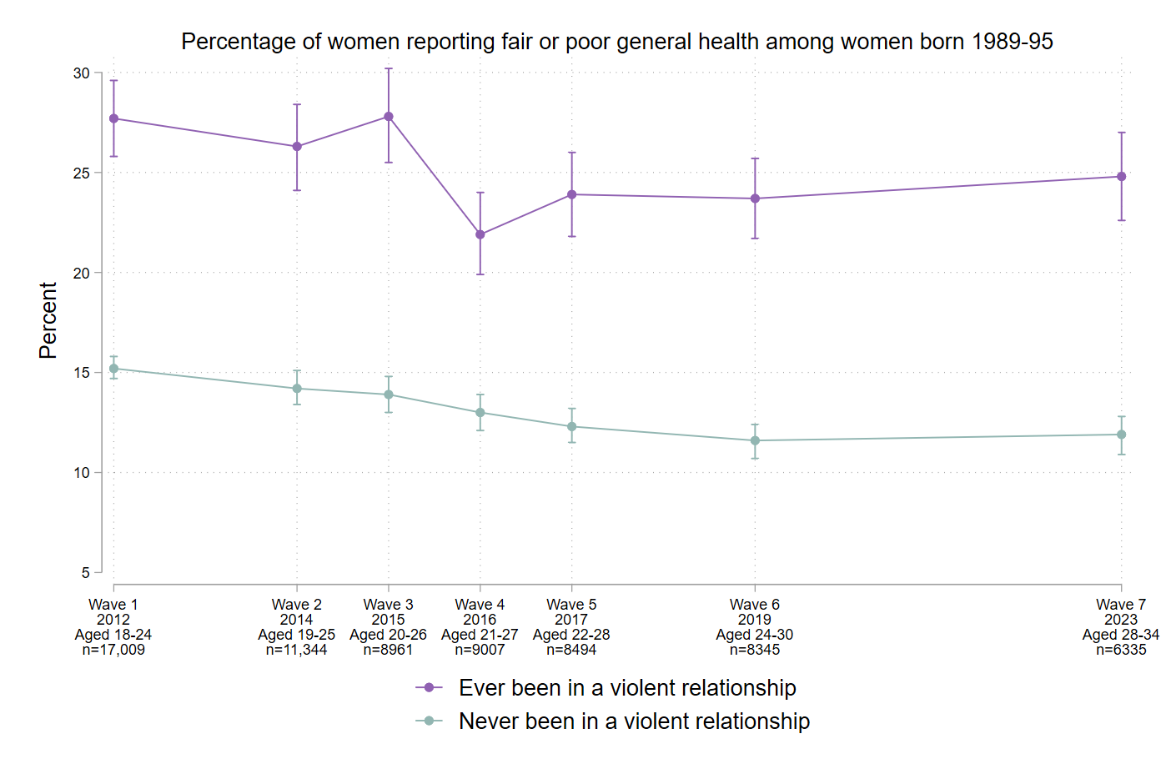
Figure 2 Percentage of women reporting fair or poor general health among women born 1973-78
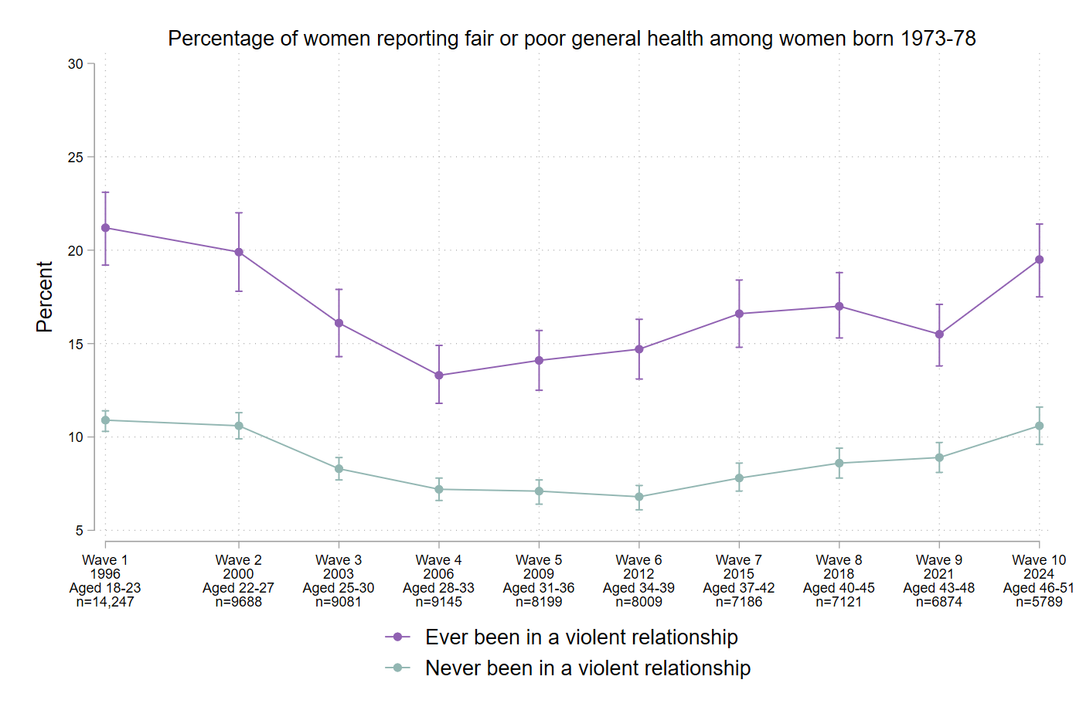
Figure 3 Percentage of women reporting fair or poor general health among women born 1946-51 (domestic violence not measured at Waves 2 and 3)
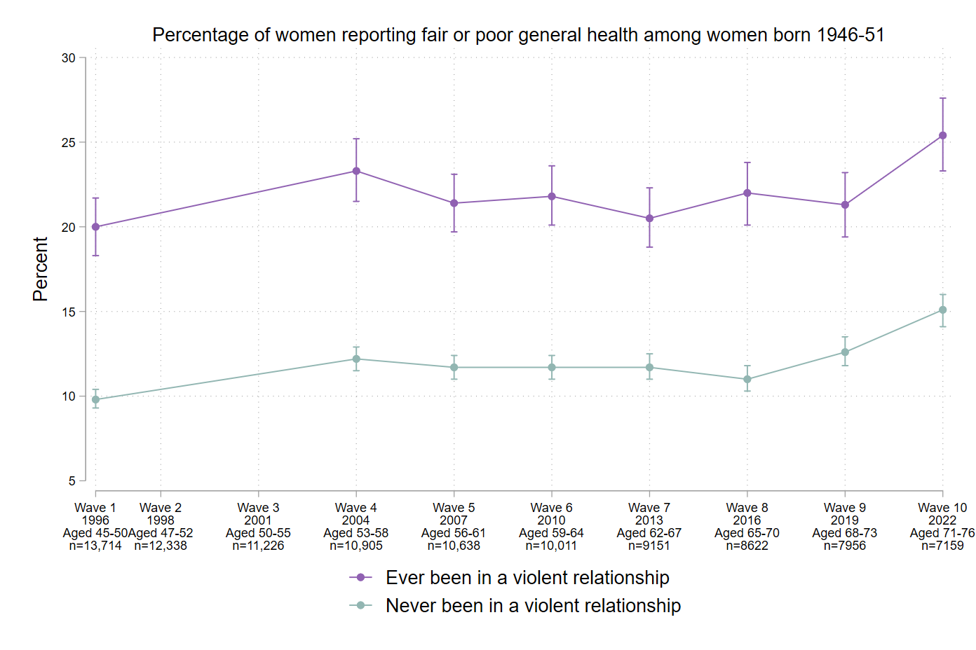
Compared to women who had not experienced domestic violence, those who had experienced domestic violence were more likely to report poor mental health at every survey wave (see Figures 4-7).
Figure 4 Psychological distress among women born 1989-95 as measured by the Kessler Psychological Distress Scale [7] (where higher scores reflect greater distress). 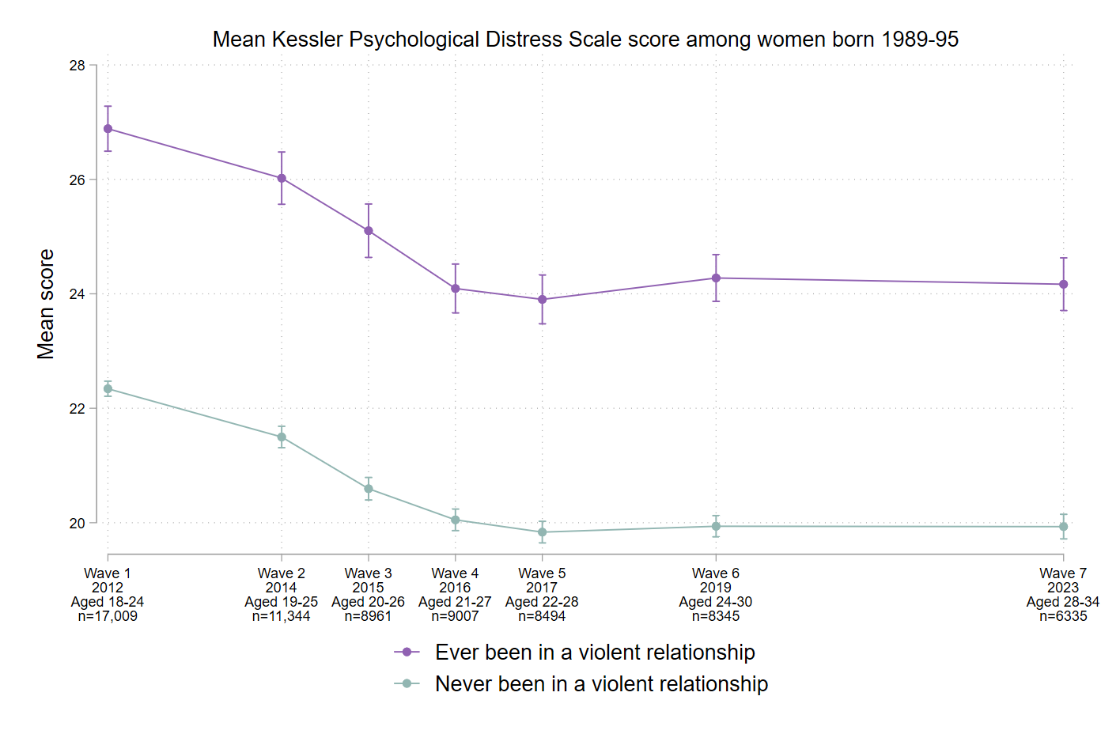
Figure 5 Mental health among women born 1973-78 as measured by the SF-36 Mental Health Inventory score [8] (where higher scores reflect better mental health).
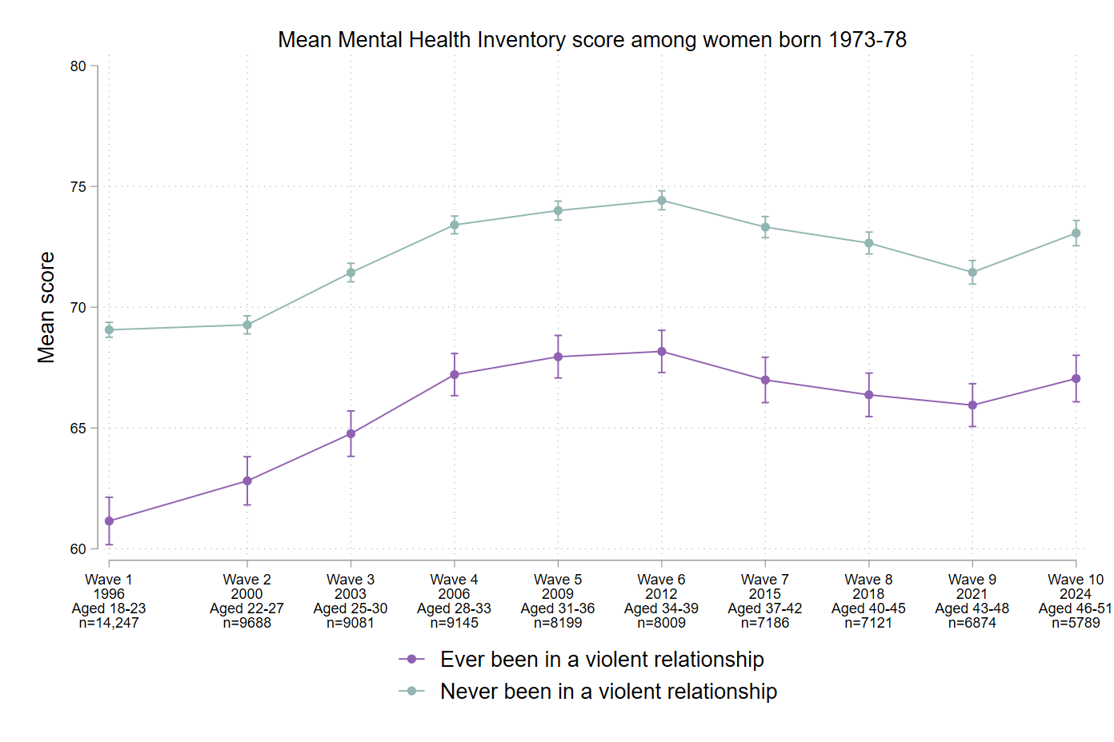
Figure 6 Mental health among women born 1946-51 as measured by the SF-36 Mental Health Inventory score [8] (where higher scores reflect better mental health; domestic violence not measured at waves 2 and 3).
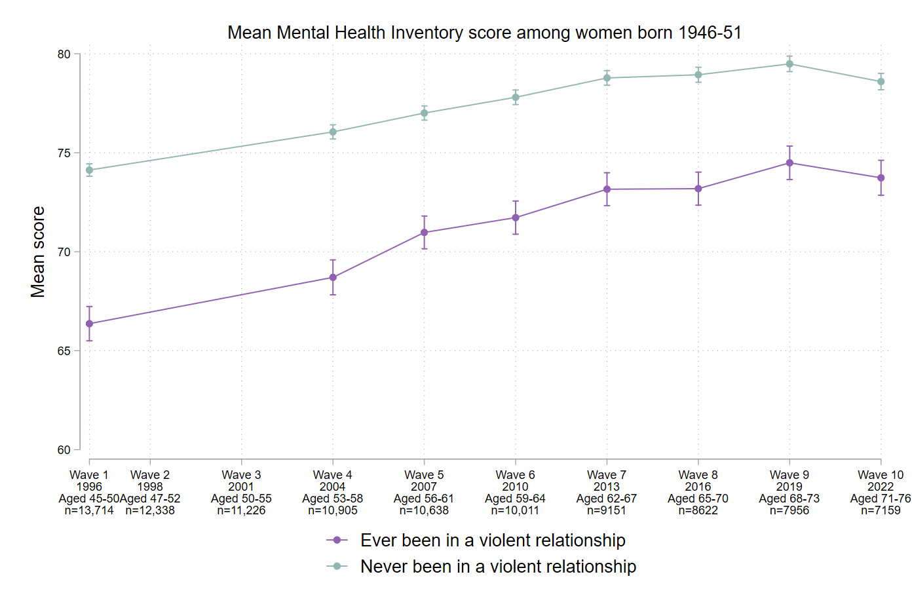
Recent ALSWH research has also demonstrated strong associations between domestic violence and suicidal thoughts and self-harm. In comparison to women who had not experienced domestic violence, those who had experienced domestic violence in the previous 12 months and were born [1]:
- 1989-95 were 2.1 times more likely to have self-harmed, and 1.7 times more likely to have had suicidal thoughts in the last 12 months
- 1973-78 were 3.4 times more likely to have self-harmed in the past 6 months, and 2.7 times more likely to have had suicidal thoughts in the previous week

Sexual violence and health [9]
Sexual violence has a similarly serious impact on women’s health and wellbeing. For example, the ALSWH-led report funded by ANROWS showed that, among women born 1989-95 and 1973-78, sexual violence was related to poorer overall general health, and worse physical and mental health outcomes, including:
- Chronic conditions and sexually transmitted infections
- Depression, anxiety and psychological distress
- Illicit drug use, high-risk alcohol consumption, low levels of physical activity and obesity
In addition, recent ALSWH research with data from women born 1989-95 and 1973-78 has shown that sexual violence is associated with an increased risk of suicidal thoughts and self-harm.

Violence in childhood and adult health [10]
Violence in childhood has also been found to impact long-term health. For example, a 2021 ALSWH paper showed that among women aged 20-25 in 2015, experiencing childhood adversity was associated with an increased likelihood of poorer adult health, including poor mental health, current tobacco use, severe obesity, poor physical health and sexually transmitted infections.

Recommendations
Experiences of violence at any point in the life course are related to ongoing physical and mental health issues. The inclusion of recovery from violence as a major pillar in the National Plan to End Violence Against Women is welcome, as is recognition that the impact of violence is very long term. The Second Action Plan should build on this by highlighting the common nature of violence against women and
- Embedding education on the prevalence and health outcomes of violence into relevant practitioner education programs, including professional continuing education, and both postgraduate and undergraduate courses (e.g. medicine, nursing, midwifery, psychology, physiotherapy, social work and occupational therapy)

Recovery from violence
ALSWH data have been analysed to identify events, experiences, circumstances, and life events that might be beneficial for women who have experienced violence. For example, among women born 1989-95, 1973-78, and 1946-51 who had experienced sexual violence, a number of factors were associated with good physical or mental health [9], including:
- Physical activity
- Social support, particularly:
  - emotional support
  - personal affection and social interaction
  - tangible or physical assistance (for mental health only)

Recommendations
Despite evidence that certain factors are associated with better health among those who have experienced violence, more research is needed to determine those elements that determine an improved trajectory in health and wellbeing as women age. The NHMRC-funded RESTORE Centre for Research Excellence is currently partnered with ALSWH to determine such trajectories in relation to the use of health services. Further research should examine:
- Changes in health related to the addition of new services targeting health support for women who have experienced violence (such as the Primary Healthcare Network Domestic, Family, and Sexual Violence Outreach Program, pioneered by Hunter New England Central Coast Primary Healthcare Network)
- Changes in health outcomes related to different life circumstances of women who have experienced violence
- The impact of policy changes on the health of women who have experienced violence

References
- Loxton D, Townsend N, Egan N, Barnes I, Tooth L, Mishra G. Bulletin 1: Violence and women’s health. Australian Longitudinal Study on Women’s Health; in press 2026.
- Australian Bureau of Statistics. Personal Safety, Australia, 2021-22. Canberra: ABS; 2023 Mar 15 [cited 2026 Jul 31]. ABS cat. no. 4906.0. Available from: https://www.abs.gov.au/statistics/people/crime-and-justice/personal-safety-australia/2021-22
- Loxton D, Powers J, Fitzgerald D, Forder P, Anderson A, Taft A, et al. The Community Composite Abuse Scale: Reliability and Validity of a Measure of Intimate Partner Violence in a Community Survey from the ALSWH. J Womens Health, Issues Care. 2013;2(4). doi:10.4172/2325-9795.1000115
- Australian Longitudinal Study on Women’s Health. Preliminary data analysis. 2026. Available on request: https://alswh.org.au/for-data-users/applying-for-data/
- World Health Organization. Violence against women. 2024 Mar 25 [cited 2025 Nov 20]. Available from: https://www.who.int/news-room/fact-sheets/detail/violence-against-women
- Felitti VJ, Anda RF, Nordenberg D, Williamson DF, Spitz AM, Edwards V, et al. Relationship of childhood abuse and household dysfunction to many of the leading causes of death in adults. The Adverse Childhood Experiences (ACE) Study. Am J Prev Med. 1998;14(4):245-258. doi:10.1016/s0749-3797(98)00017-8
- Kessler RC, Andrews G, Colpe LJ, Hiripi E, Mroczek DK, Normand SLT, et al. Short screening scales to monitor population prevalences and trends in non-specific psychological distress. Psychol Med. 2002;32(6):959-976. doi:10.1017/s0033291702006074
- Ware JE, Sherbourne CD. The MOS 36-item short-form health survey (SF-36): I. Conceptual framework and item selection. Medical Care. 1992;30(6):473-483.
- Townsend N, Loxton D, Egan N, Barnes I, Byrnes E, Forder P. A life course approach to determining the prevalence and impact of sexual violence in Australia: Findings from the Australian Longitudinal Study on Women’s Health (Research report 14/2022). Australia’s National Research Organisation for Women’s Safety; 2022. Available from: https://www.anrows.org.au/publication/a-life-course-approach-to-determiningthe-prevalence-and-impact-of-sexual-violence-in-australia-findings-from-theaustralian-longitudinal-study-on-womens-health/.
- Loxton D, Forder PM, Cavenagh D, Townsend N, Holliday E, Chojenta C, et al. The impact of adverse childhood experiences on the health and health behaviors of young Australian women. Child Abuse Negl. 2021;111:104771. doi: 10.1016/j.chiabu.2020.104771

For the cohort born 1989-95, psychological distress was measured using the Kessler Psychological Distress Scale, where higher scores reflect higher levels of distress (Figure 4). For women born 1973-78 and 1946-51, mental health was measured using the Medical Outcomes Scale Mental Health Inventory score, where higher scores reflect better mental health (Figures 5-6).

