

Submission:
Consultation on the Second Action Plan (National Plan to End Violence against Women and Children 2022–2032)

Call for Submissions:
31 July 2026
Acknowledgements
Our organisations are committed to the safety, participation, and empowerment of all people, including children and young people that engage with our organisations, including but not limited to individuals who identify as:
- Aboriginal and Torres Strait Islander.
- Culturally and/or linguistically diverse.
- Gender diverse and/or same sex attracted.
- People with disabilities.
We acknowledge Aboriginal and Torres Strait Islander peoples as the First Nations Peoples of these lands and water, their sovereignty and sacred link to these lands and waters, and the ongoing harms and impacts of colonisation.
We support all people to thrive and have zero tolerance for any form of racism, ableism, homophobia, sexism, ageism and hate speech/action that attempts to marginalise, threaten or silence.
We acknowledge the strength and resilience of survivors of family and sexual violence and recognise that women and girls with disability often face systemic barriers to safety and support when seeking a life free from violence. We recognise the courage of individuals who have experienced family violence, along with the dedicated workers responding to family violence.
About the Loddon Consortium for Gender Equality and Violence Prevention:
The Loddon Consortium for Gender Equality and Violence Prevention (the Consortium) was established in 2004, bringing together Central Victorian-based services that were working in the specialist gendered violence sector. Our partnership is the only consortium in Victoria (and possibly Australia) that provides integrated regional programs and services for victim survivors of family and sexual violence, men who use violence towards family members, and works to prevent gendered violence.
The Consortium applies a feminist governance approach – equality of participation and voice – and we are united in our desire for gender and social equality and a community free of violence.
We have a strong commitment to innovation, impactful partnerships and collaborations and evidencing our impact.

The Consortium is a partnership of specialist gender-based violence organisations across the Loddon area:
- Centre for Non-Violence (CNV)
- Annie North Women’s Refuge
- Centre Against Sexual Assault Central Victoria (CASACV)
- Women’s Health Loddon Mallee
- Omnia Community Health

Key achievements:
- Providing specialist gendered violence programs and services within the Loddon area and across the continuum of response, recovery and prevention
- Joint training and integrated models of perpetrator responses and system mobilisation Regional Integration Committee (now known as the Loddon Family Violence Systems Leadership Group) development and best practice integration interventions and responses
- Creating and leveraging place-based responses that join up systems (no wrong door)
Our strong and integrated models and practice include:
- Safe, Thriving and Connected (STC) therapeutic recovery program
- Integrated after-hours response programs (family violence) and seamless and shared intake (data/referrals) for STC
- Campaigns and advocacy including policy and legislative reforms, community engagement and violence prevention initiatives
- Workforce capacity building and joint training
- Representation on key alliances and networks in the Loddon region and statewide

Note on Language:
This submission uses gendered language (inclusive of cisgender and transgender people) to reflect gendered prevalence of both victim/survivors and perpetrators of violence, while recognising children as victim survivors in their own right and the diversity of genders and identity of those impacted by family, sexual and gender-based violence.
Contact Us:
[REDACTED]

Introduction
We welcome the opportunity to provide a formal submission to the Department of Social Services ‘Consultation on the Second Action Plan (National Plan to End Violence against Women and Children 2022–2032)’.
The Partners
Annie North Women’s Refuge has been providing crisis refuge, transitional and after-hours support to all women, children and young people who are escaping family violence as part of state-wide response since 1989. Our services are available to all adults that identify as women and their accompanying children and are open irrespective of cultural background, sexual orientation, or gender identity. We work tirelessly to challenge victim-blaming narratives and stereotypes that are widespread in the community and seek to see a world where women and children live free from family violence.
The Centre Against Sexual Assault Central Victoria (CASA CV) has worked for more than 40 years to transform society and change the systemic drivers of sexual violence. CASA CV works alongside people who have experienced sexual assault to support and advocate on their behalf. This includes care and support during criminal justice proceedings and forensic medical procedures. We also work extensively with Police, and the legal, medical and child protection systems, to advocate for better system responses for victims and families.
CASACV provides a 24-hour crisis response for recent sexual assaults which includes supporting the victim survivor and liaising, coordinating and advocating for client centred and trauma informed responses and care with Police, Forensic and Health Services.
Established in 1990, the Centre for Non-Violence (CNV) is an integrated specialist family violence organisation providing prevention, crisis and recovery support across rural and regional communities right across Central Victoria. CNV works with both victim survivors and adults using violence to provide increased safety, participation and support for families and individuals impacted by family violence. We recognise the disproportionate impacts of family violence on victim survivors, including children, from First Nation and CALD communities, as well as people living with disability and from LGBTQIA+ community. We work with all victim survivors irrespective of gender or sexual identity and orientation.
Omnia Community Health provides a wide range of services across the Hume, Macedon Ranges, Mitchell, Murrindindi and Strathbogie local government areas. We support people of all ages with everything from preventative health and chronic disease management to community-led programs and local support services.
Women’s Health Loddon Mallee (WHLM) is committed to working towards a future that sees equitable distribution of power and resources across all gender groups. We lead change by advocating for the health and wellbeing of women across the Loddon Mallee Region.
WHLM works within an intersectional feminist framework to achieve gender equality by providing health information, education and support to local government, organisations, education providers, and community groups.

Response to the Second Action Plan Call for Submissions
This submission highlights the critical role of specialist services in informing policy and legislative reform, and in shaping effective prevention and early intervention initiatives. Family, sexual and gender-based violence cannot be addressed through a one-size-fits-all approach. Effective prevention, response and recovery efforts must recognise the diverse experiences and needs of women, children and communities impacted by violence and the place-based expertise of specialist services. It also must be informed and led by the place-based expertise of specialist services working across family, sexual and gender-based violence prevention, response and recovery.
While we acknowledge the Federal Government’s recognition of family, sexual and gender-based violence as a national crisis and welcome the development of a range of national frameworks, plans and agreements, these initiatives have too often been developed without meaningful engagement with the specialist services sector. In doing so, governments forgo the invaluable insights that come from decades of frontline experience. Specialist organisations witness firsthand the impacts of violence, the barriers to safety and recovery, and the outcomes of effective interventions. Their expertise should be central to the design of policies, systems and reforms intended to address violence against women, children and diverse communities.
We echo the call of Dr Tessa Boyd-Caine, CEO of ANROWS, that achieving meaningful progress in ending violence against women, children and diverse communities requires ensuring that “national action is informed by the knowledge, experience and insight held across communities, services, workforces and systems.
To achieve this, governments must create the mechanisms and structures that enable specialist sectors across all states and territories to work collaboratively and in genuine partnership with government. This includes strengthening opportunities to build the evidence base, share knowledge and translate evidence into more effective practice, systems reform and legislation. Without a coordinated7 national response, lives will continue to be placed at risk, and people who use violence will continue to exploit gaps across systems and jurisdictions to evade accountability and responsibility for their choice to harm others.
Delivering tailored and accessible services for victim-survivors and people who use violence requires sustained investment in the specialist sector, alongside a commitment to embed specialist family violence expertise within federal policy, funding and decision-making structures.
Every victim-survivor in Australia deserves access to a safe home, a well-funded specialist family and sexual violence sector, and systems that are family violence and trauma-informed. We urge the Government to address these issues and establish a clear mandate for genuine partnership with the specialist sector to advance the shared goal of ending violence against women, children and diverse communities.

Priority 1. Violence against Women and Children and other forms of Gender-based Violence
Strengthening a whole of society and life-course approach to prevention, early intervention, response, recovery and healing with a focus on victim-survivors from all communities and backgrounds.

At time of writing this submission 42 women and 19 children have been killed as a result of violence – most often by someone they knew and at one point trusted and loved.
Concurrently, we are also seeing a distinct rise in extremism in our communities, from the Christchurch mosque massacre, an of extremism perpetrated by an Australian, to violent machete attacks in Victoria, to the Bondi shootings in 2025. It would be remiss to regard these as isolated incidents. Rising extremism and its ties to misogyny are well founded in the research.
There can be no doubt—patriarchy, misogyny, domestic abuse, and mass murder are associated, and have been for a long time […].
Violent extremism has been identified as an emerging national security concern in Australia and identifying and addressing the drivers of radicalisation has become an important area of research for the Australian government.
What a growing body of research both here in Australia and globally is showing, is the causal links between misogyny, violent extremism and community understandings gender and masculinities.
A 2024 policy brief out of the University of Melbourne highlights the need to provide a ‘holistic approach to redressing racist and misogynistic attitudes [amongst broader general community] as a matter of security urgency.’
Researchers, Johnston and True (2019) state that their findings clearly demonstrate that support for violence against women is the common underlying driver that predicts violent extremism.
And at a time where we are facing a national crisis of violence against women in Australia, with growing calls for a Royal Commission into Femicide, it’s time to seriously examine the drivers of violence, it’s inextricable links to understandings of masculinity, and how we must as a national priority, challenge masculinity myths. If we are to ever realise gender and social equality in a violence free world, we must see that this work will have to take place right across the continuum: from prevention and early intervention to tertiary response and therapeutic recovery.
1.1 Intersectional Feminist Framework
Feminism is foundational to ending violence:
The rise of misogyny and the growing influence of the online “manosphere” are contributing to a social and political environment that increasingly fuels backlash against feminism and feminist-informed reforms. This backlash frequently targets women’s rights, gender equality initiatives, and the legislative and policy gains that feminist movements have fought for over decades to advance equality and safety in Australia.
Now more than ever, Australia must remain steadfast in its commitment to feminist principles that promote social justice, gender equality and human rights as fundamental pillars of a free, democratic and inclusive society. Achieving a future free from violence requires a continued focus on addressing the structural and systemic drivers of inequality that enable and perpetuate violence against women, children and diverse communities.
Central to this commitment is recognising the importance of an intersectional feminist approach across prevention, early intervention, response and recovery. An intersectional feminist lens acknowledges that experiences of violence are shaped by the interaction of gender with other social and structural factors, including race, disability, sexuality, age, socioeconomic status, geographic location and immigration status. Effective policies, services and systems must be informed by these intersecting realities if they are to meet the needs of all victim survivors.
What is intersectional feminism?
An intersectional feminist approach recognises that there is no single or universal experience of gendered discrimination, violence, systemic oppression, or abuse. A person’s experience of violence and access to safety is shaped by compounding and intersecting factors, including race, disability, cultural background, sexual identity, gender expression, class, age, geography and visa or migration status. It also recognises that people can experience oppression and privilege at the same time.
For specialist family, sexual and gender-based violence services, an intersectional feminist framework provides the basis for culturally safe, trauma-informed, and evidence-based policy and practice. It supports a culture built on respect, gender and social equality, and recognition of lived, professional and cultural expertise. It also ensures that prevention, early intervention, response, and recovery efforts are designed around the diverse realities of victim survivors, including children, rather than around assumptions of a single pathway to safety.
As hard-won rights and protections for women and children face increasing challenge both online and offline, there is an urgent need to ensure that all efforts aimed at ending family, sexual and gender-based violence are grounded in an intersectional feminist framework. This is not simply a matter of ideology; it is a matter of evidence, effectiveness and accountability. Without a clear commitment to feminist principles and the expertise of those working to advance gender equality, Australia risks undermining decades of progress and weakening its capacity to prevent and respond to violence.
Nothing about us without us. Policies and reforms intended to address violence against women, children and diverse communities must be developed in genuine partnership with the people, communities, services and sectors that hold specialist, lived, professional and cultural expertise. Only through meaningful collaboration, informed by intersectional feminist principles, can Australia realise the goal of a safer, more equitable and violence-free future for all.

Key policy asks:
- Embed intersectional feminist principles across the Second Action Plan: The Federal Government should ensure that all prevention, early intervention, response and recovery measures are explicitly grounded in intersectional feminist principles, human rights, gender equality and social justice.
- Respond to misogyny, the manosphere and backlash against gender equality: The Federal Government should recognise violent misogyny, rigid masculinities and online backlash against feminist reforms as emerging risks that require coordinated prevention, early intervention, research, regulation and community-level responses.
- Require meaningful partnership and co-design: National policy, funding and legislative reform should be developed in genuine partnership with victim survivors, children and young people, Aboriginal and Torres Strait Islander communities, culturally diverse communities, people with disability, LGBTQIA+ communities and specialist family, sexual and gender-based violence services.
- Strengthen accountability for gender equality outcomes: The Federal Government should establish clear accountability mechanisms to ensure that funded initiatives demonstrate how they address the structural and systemic drivers of violence, including gender inequality, racism, ableism, homophobia, transphobia, economic inequality and geographic disadvantage.
- Invest in intersectional evidence, data and evaluation: The Federal Government should fund national data, research and evaluation approaches that capture diverse experiences of violence, including the experiences of communities that are currently underrepresented in evidence systems.

1.2 Safe and Affordable Housing
When ‘home’ isn’t safe:
For a significant number of the women and children who are seeking safety from family violence, housing and the risk of homelessness informs much of the decision-making on when or how to leave a violent relationship. The combined pressures of a rise in the cost of living, housing unaffordability and availability and the devasting impacts of climate change, particularly for regional and rural communities at risk of flooding and bushfires is placing very real and immediate need to address a safe housing response for victim survivors.

The latest data from the AIHW unequivocally family violence is the leading cause of homelessness. In 2024-2025, 41 per cent of all clients seeking housing support had experienced family violence and 1 in 4 of these clients had their housing needs unmet, including children.
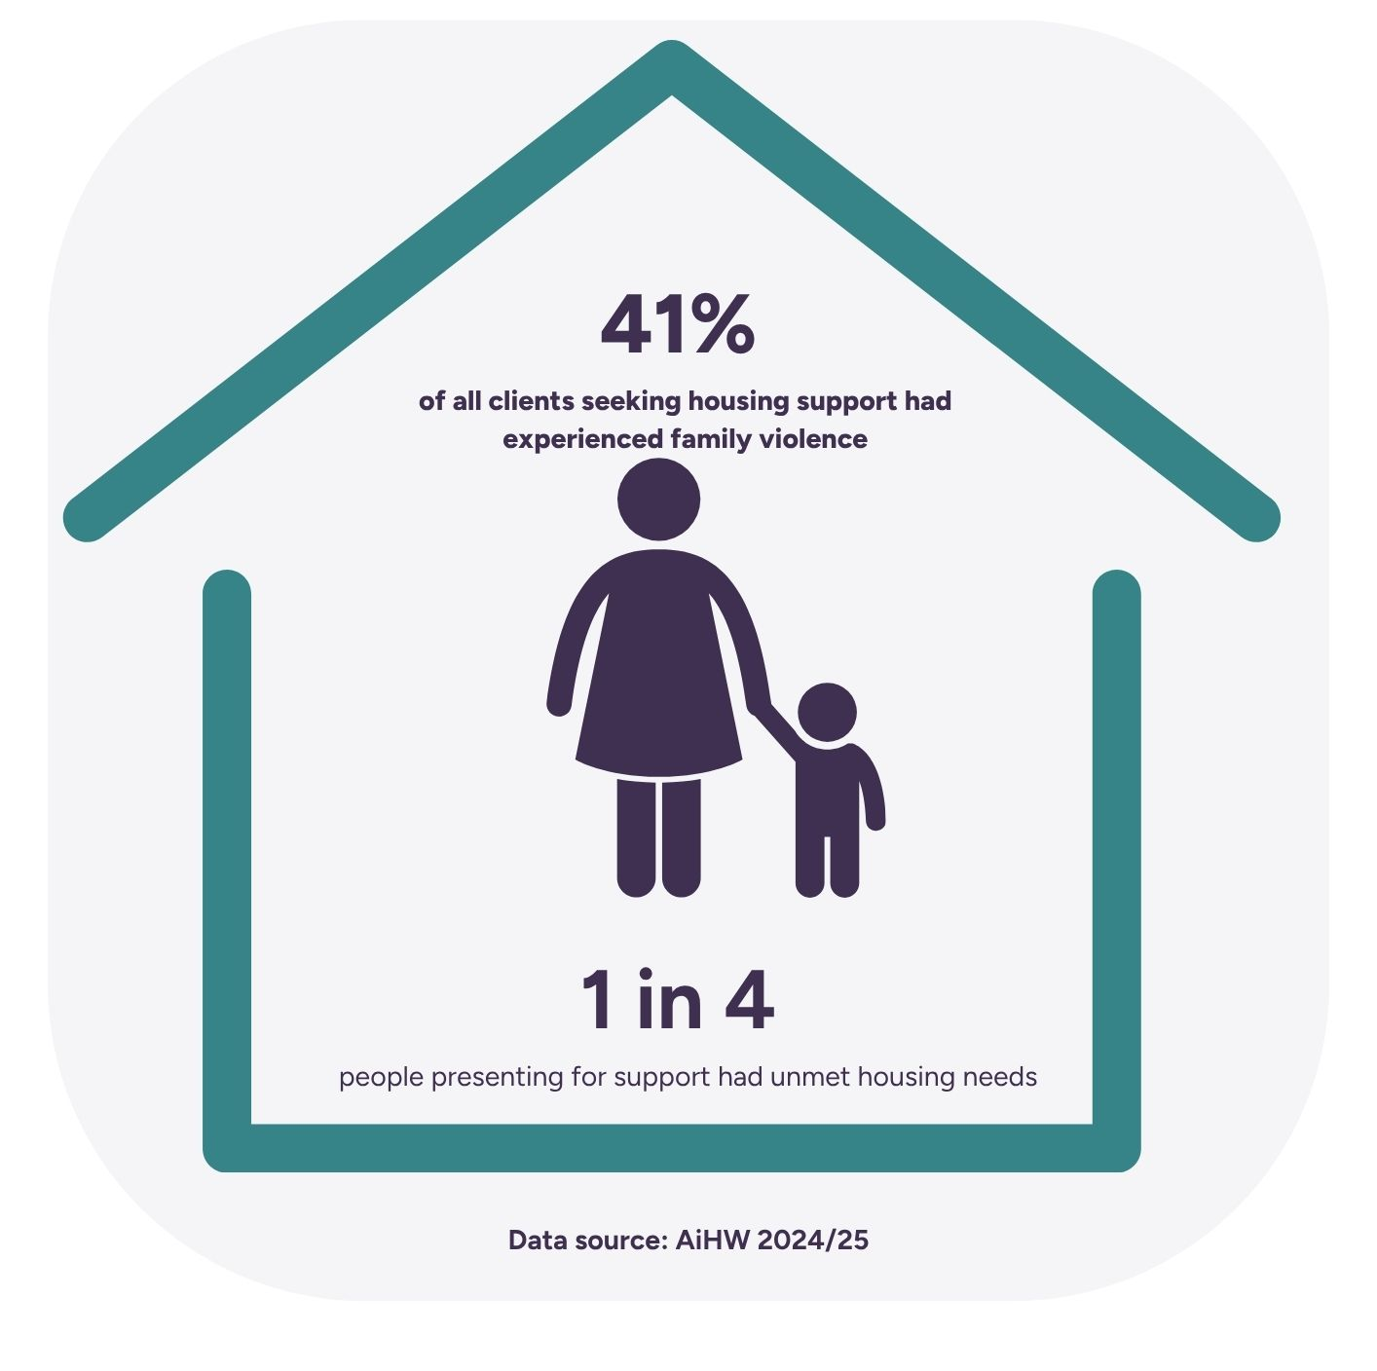
More than 80 women and children who accessed CNV support in 2024-2025 spent over 6 months in crisis accommodation – predominantly motels, and for Aboriginal and Torres Strait Islander women and children accessing emergency housing services, the average time spent in crisis accommodation is more than three months.
Crisis accommodation is designed as a short-term immediate need solution. It is not a long-term solution for those who have experienced or are experiencing family violence – and yet, for many of our clients, with no long-term housing options beyond the crisis, the only choice is to risk homelessness or return to the perpetrator.
This is no choice at all.

Far too often the only crisis housing that our staff are able to secure for clients are motel rooms. These are not fit for purpose housing options and often lack the necessary infrastructure that would enable victim survivors to have a safe place to land and recover. Often, the motel rooms lack basic facilities like kitchens and safe spaces for children to play.
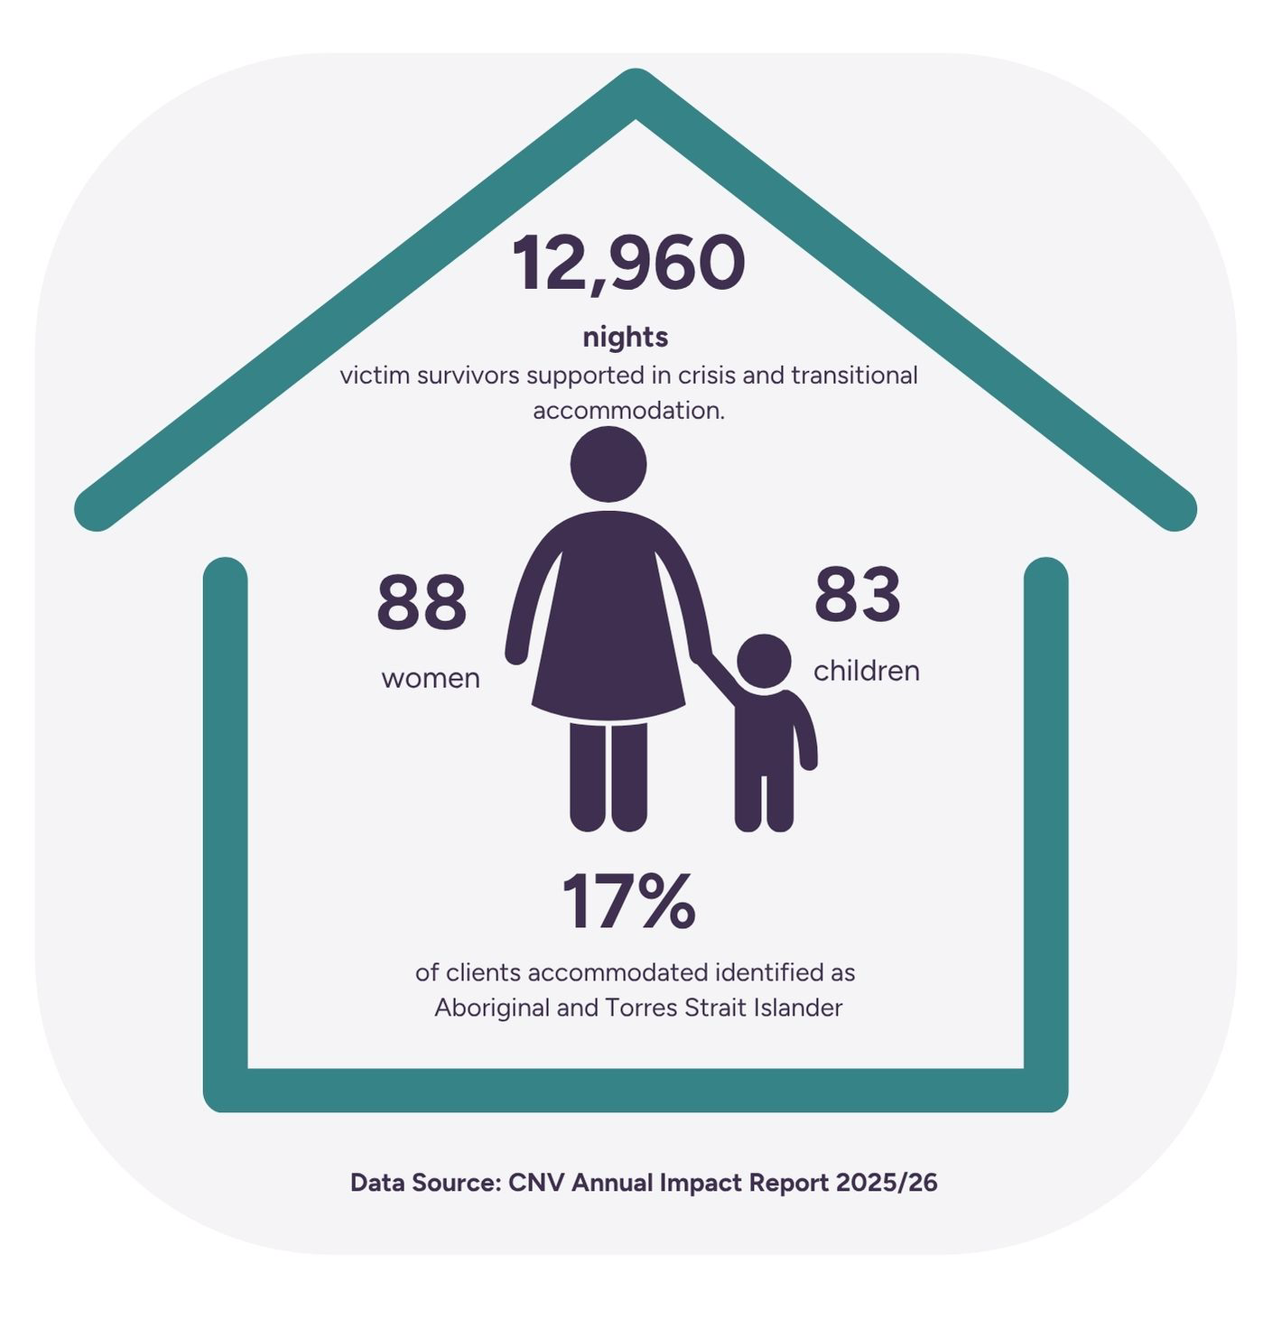
For victim survivors living in rural and regional areas access to crisis accommodation – including motels – is further reduced as often, including in our own region, tourism impacts availability; particularly during holiday periods and long weekends.
Concerningly, this is also where we often see an escalation in the reported rates of family violence and far too often, there is nowhere safe to go.
Success Story: Safe Places Emergency Accommodation Program
The Centre for Non-Violence alongside Annie North Women’s Refuge and Haven Home Safe were successful in a bid to build three purpose-built crisis properties in Bendigo to support women and children who have experienced family violence.
Through this program, the Centre-for Non-Violence and Annie North are able to provide specialised risk and safety focused family violence support services, including therapeutic recovery programs to the women and children housed in the purpose-built homes, while Haven Home Safe manage the properties and link residents in with other supports as part of the Sidney Myer Haven Program.
This partnership is an example of a positive, tailored solution for rural and regional communities that prioritises specialist family violence and trauma-informed wrap around supports for victim survivors. No one housing solution will address the rise of homelessness among victim survivors: these must be tailored to meet local, place-based needs. Importantly, it requires a dedicated and coordinated investment between the states, territories and Federal Government.

A lack of sustainable housing options is contributing to victim survivor displacement and having long-term impacts on wellbeing.
Far too often victim survivors are forced to not only leave their homes, but due to a lack of affordable housing in our region, also leave their community, their employment, change schools, and move away from supports, including family and friends and critical wrap around supports provided by specialist family and sexual violence services.
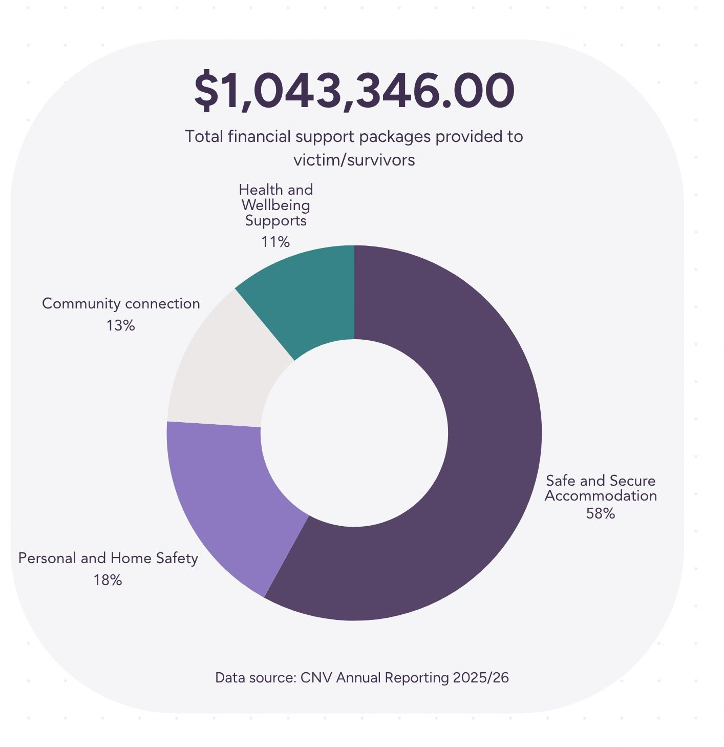
While emergency and transitional housing requires critical investment and increase in availability, we know that an outcome that can provide a ‘safe at home’ response – where victim survivors are able to remain their own home – remains an important objective. A safe at home response for victim survivors prioritises safety and stability, particularly for children; they are able to remain within community, schools and jobs, routines can be upheld to a greater degree and importantly, it prioritises the re-building of the mother child dyad where housing insecurity and risk of homelessness has been reduced or mitigated altogether. where housing insecurity and risk of homelessness has been reduced or mitigated altogether.
Our experience shows that women holding Temporary Protection Visas face significant barriers to creating a safe, stable, and positive future. In addition to an inability to secure housing due to having no income, ongoing uncertainty about visa status and review timeframes contributes to insecurity and stress, while social isolation and economic disadvantage further limit opportunities. Access to employment, education, and training is hindered by the lack of affordable and accessible childcare, preventing many women from fully participating in community and economic life.

Simple Innovations, Big Impact: The Personal Safety Initiative (PSI)
PSI is an excellent example of how, through comprehensive risk assessments, front-line services are able to provide victim survivors with a range of safety packages that support them to stay in the home, once the perpetrator has left.
Supported by safety planning that can include the installation of security cameras, sweeping of homes, cars and technology including mobile phones and the provision of personal safety devices to victim survivors. This program is a necessary and critical service delivery that can offer a safe and long-term solution for victim survivors. Despite the increased safety and wellbeing that the PSI offers victim survivors, front-line services are not given the guarantee that the program will be funded beyond a short-term 12-month cycle.

Regional and rural areas across the spectrum of housing from emergency and crisis accommodation, right through to social housing and affordable housing in the private rental market are at a critical disadvantage and it’s placing lives at risk and impacting on long-term victim survivor safety and wellbeing.Despite the Federal Government ratifying the UN CRPD in 2008, Australia remains the only liberal democracy to not have a Human Rights Act and because of this missing piece of key legislation, housing is still regarded as a commodity rather than a basic human right.

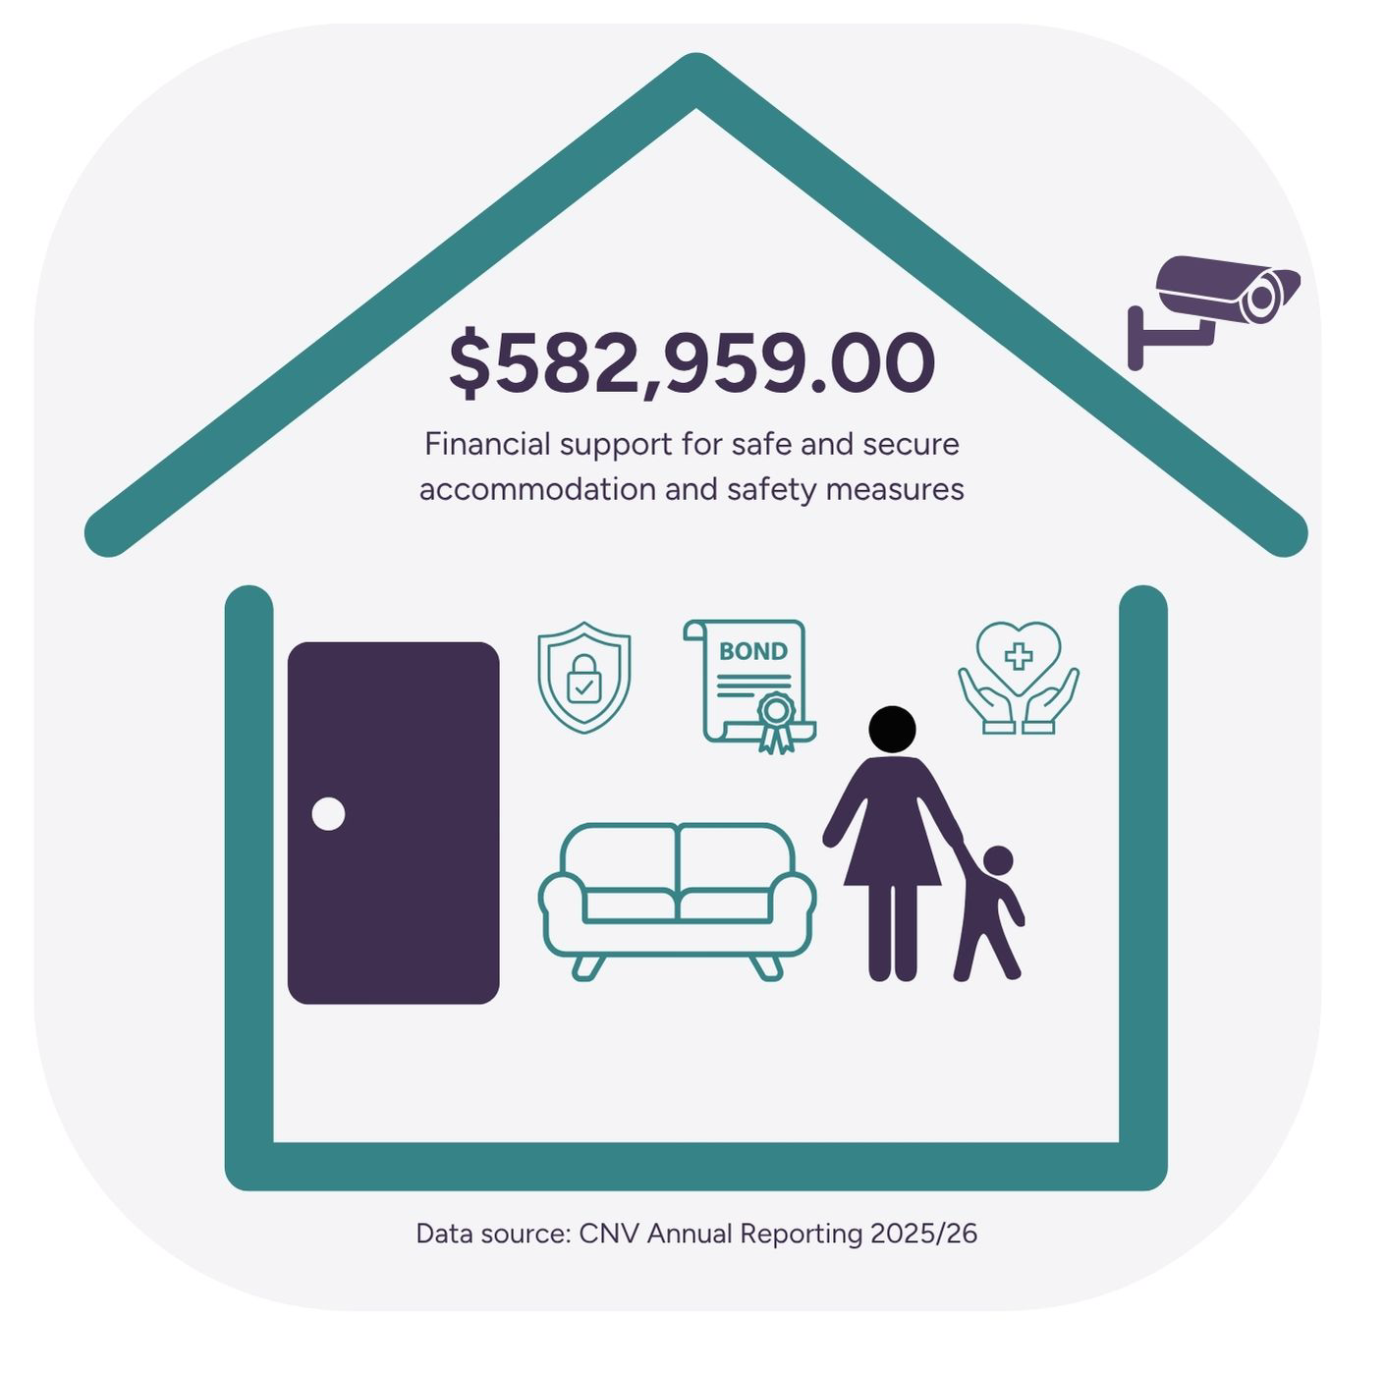
Recommendations:
- Expand the Safe Places Emergency Accommodation Program: The Federal Government should increase capital investment to build, purchase and renovate emergency accommodation for women and children escaping violence, with dedicated allocations for rural and regional communities where crisis accommodation is limited or not fit for purpose.
- Establish housing as a human right: The Federal Government should progress national human rights protections that recognise access to safe, secure and affordable housing as a fundamental right, including for victim survivors and children escaping family, sexual and gender-based violence.
- Provide ongoing funding for safe at home responses: The Federal Government should commit recurrent funding for the Personal Safety Initiative and other safe at home responses as core service delivery, enabling victim survivors and children to remain safely connected to their home, school, employment and community where appropriate.

  - Improved state, territory and national monitoring systems evidencing prevalence of and forms of family, sexual and gender-based violence. Including strengthened national data systems to better capture patterns of harm, including repeat victimisation, severity, and cumulative impacts

Understanding Violence: patterns, prevalence and perpetration:
To date, there does not exist a national database on the prevalence of deaths related to FSGV in Australia. Systems and sector services are reliant on voluntary, groups and individuals to provide this much needed data. If we do not know, who, when and how people are having their lives forcibly ended due to FSGV, then how are we to fully understand prevalence and risk?
Right across states and territories specialist services are calling on greater investment into monitoring systems that would give valuable insight and understanding into the prevalence of FSGV and emerging themes and forms of violence. This monitoring would necessarily inform not only practice decision-making for frontline services, but also inform policy development and provided targeted, evidence-based data to inform primary prevention and early intervention work – stopping the violence before it begins.
It is imperative that this data is comparable. National reporting standards that provide a base-line that is informed by specialist services to measure impact and outcomes is necessary to help prevent FSGV against women, children and diverse communities. Equally, there must be greater and dedicated investment into the development of systems that measure the impact of FSGV for people who face greater intersectional risk of harm, including rural and remote communities, Aboriginal and Torres Strait Islander people, people from CALD, including migrant and refugee backgrounds, people with disability and people from the LGBTQIA+ community.
Currently data and mapping of sexual violence is fragmented and may or may not be collected across multiple systems, including police, courts, health services, child protection, sexual assault services, homelessness services, family violence services and population surveys. There is no one source of prevalence, response, prevention and system accountability. A dedicated data set and monitoring system for sexual violence, in all its forms, will assist in determining the full scope and impact of the violence occurring and inform prevention, policy and funding responses.
These systems are possible. Integrated services, particularly since the Victorian 2015 Royal Commission into Family Violence have been leading the way in developing best-practice models.
Integrated service models that work with both victim survivors and adults using violence represent best-practice service delivery. By applying an intersectional lens to safety assessment and risk management, these models strengthen both safety outcomes and system accountability, while keeping perpetrators in view. For example, the Family Violence Multi-Agency Risk Assessment and Management Framework (MARAM) provides the legislative foundation for identifying, assessing and managing family violence risk across a range of professional and service sectors.
CNV has recently participated in the Australian Institute of Health and Welfare (AIHW) ‘Specialist Crisis Family and Domestic Violence (FDV) Services Pilot Project’ aimed at informing a national evidence base on service demand, responses and unmet need. The overarching objective of the project is to develop recommendations for a nationally consistent approach to collecting data on specialist family violence crisis services, supporting improved service planning, policy development and system-wide accountability. This is an important first step and has highlighted the necessity of consistent national data collection that supports the system and the sector to better understand, respond to and tailor policies, programs and services to meet the needs of those experiencing or at risk of experiencing FSGV in Australia.
There is a distinct lack of consistent, national data collection for communities at higher risk of harm of FSGV including First Nation, LGBTQIA+, CALD and people with disability. To date, national conversations are informed by now largely outdated statistical data that are not able to adequately capture the intersectional and often unique experiences of FSGV by First Nation and diverse communities.
Recommendations:
- Greater investment into monitoring systems that would give valuable insight and understanding into the prevalence of FSGV and emerging themes and forms of violence, including national consistent data collection on family violence related homicides.
- A dedicated sexual violence minimum data set is established to facilitate understanding of prevalence to inform policy and funding decisions across the sexual violence prevention and response continuum.
- Greater investment into research and monitoring systems, including data collection systems that specifically focus on prevalence, impacts and outcomes for communities that are chronically underrepresented in the data. This includes consistent and dedicated focus on First Nation, migrant and refugee communities, people with disabilities and LGBTQIA+ communities.

  - Evidencing Impact and Outcomes: keeping victim survivor safety and wellbeing central to all decision-making

Integrated service models that work with both victim survivors and adults using violence represent best-practice service delivery. By applying an intersectional lens to safety assessment and risk management, these models strengthen both safety outcomes and system accountability, while keeping perpetrators in view.

The Family Violence Multi-Agency Risk Assessment and Management Framework (MARAM) provides the legislative foundation for identifying, assessing and managing family violence risk across a range of professional and service sectors.

CNV has recently participated in an Australian Institute of Health and Welfare (AIHW) project aimed at informing a national evidence base on service demand, responses and unmet need.

The overarching objective of the project is to develop recommendations for a nationally consistent approach to collecting data on specialist family violence crisis services, supporting improved service planning, policy development and system-wide accountability.

Recommendations:

- A national, comprehensive database that collects evidence, impact and outcomes for victims of family, sexual and gender-based violence is necessary if we hope to end violence against women and children.

  - Systems Abuse
Systems abuse is often realised through weaponisation by the perpetrator through the deliberate misuse of government systems such as Child Support, Child Protection, and Family Law to intimidate, threaten, and harm victim-survivors of family and sexual violence. It is pervasive, particularly within the Family Court where the legal system continues to disbelieve women and validate abusers.
Each year, around 22,000 families navigate the Federal Circuit and Family Court of Australia (FCFCOA) system for parenting and property matters. In 2022–23, more than 84% of cases involved allegations of family violence, including risks to children. Yet the Family Court continues to assert that it is not part of a family violence response — even as it routinely sidelines the voices of children, young people, and mothers, including in cases involving allegations of child abuse and child sexual abuse.
This becomes an even more complex issue where there is a protection order in place issued by state and territory magistrates courts that, with the presence of a Final Parenting Order issued by the FCFCOA becomes, in practical terms, unenforceable. Perpetrators of family violence are able to circumnavigate protection orders such as police issued Family Violence Intervention Orders by initiating parenting proceedings in the FCFCOA. It becomes near impossible with the presence of interim or final parenting for police to successfully prosecute breaches against the protection orders where there are parenting matters on hand, or finalised. This places victim survivors, particularly children at increased risk of harm, particularly where the Family Law Courts fail to recognise post separation abuse and the ongoing impacts of family violence on children where protective measures within parenting orders fall short of protection orders.
The impacts on the health, financial security and legal standing of victim survivors within the Family Law system also cannot be ignored. It must change. And while state and territory courts can, and are often misused by perpetrators, we agree with the findings from the 2025 South Australian Royal Commission into Domestic, Family and Sexual Violence that the Family Law system is the worst offender for perpetration of systems abuse for victim survivors by perpetrators.
The current capacity of the FCFCOA to recongise and respond to family violence when considering parenting and property matters is falling short to the point of compromising the safety of families affected by family violence. It is imperative that improving understanding of family violence by all judicial officers and officials, particularly when determining parenting and property matters before the court is prioritised.
There also must be a commitment to improving access for victim survivors within legal and judicial settings to seek justice, hold perpetrators to account and have greater understanding of FSGV within the courts systems: from local country courts managing protective orders and breaches, through to transformational change with the Federal Circuit and Family Law Courts of Australia.

Recommendations:

- Prioritisation of an independent audit of the family law system to identify and address the potential for systems abuse
- Continuation of co-funding by Australian Government, with the states and territories, of the National Judicial College of Australia to delivery of family violence training packages for judicial officers across Australia in all jurisdictions beyond June 2027. This training to be informed and regularly reviewed in consultation with specialist family violence services.
- Tailored family violence training packages within the FCFCOA be developed and managed by experienced trainers who have expertise in training design and delivery.
- Strengthened engagement with the specialist family and sexual violence sectors in the development and reform of relevant legislation and decision-making processes. Increased presence and priorisation of specialist services within the FCFCOA to ensure that victim survivors, including children, are appropriately supported, risk identified.
- Increased information sharing between state and federal judicial and legal systems, including improved understandings and application within the family courts to recognise and allow greater state policing responses to enforce protection orders.

Improved understanding of what sexual violence looks like in all its forms and what service responses are currently being provided by the specialist sexual violence sector to meet the varied needs of victim-survivors.
Whilst acknowledging the intersections with family and domestic violence, sexual violence must be considered as a distinct form of violence that also occurs in other settings. Sexual violence requires distinct prevention strategies, specialist clinical, forensic and therapeutic responses, and particular workforce expertise. While there are common drivers, policy and funding frameworks, sexual violence should be recognised as a distinct issue to ensure that victim-survivors have access to appropriately funded specialised services, and that prevention and response efforts address the unique dynamics of sexual offending.
It is important to note that the specialist sexual violence services are different to domestic and family violence services. Specialist sexual violence services respond to all victim-survivors of sexual violence: women, men, children, and people who identify as gender diverse, as well as children and young people who display harmful sexual behaviours (HSB).
Specialist sexual violence services respond to violence that has occurred in a wide range of relationships or settings over the course of a person’s life. Sexual violence, including child sexual abuse, can occur in every domain of people’s lives, not solely within the family or intimate partner contexts. Around two-thirds of sexual violence occurs outside domestic or family violence settings (ABS, Sexual Violence Victimisation 2021). This includes institutional settings, workplaces, schools, universities, residential aged care, online environments, public spaces, and between acquaintances or strangers.
Sexual violence, including child sexual abuse, is a serious, underreported and increasingly prevalent problem in Australia. Approximately 2.8 million (14 per cent) Australians experienced adult-perpetrated sexual violence since the age of 15 (AIHW, Sexual Violence, 2021).
The rate of recorded sexual assault incidence has climbed consistently, with the number of victims recorded in 2024 alone rising by 10 per cent, marking the fourteenth consecutive year of increases, with rates outpacing population growth in four of the previous five years (ABS, Recorded Crime – Victims, 2024). Police recorded crime data substantially underestimates the true prevalence of sexual violence, and the 2021-22 ABS Personal Safety Survey (2021) found 92 per cent of women did not report their most recent sexual assault to police.
A recent study (University of Adelaide 2025) found 14 per cent of young Australians have experienced online child sexual victimisation, including non-consensual sexual image sharing. Approximately one in four of these examples involved Artificial Intelligence (AI). In 2024-25, the Australian Centre to Counter Child Exploitation saw a 180 per cent increase in reports since the Centre launched in 2018 (AFP, 2023) The Australian Federal Police has warned of a surge in AI-generated Child Sexual Abuse Material (CSAM). Technology is rapidly evolving, changing patterns and methods of victimisation. AI is also being utilised for sexual violence disclosures and help-seeking, with no safeguards in place.
There are also concerning trends in relation to attitudes towards women and girls, particularly amongst young men. The National Community Attitudes Towards Violence Against Women Survey found that while Australians have generally become less accepting of violence against women over the past twenty years, progress on some measures has stalled or gone backwards, such as victim-blaming, understanding consent and the minimisation of sexual violence. These shifts are occurring alongside increasing reports of technology-facilitated abuse, exposure to extreme misogyny through influencers and online forums, widespread availability of violent and degrading pornography, AI generated sexual abuse material and image-based abuse. On occasion, girls and women are absorbing this messaging too, which internalises misogyny and contributes to a victim-blaming culture.
Conflating sexual violence with family and domestic violence within the National Plan is obscuring its prevalence, limiting prevention efforts, weakening data collection, and reducing access to specialist support for victim-survivors. An effective national response requires dedicated policy and investment in the existing sexual assault service system and recognises sexual violence as a standalone issue while also responding to its intersections with family and domestic violence where they occur.
Recommendations

- Recognise sexual violence as a stand-alone issue with dedicated funding allocated for research, prevention, policy development and response services within the National Plan.

- Transparent, sustainable and sufficient funding is prioritised for the specialist sexual violence service sector to meet demand, particularly in regional, rural and remote areas.

- Strengthen prevention of, and response, to sexually violent technology-facilitated abuse of children, young people and adults.

Priority 2: Prevention and Early Intervention
Embedding initiatives where people live, work, learn and connect to address the gendered drivers of this violence; address substantive influences on perpetration and risk such as harmful substance use, gambling, and adverse childhood experience; support attitudinal and behavioural change to prevent harm before it occurs; and to prevent escalation. It also requires collaboration and integration across sectors to strengthen primary prevention and early intervention approaches.

Frontline family and sexual violence services were established by feminist activists, not only to address gaps in mainstream service systems but also as a form of political and social action. Grounded in the feminist principle that “the personal is political”, these services recognised that preventing gender-based violence requires more than responding to individual experiences of harm. Rather, family and sexual violence are understood as deeply connected to gender inequality and broader systems of oppression.

Guided by intersectional feminist practice, frontline services have continued to mobilise communities, challenge inequitable structures and contribute to lasting social and cultural change.

Despite their critical role, the contribution of frontline services to the prevention of gender-based violence is often overlooked, including within prevention frameworks and, at times, by the services themselves. This is partly due to narrow definitions of primary prevention that prioritise population-level initiatives, while undervaluing local community engagement, advocacy, consciousness-raising and activism. In practice, feminist frontline services undertake prevention work every day by amplifying lived and living experience, identifying systemic barriers, advocating for policy and systems reform, and engaging communities to drive collective action and social change.

For frontline feminist services, investing in, attending and contributing to regional, state, national and international networks is an important form of prevention work. These networks create opportunities to share lived and living experience insights, identify structural barriers, influence local decision-making, and foster collective action to address gender inequality and other drivers of violence.

Prevention, early intervention, response and recovery should not be viewed as discrete or sequential activities, but as interconnected elements of a continuum of transformation. Together, they create opportunities to address the gendered drivers of violence, influence community attitudes and norms that condone inequality, strengthen accountability, and support lasting change at individual, community and systems levels.

Priority 3: Children and Young People in their Own Right
Centring children and young people’s voices, rights, and safety across prevention, early intervention, response and recovery, and providing tailored, age and developmentally appropriate support for children and young people. This priority includes young people who use violence (in the home and/or in intimate partner relationships, including the use of sexual violence).
The Consortium recognises that children have the right to live in safety and are victim survivors in their own right.
All of our programs, right across the continuum from prevention and early intervention through to response and recovery centre the lived experience of victim survivors – including children.
Necessarily, this has required our organisations to develop dedicated programs and interventions that increase safety for children experiencing family violence and to support their individual and tailored therapeutic recovery.
For example, CASACV delivers the Refocus program, a prevention and early intervention program working with children and young people, up to the age of 18, with problematic or harmful sexual behaviours. This program is underfunded and oversubscribed, and we cannot meet demand in our catchment area. The children and young people in this program have usually experienced one or more of the either family violence, sexual assault or exposure to inappropriate sexual behaviour or pornography.
The Consortium encourages a broader understanding of prevention that recognises the role of specialist response and recovery services for children and young people. Effective responses to children's experiences of family violence can reduce the long-term impacts of trauma, strengthen resilience and protective factors, and support healthy development.
By responding early to the impacts of violence and supporting children's recovery, these interventions can mitigate the long-term effects of trauma, strengthen protective factors, and help prevent the intergenerational impacts of violence and trauma.
3.1 Dedicated Programs and Services for Children: Safe, Thriving and Connected, Specialist Family Violence Therapy for Adult and Child Victim Survivors.
Safe, Thriving & Connected (STC) is a therapeutic recovery program for victim survivors of family violence. The program includes individual counselling, dyad (parent/child) counselling and a range of modalities such as EMDR, art, play, music, narrative and gestalt therapies. We support victim survivors to reclaim their sense of self, tell their story in strengthening ways, repair parent-child relationships impacted by family violence, and increase feelings of solidarity and connection with others. STC is delivered by the Consortium and continues to experience high demand for therapeutic services right across the region.
In response to the high demand for children’s therapy, STC practitioners are developing a 4-week group program for parents whose children have been referred to the program. The purpose of the group is to increase the capacity of parents and carers to support their children’s healing.

Innovative Child-focused Therapeutic Resources: ‘Healing Together

As part of our innovative approach to supporting emerging client needs, we developed best practice resources to support children’s safety, wellbeing and recovery.
The Healing Together resources were developed for children, parents, practitioners and community to support children’s safety, wellbeing and recovery from family violence. We recognise that children have their own unique experiences and responses to family violence. It is not uncommon for safe and protective parent-child relationships to be undermined by adults who use violence. In recovering from family violence, one of the most important things in a child’s wellbeing is their relationships with safe caregivers.

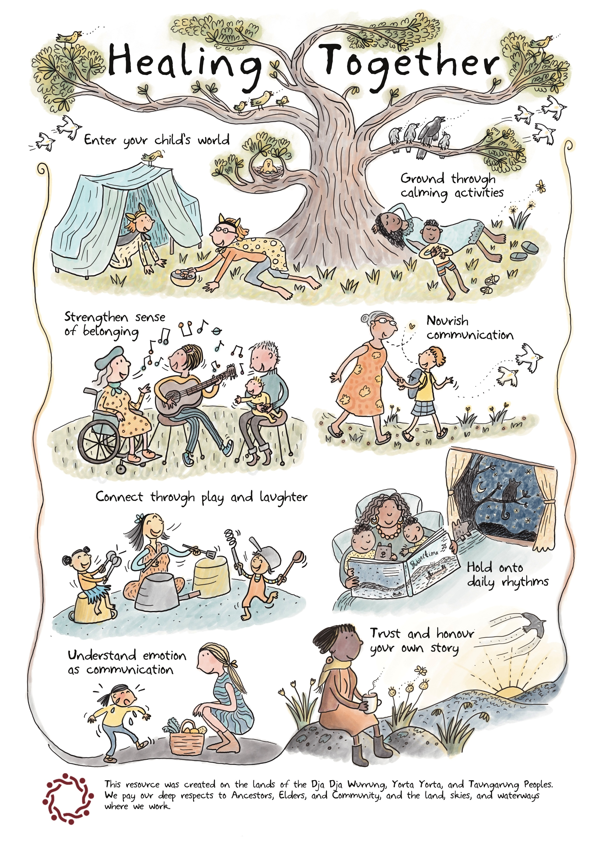

The resources support parent/carer understandings of the impact of family violence on children. They include ideas for how parents/carers can communicate with children, connect on their level, and strengthen feelings of safety, wellbeing and recovery. The resources were co-designed and developed in consultation with CNV’s STC clinicians, [REDACTED] and informed by client experiences. They consist of a poster for parents, activity sheets for children, a practitioner guide, postcards with conversational prompts and community posters for display in, for example, early childhood settings, Maternal Child Health centres and libraries.

Recommendations:

- Investment into research and consistent national data collection capturing children’s experiences of family and sexual violence as victim survivors in their own right.
- Enhanced funding to respond therapeutically to children when in crisis through funded specialist children’s workers.
- Increased investment into specialist family and sexual violence services to provide innovative, tailored and place-based programming to support crisis response and therapeutic recovery.

Priority 4: People who use Violence
Advancing prevention, early intervention, response, and recovery and healing throughout the life course on both family and domestic violence and sexual violence, supporting earlier identification, and multi-sector approaches to accountability and behaviour change, for example (but not limited to) strengthening policing and justice sector responses.

Advancing prevention, early intervention, response, recovery and healing across the life course requires a stronger focus on people who use violence. This includes improving the early identification of risk factors and abusive behaviours, strengthening pathways to accountability, and supporting meaningful behaviour change through coordinated, multi-sector responses.
Effective approaches require collaboration across specialist family violence services, health, alcohol and other drug services, mental health, gambling support, child and family services, policing and the justice system to address the complex factors that can intersect with the use of violence.

There is a recognised and complex interplay between trauma, harmful substance use, mental ill-health, gambling-related harm, and violence against women and children and other forms of gender-based violence. While these factors do not cause violence, they can increase risk, compound harms, and create additional barriers to safety, accountability and recovery. Responses must therefore avoid excusing violence while ensuring people who use violence can access coordinated interventions that address underlying needs, build accountability and support sustained behavioural change.

A gendered analysis remains critical. The overwhelming majority of family, domestic and sexual violence is perpetrated by men against women and children, reflecting broader patterns of gender inequality, entitlement and power. Importantly, not all men use violence. However, all men benefit to varying degrees from social structures, norms and systems that privilege men and reinforce gender inequality.
Advancing community safety therefore requires not only holding individual perpetrators accountable, while also challenging the social and structural conditions that enable violence and limit women's safety, freedom and equality.
Strengthening responses to people who use violence is essential to reducing risk, preventing escalation and repeat offending, increasing victim survivor safety, and contributing to long-term cultural and systems change. This includes investment in evidence-informed interventions, enhanced risk assessment and information sharing, and stronger integration between prevention, justice, health and community service systems.
People using violence: keeping the gendered nature of violence in view
Prevalence data, research and specialist family and sexual violence practice consistently show that people who use family, domestic and sexual violence are predominantly men, and that this violence is predominantly perpetrated against women and children. This does not mean all men use violence, nor does it diminish the experiences of victim survivors from diverse communities, including people with disability, LGBTQIA+ communities, Aboriginal and Torres Strait Islander communities, and migrant and refugee communities.
For this reason, our work with people using violence is largely work with men. It must therefore hold together two core objectives: increasing safety and recovery for victim survivors, including children, while creating clear, consistent pathways for men who use violence to take responsibility, be held accountable and change their behaviour.
Integrated services such as the Centre for Non-Violence work with both victim survivors and adults using violence. This whole-of-family model enables risk to be identified earlier, victim survivor safety to remain central, and men using violence to be invited into specialist interventions that support accountability, safer decision-making and respectful relationships with partners, former partners, children and other family members.
However, specialist services continue to experience low voluntary engagement from people using violence. Most men enter programs through court-mandated pathways, often after risk has already escalated. This points to the need for stronger early intervention, clearer referral pathways and more consistent accountability at every point of system contact.
Investment is needed to strengthen system responses to adults using violence, including the capacity and capability of specialist services to fast-track men using violence into programs and services at the point of first contact. Where there has been a police response to a family violence incident, there is often a short window in which the person using violence may be more visible to systems and more open to intervention. That window can close quickly when there is no timely follow-up, coordinated accountability or meaningful pathway into specialist support.
It is not uncommon for people using violence to remain out of view and unaccountable within policing and judicial responses. For example, the 2022 ANROWS report Pathways to intimate partner homicide identified a cohort of men who used homicide in the context of family violence who previously had low levels of contact with the criminal justice system and were often viewed as non-offending or low risk and functioning well in other areas of life, despite using coercive, controlling and abusive behaviours in their intimate relationships.
We note that while Victoria Police is working with the sector to address the significant issue of misidentification, much more needs to be done in this area to ensure that victim survivors are not further traumatised and subjected to unintended legal and systemic harm that incorrectly identify them as perpetrators, thereby limiting their access to protection, support, and justice, while undermining their wellbeing.
Coercive and controlling behaviours are significant indicators of serious and escalating risk. This includes patterns of stalking, monitoring, isolation, intimidation, threats, non-fatal strangulation and heightened control at the point of separation or attempted separation. These patterns are consistent with the risk indicators that CNV continues to identify through its own service data and frontline practice.
Systems must be designed to keep the person using violence in view, particularly where there is limited or no ongoing contact with the criminal justice system. Men who are socially, professionally or financially well-resourced may be able to minimise, deny or obscure their use of violence, including stalking, surveillance, systems abuse and non-fatal strangulation. A coordinated response must therefore strengthen information sharing, risk assessment, cross-sector accountability and timely referral into specialist interventions.
This is where investment in the integrated specialist family, sexual and gender-based violence sector is essential. Specialist services are best placed to provide whole-of-family responses that keep victim survivor safety central while maintaining a clear focus on the person using violence. These services are already developing and delivering practice models that respond to local need, but they cannot continue to carry escalating risk within insecure and insufficient funding arrangements.
Innovation in practice: working with men who use violence
Investment in innovative, evidence-informed and place-based programs is critical to expanding the reach and effectiveness of interventions with people who use violence. Since 2017, the Centre for Non-Violence has delivered Making aMENDs, an integrated, father-focused men’s behaviour change program. The model has helped inform CNV’s practice with men using violence while centring the safety, needs and recovery of victim survivors, including children.
- Enhanced intake, risk and safety assessment for both victim survivors and men using violence
- Family centred, holistic and trauma-informed support, monitoring and follow up
- Integrated services and Family Safety Contact for adult victim survivors and children, including responding to children as victim survivors in their own right
- Father focused 1:1 case management support, group programs and curriculum
- Access to accommodation and housing support for men using violence when they are excluded from the family home
- Access to therapeutic recovery and counselling supports (for both adult and child victim survivors and fathers using violence)
- Child-centred behaviour change programs for men using violence to recognise and understand the impacts of family violence on parenting, children’s wellbeing, development and safety
Program outcomes demonstrate the value of integrated interventions that combine accountability, safety planning, therapeutic support and coordinated family safety contact. Reported outcomes include:
- Increased recovery and justice outcomes
- Integrated access to therapeutic counselling programs and services for victim survivors through Family Safety Contact
- Best practice model development and family centred curriculum, resources and tool development
- Enhanced service and system integration and case coordination to increase family safety, accountability and access to services to address intersecting needs such as mental health, AoD, CALD and disability supports.
As front-line services we see the real impacts that these innovative programs have in increasing safety and improving lives for victim survivors including children.
For example, our program evaluation study demonstrated that 80 per cent of women reported feeling safer due to support received through Family Safety Contact during the program. 42 per cent of the women also had observed positive behavioural changes in the men participating in the program.
For the men engaged in the program, there was demonstrable increased understandings of how their behaviour affects children, including emotion and psychological distress, long-term development impacts, and disrupted trust and relationships.

“I know that not seeing my children has been hard, but it has been necessary for me to become who I really want to be as a father.”
- Making aMENds Group Participant (father-focused group program)

Despite these positive outcomes, CNV has been forced to reduce the scope of Making aMENDs due to a lack of sustainable funding. This undermines the availability of a proven local intervention at a time when risk is increasing and demand for specialist responses continues to grow. Without secure investment, programs that improve accountability, increase safety and support behaviour change will remain vulnerable to reduction or closure.
The rise of the manosphere and violent misogyny
The rise of the manosphere and increasingly visible forms of online misogyny must be understood as part of a broader social and structural context. These movements do not emerge in isolation. They draw on, amplify and legitimise existing gender inequalities, rigid ideas about masculinity, entitlement, control and backlash against feminism and gender equality.
For boys, young men and men, exposure to misogynistic online content can normalise contempt for women, minimise the seriousness of violence, encourage grievance-based identities and reinforce narratives that position equality as a threat. This creates additional prevention and early intervention challenges, particularly where online harms intersect with family violence, sexual violence, stalking, coercive control and extremist attitudes.
Responses must therefore extend beyond individual program interventions. They require coordinated prevention, education, digital safety, research, regulation and community mobilisation that directly challenge misogyny, rigid masculinities and the social conditions that enable violence.
National leadership is needed to build coalitions across specialist services, researchers, educators, technology and online safety experts, regulators, justice agencies and community organisations. Frontline services cannot be expected to respond to these harms alone. A comprehensive response must link local practice with national policy, legislative reform and sustained investment in prevention and early intervention.

Recommendations:
- Invest in specialist interventions with men using violence: The Federal Government should provide sustainable, ongoing funding for specialist, evidence-informed and place-based programs that work with men and boys across prevention, early intervention, response and accountability, including programs that respond to rigid masculinities and misogynistic attitudes.
- Establish a national specialist advisory mechanism: The Federal Government should establish a national consortium of specialist family, sexual and gender-based violence services to advise on emerging risks, policy design, implementation and system reform, including risks associated with violent misogyny, online harms and the manosphere.
- Develop a national family, sexual and gender-based violence data system: The Federal Government should work with states and territories to establish a nationally consistent data system that tracks prevalence, risk indicators, patterns of perpetration, repeat victimisation, severity and outcomes across family, sexual and gender-based violence.
- Maintain independent national research capacity: The Federal Government should continue long-term investment in ANROWS and other independent research infrastructure to support critical analysis, evidence translation, policy development and evaluation across prevention, early intervention, response and recovery.
Priority 5: System Integration and Workforce
Safe and effective prevention, early intervention, response and long-term recovery including justice and health sector responses, drawing on an integrated system and a connected and capable workforce that utilises trauma and violence-informed approaches across multi-sector services and programs.

5.1 Criticality of specialist services

The family violence sector right across the nation is facing major challenges. With the rise in extremist misogyny right across our communities, services like ours are experiencing a distinct and worrying increase in not only demand on services, but also the risk of lethality for victim survivors, including children. Each and every year thousands of victim survivors require the support of family violence services and disappointingly many do not receive the service they so desperately need due to demand.

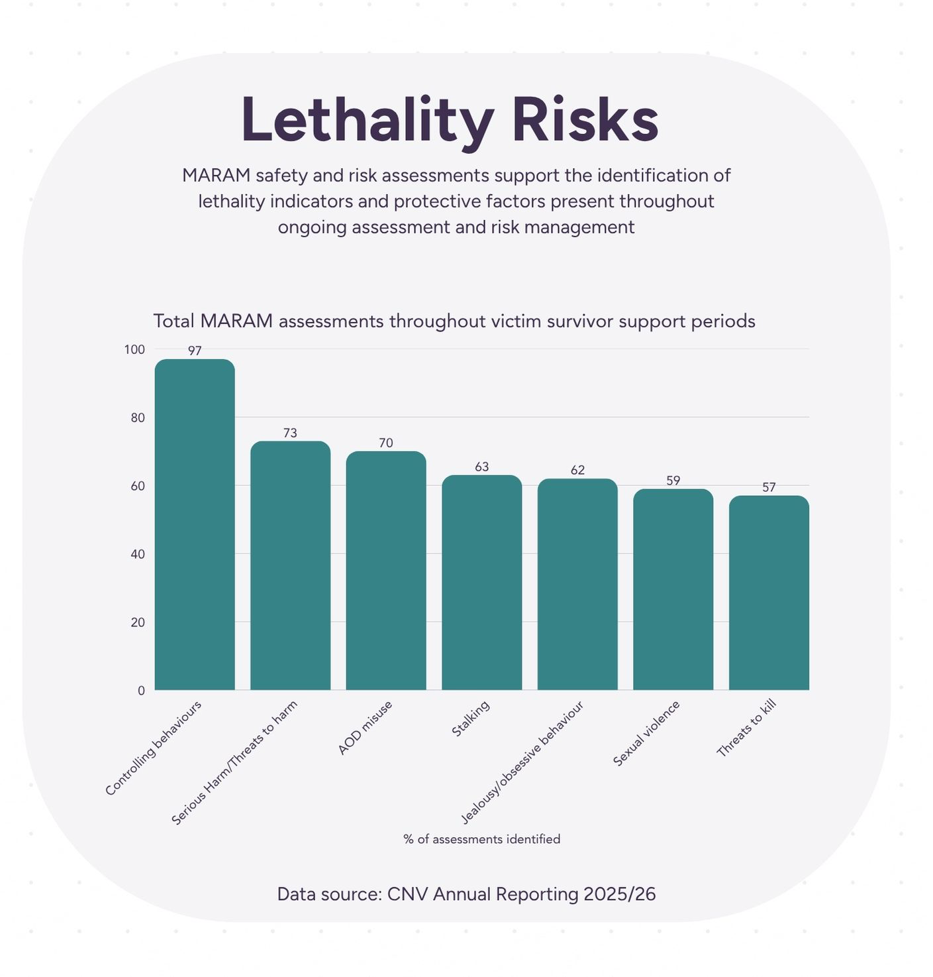

For example, last financial year, the Centre for Non-Violence provided intensive case management for over 2000 individuals seeking safety and support from family violence in the last financial year (2024-2025), 990 of these individuals were children experiencing family violence. This is in addition to the 4,200 women and children provided intake and assessment through The Orange Door network in our region.

CASACV is funded to provide information, support, therapeutic counselling to victim survivors across all genders and ages. The organisation provides support and advocacy with, and for, victim survivors to a range of other systems, where needed, including the justice system, medical and allied health services, education, mental health, alcohol and other drug services, housing, family and domestic violence services.
CASACV also delivers the Refocus program, a prevention and early intervention program working with children and young people, up to the age of 18, with problematic or harmful sexual behaviours. This program is underfunded and oversubscribed and we cannot meet demand in our catchment area. The children and young people in this program have usually experienced one or more of the either family violence, sexual assault or exposure to inappropriate sexual behaviour or pornography.
CASACV is funded to provide a 24-hour crisis response for recent sexual assaults which includes supporting the victim survivor and liaising, coordinating and advocating for client centred and trauma informed responses and care with Police, Forensic and Health Services.
CASACV provided over 1200 therapeutic (counselling) episodes of care to children, young people and adults in the last financial year. These episodes care range between short, medium- and long-term care. We provided over 50 long term and specialist episodes of care to children and young people with problematic or harmful sexual behaviour.

CASACV also provided over 400 consultations and expert advice to a range of services and professionals including family services, schools, health services and early years settings regarding how to respond to disclosures, harmful sexual behaviour and how to talk about consent, mandatory reporting and referral pathways.

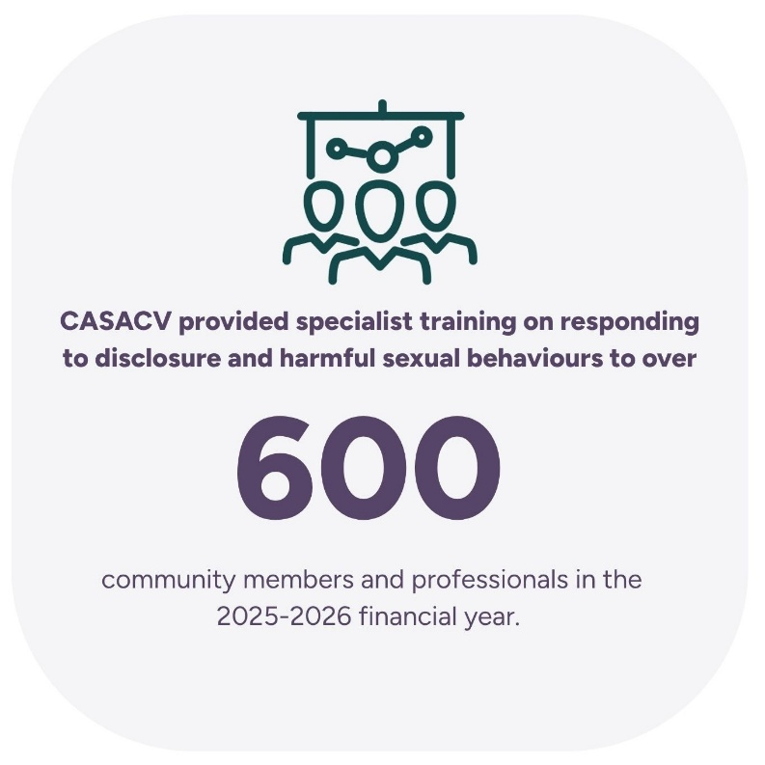

In Victoria, police respond to a family violence incident every 6 minutes. The latest data from the Victorian Crime Statistics supports what our staff are witnessing on the front lines: increased reports of family violence incidents, increased risk, and an increasing number of children victim survivors.

In the 2025-26 financial year, Annie North supported 231 individuals - 103 women and 128 children and young people. Of this group, 27 per cent were First Nations individuals, 21 per cent were Culturally and Racially Marginalised and 12 per cent were in receipt of NDIS packages.

5.2 Resourcing
Achieving the objectives of the National Plan requires a specialist family, sexual and gender-based violence sector that is funded to respond to immediate crisis, sustain long-term recovery, and undertake earlier intervention with people using violence. Current funding arrangements do not meet this requirement.
Front-line services are experiencing sustained growth in demand alongside increasing complexity of risk. This includes coercive control, technology-facilitated abuse, stalking, systems abuse, escalating threats and heightened lethality indicators.
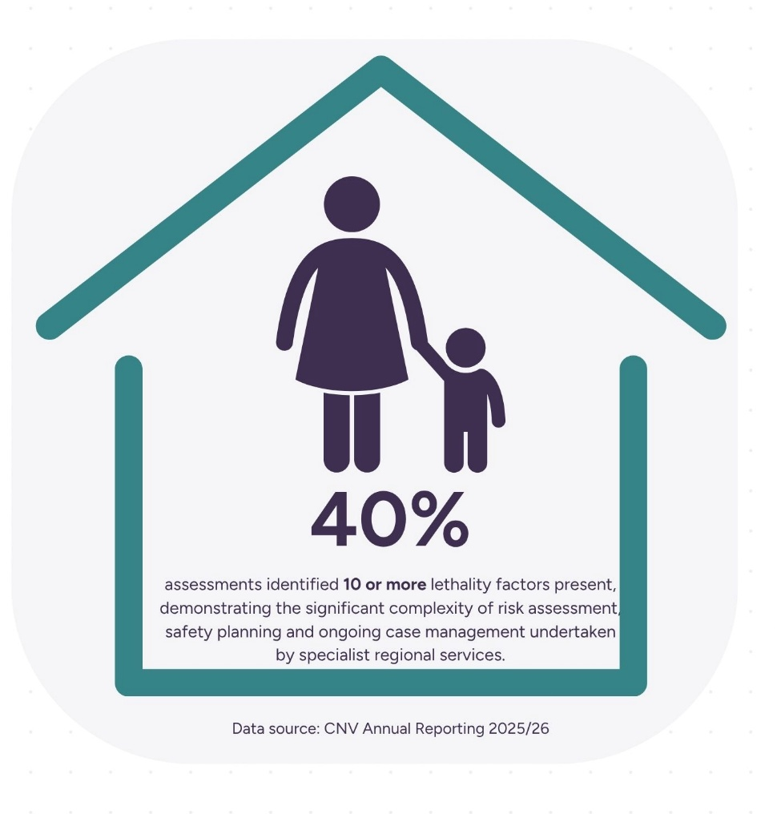
These patterns of harm are occurring within a broader community context in which more rigid, extreme and misogynistic views of masculinity are being normalised and amplified, including through online spaces. This increases the complexity of risk assessment, safety planning and accountability work with men who use violence, and heightens the risks experienced by victim survivors and children.
Despite this, specialist services continue to operate within short-term, insecure and insufficient funding models. These arrangements force organisations to redesign programs around funding gaps rather than community need, reduce access to critical supports such as crisis brokerage, housing assistance, therapeutic recovery and specialist case management, and limit the capacity of services to keep the person using violence in view.
A policy response focused only on crisis demand will not be sufficient. Victim survivors and children require timely crisis responses, sustained recovery pathways and integrated service models that support safety over time. Men who use violence also require earlier, stronger and more consistent intervention, particularly at points of system contact where motivation and accountability can be strengthened. Without this investment, the system will continue to carry risk rather than reduce it.
The current funding environment also has direct workforce implications. Specialist workers hold significant expertise in responding to the gendered, structural and intersectional drivers of violence. However, short-term funding and reduced service capacity constrain the use of this expertise, increase ethical and practice complexity, and contribute to burnout, vicarious trauma and workforce attrition. A sustainable workforce strategy must therefore include secure resourcing for specialist service delivery, supervision, training, integrated practice and long-term recovery work.
For the Second Action Plan to achieve meaningful implementation, the Federal Government must move beyond short-term funding cycles and establish a secure investment model for specialist services. This should recognise specialist family, sexual and gender-based violence services as essential social infrastructure within Australia’s public safety, health, housing and justice systems.
Recommendations:
- Establish long-term, indexed and demand-responsive funding: The Federal Government should work with states and territories to fund specialist family, sexual and gender-based violence services through a secure model that reflects demand, complexity, indexation and the true cost of service delivery across crisis response, recovery, therapeutic services, specialist children’s support, housing-related brokerage and integrated interventions with people using violence.
- Embed workforce sustainability in the Second Action Plan: The Federal Government should include a dedicated specialist workforce sustainability measure, including investment in supervision, training, reflective practice, specialist capability development, integrated practice and retention strategies.
- Require partnership with specialist services in national commissioning: National funding and commissioning arrangements should require genuine partnership with specialist services in policy design, implementation and evaluation, ensuring emerging risks, including violent misogyny and rigid masculinities, are identified and addressed across prevention, early intervention, response and recovery.
Conclusion
Specialist family, sexual and gender-based violence services are one of government’s greatest assets in achieving the shared goal of ending violence against women and children. These services hold the frontline expertise, trusted community relationships, evidence-informed practice and deep understanding of risk that are essential to effective prevention, early intervention, response and recovery. To realise the ambition of the National Plan, governments must treat specialist services as critical social infrastructure: partnering with them meaningfully, funding them sustainably, and embedding their expertise in policy, legislation, commissioning and system reform. Without this partnership and investment, Australia will continue to respond to violence after harm has occurred. With it, we can build the integrated, accountable and specialist system needed to prevent violence, increase safety, support recovery and create lasting change.
At the centre of this work must be the safety, dignity and wellbeing of victim survivors, including children as victim survivors in their own right. Ending family, sexual and gender-based violence cannot be measured only by system activity, funding outputs or policy commitments; it must be measured by whether women, children and all victim survivors are safer, believed, supported to recover, connected to housing, justice, health and community, and able to live free from fear and control.
A truly effective national response must listen to lived experience, uphold children’s rights and voices, and ensure that every decision across prevention, early intervention, response and recovery is guided by the question of whether it increases safety, strengthens wellbeing and supports healing for those most impacted by violence.

Centre for Non-Violence
Centre Against Sexual Assault Central Victoria
Women's Health Loddon Mallee
Annie North Women's Refuge
Omnia Community Health

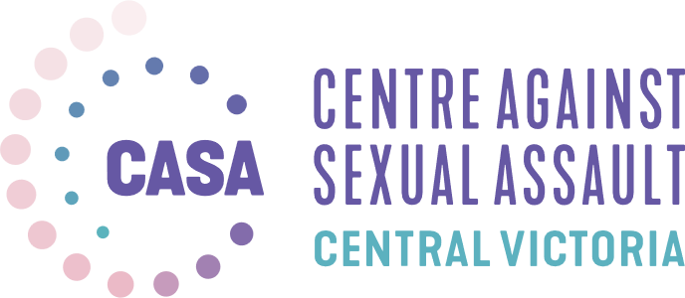

References:
Australia’s National Research Organisation for Women’s Safety. (2026, June). Monthly newsletter.
Australian Government. (2025). A safer Australia: Australia’s counter-terrorism and violent extremism strategy 2025. Retrieved June 2, 2026, from A Safer Australia | Australia’s Counter-Terrorism and Violent Extremism Strategy 2025.
Australian Institute of Health and Welfare. (2025). Clients experiencing family and domestic violence. Retrieved January 19, 2026, from https://www.aihw.gov.au/reports-data/health-welfare-services/homelessness-services/shs-client-groups/o-clients-experiencing-family-and-domestic-violence
Australian Institute of Health and Welfare. (2025). Homelessness and homelessness services. Retrieved January 19, 2026, from http://aihw.gov.au/reports/australias-welfare/homelessness-and-homelessness-services
Australian Institute of Health and Welfare. (2025). Legal systems. Australian Government. Retrieved February 5, 2026, from https://www.aihw.gov.au/family-domestic-and-sexual-violence/responses-and-outcomes/legal-systems
Barber, A., & Wailes, S. (2024). Why Australia needs a Human Rights Act: Addressing the housing crisis and strengthening whistleblower protections. Australian Human Rights Institute, University of New South Wales. Retrieved October 23, 2025, from https://www.humanrights.unsw.edu.au/students/blogs/human-rights-act-australia-housing-crisis-whistleblower-protections
Death, J., Ferguson, C., & Burgess, K. (2019). Parental alienation, coaching and the best interests of the child: Allegations of child sexual abuse in the Family Court of Australia. Child Abuse & Neglect, 94. https://doi.org/10.1016/j.chiabu.2019.104045
DV-alert. (2025, August 25). Understanding systems abuse. Retrieved February 5, 2026, from https://www.dvalert.org.au/about/news-blog/understanding-systems-abuse
Government of South Australia. (2025, August). Royal Commission into Domestic, Family and Sexual Violence report. Retrieved July 23, 2026, from Royal Commission into Domestic, Family and Sexual Violence Report.
Hill, J. (2026, May 28). Australians want a royal commission into femicide. What haunts me is wondering if it’ll be enough to make leaders act. The Guardian. Retrieved June 1, 2026, from Australians want a royal commission into femicide. What haunts me is wondering if it’ll be enough to make leaders act | Jess Hill | The Guardian.
Johnston, M., & True, J. (2019, October). Misogyny and violent extremism: Implications for preventing violent extremism [Policy brief]. Monash University and UN Women; Meger, S., Johnston, M., & Riveros-Morales, Y. (2024, June). Misogyny, racism and violent extremism in Australia [Policy brief]. University of Melbourne.
Johnston, M., & True, J. (2019, October). Misogyny and violent extremism: Implications for preventing violent extremism [Policy brief]. Monash University.
Meger, S., Johnston, M., & Riveros-Morales, Y. (2024, June). Misogyny, racism and violent extremism in Australia [Policy brief]. University of Melbourne.
Moody, S. (2026). Femicide Watch Australia data [Instagram data set]. Retrieved June 2026, from @sherelemoodyfemicidewatch. Note: Australia does not have a nationally collated central data point for monitoring femicide.
Phelan, A., White, J., Wallner, C., & Paterson, J. (2025). Gendered narratives and misogyny as motivators towards violent extremism: The case of far-right extremism in the UK and Australia. Terrorism and Political Violence, 37(7), 961–978. https://doi.org/10.1080/09546553.2025.2498505
Reeves, E., Fitz-Gibbon, K., Meyer, S., & Walklate, S. (2023). Incredible women: Legal systems abuse, coercive control and the credibility of victim-survivors. Violence Against Women, 1–22.
Safe and Equal. (2025, March 31). Inquiry into the supply of homes in regional Victoria [Submission]. Retrieved January 28, 2026, from https://safeandequal.org.au/wp-content/uploads/SUB_20250331_SaE-Submission-to-Inquiry-into-the-Supply-of-Homes-in-Regional-Victoria-FINAL.pdf
Yardley, E., & Richards, L. (2023). The elephant in the room: Toward an integrated, feminist analysis of mass murder. Violence Against Women, 29(3–4), 752–772.

ANROWS 2026. Monthly Newsletter, June.
Data sourced from @sherelemoodyfemicidewatch (Instagram). Noting that there is no nationally collated, central data point for the monitoring of femicide in Australia.
Phelan, A, White, J, Wallner, C, and Paterson, J. 2025. ‘Gendered Narratives and Misogyny as Motivators Towards Violent Extremism: The Case of Far-Right Extremism in the UK and Australia’, Terrorism and Political Violence, 37(7), 961–978. https://doi.org/10.1080/09546553.2025.2498505
Yardley E and Richards L 2023. ‘The Elephant in the Room: Toward an Integrated, Feminist Analysis of Mass Murder,’ Violence Against Women 29(3–4), 752–772.
See: Australian Government 2025. ‘A Safer Australia: Australia’s Counter-Terrorism and Violent Extremism Strategy 2025’. Available from: A Safer Australia | Australia’s Counter–Terrorism and Violent Extremism Strategy 2025 [accessed: 2 June 2026] See also: Australian Human Rights Commission 2020. ‘Commemorating one year since the Christchurch mosque attack’, media release, available from: Commemorating one year since the Christchurch mosque attack [accessed: 23 July 2026]
See: Johnston M and True J 2019. ‘Misogyny and Violent Extremism: Implications for Preventing Violent Extremism’, Policy Brief, October, Monash University and UN Women and Meger S, Johnston M and Riveros-Morales Y 2024. ‘Misogyny, Racism and Violent Extremism in Australia’, Policy Brief, June, University of Melbourne: Melbourne.
Meger S, Johnston M and Riveros-Morales Y 2024. ‘Misogyny, Racism and Violent Extremism in Australia’, Policy Brief, June, University of Melbourne: Melbourne.
Johnston M and True J 2019. ‘Misogyny and Violent Extremism: Implications for Preventing Violent Extremism’, Policy Brief, October, Monash University
More than 100,000 people have signed a petition to the Federal Government to initiate a Royal Commission into Femicide. See: Hill J 2026. ‘Australians want a royal commission into femicide. What haunts me is wondering if it’ll be enough to make leaders act’, The Guardian, 28 May. Available from: Australians want a royal commission into femicide. What haunts me is wondering if it’ll be enough to make leaders act | Jess Hill | The Guardian [accessed: 1 June 2026]
Safe and Equal 2025. Inquiry into the Supply of Homes in Regional Victoria, 31 March. Available from: chrome-extension://efaidnbmnnnibpcajpcglclefindmkaj/https://safeandequal.org.au/wp-content/uploads/SUB_20250331_SaE-Submission-to-Inquiry-into-the-Supply-of-Homes-in-Regional-Victoria-FINAL.pdf [Accessed: 28 January 2026]
Barber A and Wailes S 2024. ‘Why Australia needs a Human Rights Act: Addressing the housing crisis and strengthening whistleblower protections’, Blog Post, Australian Human Rights Institute, University of New South Wales. Available from: https://www.humanrights.unsw.edu.au/students/blogs/human-rights-act-australia-housing-crisis-whistleblower-protections [Accessed: 23 October 2025]
DV Alert 2025. ‘Understanding Systems Abuse’, 25 August. Available from: https://www.dvalert.org.au/about/news-blog/understanding-systems-abuse#:~:text=Following%20the%20National%20Cabinet%20meeting,manipulated%20to%20further%20harm%20someone. [Accessed: 5 February 2026]
Reeves E, Fitz-Gibbon K, Meyer S and Walklate S 2023. ‘Incredible Women: Legal Systems Abuse, Coercive Control and the Credibility of Victim-Survivors’, Violence Against Women, pp. 1-22
Australian Government 2025. ‘Legal Systems’, Australian Institute of Health and Welfare. Available from: https://www.aihw.gov.au/family-domestic-and-sexual-violence/responses-and-outcomes/legal-systems#:~:text=Family%20courts,property%20orders%20in%202022%E2%80%9323.&text=A%20Notice%20of%20Child%20Abuse,the%20proceedings%20(FCFCOA%202024). [Accessed: 5 February 2026]
Death J, Ferguson C and Burgess K 2019. ‘Parental alienation, coaching and the best interests of the child: Allegations of child sexual abuse in the Family Court of Australia’, in Child Abuse and Neglect, Vol.94. Available from: https://doi.org/10.1016/j.chiabu.2019.104045Get rights and content [Accessed: 5 February 2026]
Government of South Australia 2025. ‘Royal Commission into Domestic, Family and Sexual Violence’, report, August. Available from: Royal Commission into Domestic, Family and Sexual Violence Report [accessed; 23 July 2026]

