Submission to the Second Action Plan Consultation
National Plan to End Violence against Women and Children 2022-2032
Primary Area of Response - Priority Area 2 - Prevention and Early Intervention

About Challenge DV
Challenge DV is a Queensland charity established in 2001 that works to prevent domestic and family violence through practical, community-based education and early intervention.
Our work focuses on:
- Community-based prevention: supporting individuals and organisations to model healthy relationships, challenge harmful behaviours and foster cultures of respect and safety.
- Early intervention: equipping people across everyday settings with practical tools to recognise early patterns of coercive and controlling behaviours, respond safely and refer appropriately.
- Capability-building: working collaboratively and in trauma-informed ways to strengthen confidence, leadership and shared responsibility across communities.
Challenge DV works across workplaces, schools, sporting clubs and diverse communities, with a focus on practical prevention, early intervention and community capability-building. This submission draws on that delivery experience to outline where the Second Action Plan can strengthen prevention and early intervention in everyday settings. Programs informed by lived experience perspectives strengthen relevance, safety and community trust.
Selected Programs and Practice Examples
1. Recognise, Respond and Refer (RRR) & Respect at Work
- In the last year, Challenge DV delivered training to approximately 80,000 government employees and 1,000 non-government employees, helping participants recognise patterns of coercive control and other forms of domestic and family violence.
- Programs are delivered by qualified professionals through in-person and online formats.
- The Recognise, Respond and Refer e-learning platform has been redeveloped to improve interactivity and reflect current practice.

2. Schools & Youth Engagement: Darkness to Daylight (D2D)
- School-based programs combine education, empathy and participation in the Darkness to Daylight event, with training for teachers and students and information webinars for parents, helping communities identify early warning signs and support prevention before violence escalates.
- Students engage with age-appropriate content on power, control, empathy and respect, including early patterns of coercive and controlling behaviours, non-physical abuse, online misogyny and technology-facilitated abuse.
- The program received a Brisbane Catholic Education Award in 2024.
- Expansion is planned for 2027, including delivery in additional schools and the introduction of online teacher and parent resources.

3. Community & Sporting Partnerships: Our Club Says No to DV
- Programs for sporting clubs support safer and more inclusive environments.
- The work focuses on gender equality, inclusion, accountability and role-modelling.
- Partnerships with major sporting codes, including Queensland Rugby League and Brisbane Roar, support the integration of prevention into club culture.

4. CALD Advocacy & Workforce Upskilling
- Tailored workshops and advocacy support culturally and linguistically diverse communities.
- Prevention approaches must also be culturally responsive and accessible for multicultural and linguistically diverse communities experiencing additional barriers such as language access, migration dependency and social isolation.
- Spanish-language Recognise, Respond and Refer workshops have been delivered in partnership with the Colombian Consulate.
- This work includes participation in national advisory forums and webinars on inclusive prevention approaches.

5. Indigenous Partnerships: The Purple Army
- Partnerships include Gawun Supplies and Black Diamond Women’s Empowerment.
- The Indigenous-designed Purple Shirt Campaign promotes strength, unity and visibility in prevention efforts.
- The Purple Army Network includes more than 1,100 members and supports awareness and prevention through resources and events.

Challenge DV’s Prevention Wheel
Challenge DV’s Prevention Wheel illustrates a whole-of-community approach to preventing domestic and family violence before it starts. It reflects the submission’s core argument that prevention and early intervention are most effective when embedded in the everyday settings where people connect.
Across workplace training, youth education, sporting engagement, culturally responsive practice, community awareness and specialised advocacy, the model emphasises repeated learning, visible leadership and practical pathways for action.
It is designed to build capability in non-specialist settings to recognise early signs of domestic and family violence, including patterns of coercive control and non-physical abuse, respond safely and connect people to specialist support where needed.
By engaging young people, men and boys, families, community leaders and diverse communities, the model supports the attitude, behaviour and practice change needed for sustained prevention outcomes.

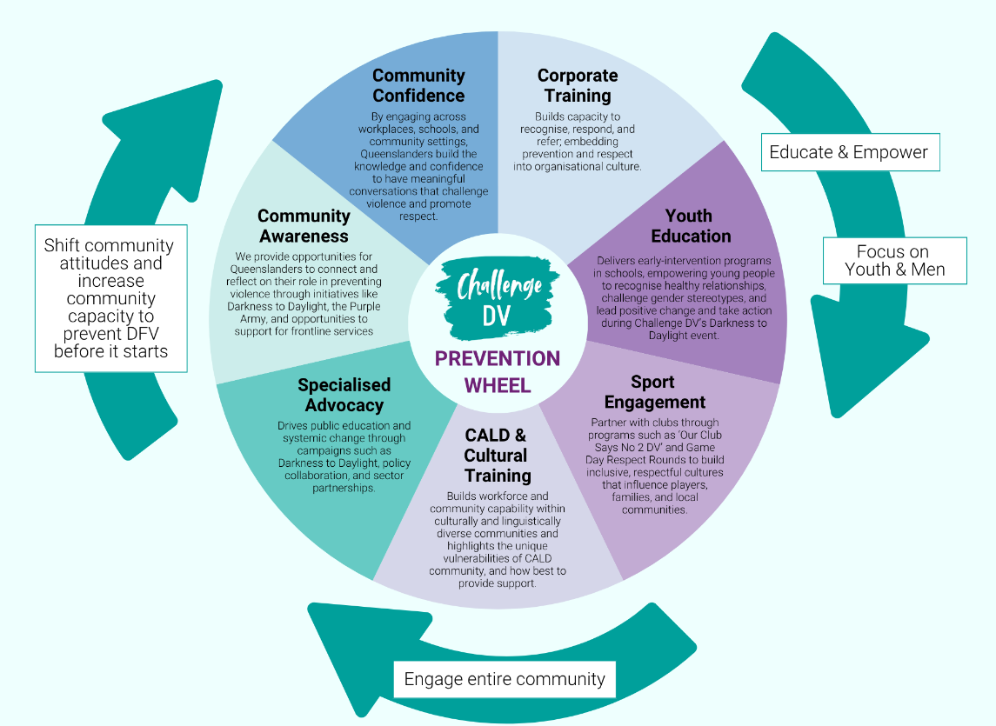

Executive Summary
Challenge DV welcomes the opportunity to contribute to consultation on the Second Action Plan under the National Plan to End Violence against Women and Children 2022–2032.
This submission argues that prevention and early intervention are most effective when embedded in everyday settings such as workplaces, schools, sporting clubs and community organisations, where harmful attitudes, patterns of coercive control and technology-facilitated abuse can be identified early and safe response pathways can be strengthened.
Challenge DV’s experience shows that effective prevention is practical, repeated over time and supported by role-specific education that helps non-specialist settings recognise warning signs, including early patterns of coercive and controlling behaviours, respond safely and refer appropriately.
A key gap is that many organisations want to play a role but need clearer guidance, stronger referral pathways and practical support to do so safely. This submission recommends sustained education, stronger community capability, targeted work with young people, boys and men, recognition of workplaces as prevention settings, and better evaluation of community-based prevention.
The submission’s five recommendations are summarised below.
Priority Area 2: Prevention and Early Intervention
What would make the biggest difference
The greatest impact will come from sustained, practical prevention delivered repeatedly across the settings that shape attitudes and behaviour. Workplaces, schools, sporting clubs and community organisations are critical because they influence culture, provide visible leadership and create opportunities for early intervention before harm escalates. Workplaces are often one of the first places where warning signs become visible.
Our experience demonstrates that sustained prevention requires repeated education, practical skill-building, active bystanders, visible leadership, safe referral pathways and culture change. The Second Action Plan should support connected approaches that embed these elements across everyday settings.
Community participation initiatives such as Darkness to Daylight also play an important role by turning awareness into shared commitment and action across schools, workplaces and the broader community.
How existing prevention efforts can be strengthened
Existing efforts can be strengthened by moving from one-off activities to connected, capability-building approaches that support implementation over time.
Recent focus group and survey findings indicate that while awareness of domestic and family violence is high, many workplaces and community settings still lack confidence to recognise patterns of coercive control, identify technology-facilitated abuse and intervene early and safely.
The main barriers identified were limited time, uncertainty about safe responses, low confidence in recognising warning signs, unclear referral pathways and a need for role-specific training.
Supporting people to recognise and respond
Everyday settings are better able to respond when people understand what harmful attitudes and behaviours look like, including non-physical abuse, coercive and controlling behaviours and technology-facilitated abuse, know the limits of their role, and have practical guidance on safe response and referral.
Recognise, Respond and Refer training helps build that confidence across teachers, managers, coaches, volunteers and other trusted contacts, while community participation initiatives help translate awareness into visible commitment and broader culture change.
Promising approaches and what is needed
The most promising approaches are those that combine reach, practicality and implementation support, particularly across non-specialist settings.
- blended education models that combine face-to-face training, e-learning, webinars and practical resources;
- school and sporting club programs that engage young people alongside the adults and community structures around them;
- practical Recognise, Respond and Refer frameworks that strengthen confidence in non-specialist settings.
To expand these approaches, organisations need sustained investment, implementation support and evaluation that measures changes in knowledge, confidence, practice and community capability over time.
Recommendations
1. Fund sustained prevention education in everyday community settings
Commit to long-term prevention education across workplaces, schools, sporting clubs and communities rather than one-off awareness campaigns.
2. Strengthen community capability to Recognise, Respond and Refer
Provide practical education, tools and referral pathways so non-specialist settings can identify warning signs, including patterns of coercive control, respond safely and connect people to specialist support.
3. Increase investment in prevention initiatives for young people, boys and men
Expand age-appropriate prevention initiatives for young people, boys and men, including responses to online misogyny and technology-facilitated abuse.
4. Recognise workplaces as critical prevention and early intervention environments
Recognise workplaces as prevention and early intervention environments and support action on education, leadership, policy implementation and safe support pathways. Workplaces are often one of the first places where warning signs become visible.
5. Strengthen evaluation of community-based prevention programs
Evaluate community-based prevention through changes in knowledge, confidence, organisational practice, bystander capability and referral awareness, not just participation numbers.
Conclusion
Challenge DV welcomes the consultation’s focus on prevention and early intervention in the places where people live, work, learn and connect.
Our experience shows that communities are willing to play a role, but need practical education, leadership, safe response capability and clear referral pathways to turn awareness into action. The Second Action Plan is an opportunity to embed prevention more deeply across everyday life and strengthen capability across non-specialist settings.

